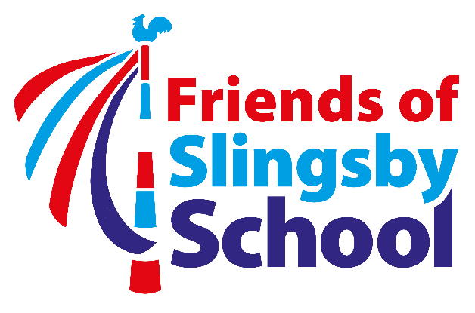

FOSS Ordinary Meeting Agenda
Wednesday, 16 January 2019 at 7pm at School

- Attendance

- Apologies

- Minutes of the last meetings 24.10.18 (copies available at meeting)

- Matters arising

- Finance update – overview with findings compared to last year; Parentkind membership; balances; Gift Aid.

- Report on past fundraisers and events: Halloween Party; Bags2School; Christmas Raffle; tombola/refreshments at Christmas Productions; Christmas Party.

- Update on future events:
Quiz and Curry Night – Feb – Date TBA
Bags2School – May – Date TBA – Mel Staley to lead
Working groups to be decided for:
Scarecrow Trail – May Day weekend – Sam Burnett to lead
Duck Race – July – Date TBA – Liz Wilson to lead

- Other fundraising ideas – all ideas welcome. A Readathon has been suggested – discuss and decide whether to go ahead and who should lead.

- Any other business.

- Date of next meeting - TBA

