Home Learning for w/c 30.03.20

Hello Class 3, I hope you are all keeping busy and getting lots of fresh air in your garden as well as doing lots of jobs for your adults? Remember to keep washing your hands and look after each other. Mrs Jordan

Maths
- Continue to practice your times tables.
Money
  - Check that the children are all familiar with the different coins and notes.
  - Give your child an amount e.g. £2.31 – Can you make this amount using a range of different coins? How many ways can you make the same amount? Change the value depending on how confident your child is.
  - Show different coins and notes, can your child say how much is there.
  - Using an old shopping receipt can you choose 2 or more items of different values and add them together. Remember the importance of the decimal point.

Check out White Rose Maths Home learning for some excellent activities for your children separated out by year group.

Top Marks Maths Games linked to money

English
- Continue with your diaries and remember to include anecdotal things that people have said or how you are feeling.
- Choose a favourite photograph, picture from a book and write a description using all / some of the features below.
  - Expanded noun phrases
  - Conjunctions
  - Prepositions
  - Personification
  - Simile

Art
- Make a rainbow and put this in your window – you could use felt pens, paints, crayons, collage or even make it out of lego.
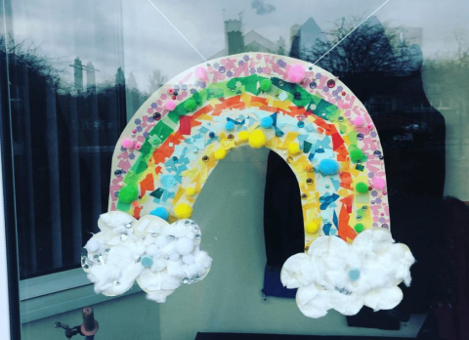
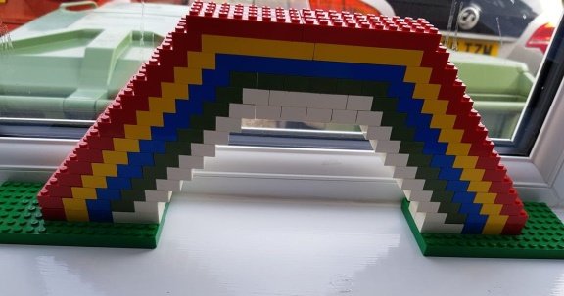

- Research the artist Giuseppe Arcimboldo, he created portraits by using simple objects such as fruit and vegetables. The picture below is a portrait using fruit and vegetables from the season spring. Can you make a portrait using simple items from around your house or garden? Or can you paint or colour a portrait using different fruit and vegetables?
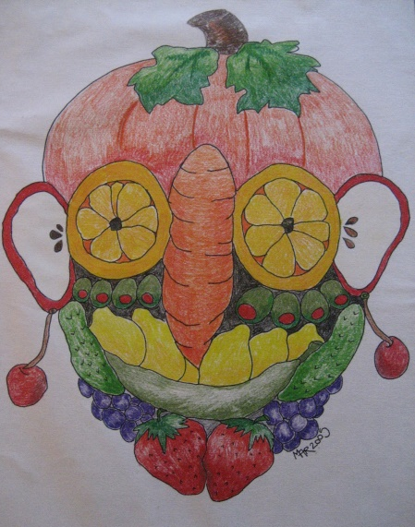

Geography
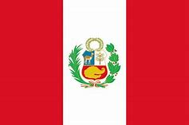
- Below is a flag of a country and a famous landmark, can you find out which country they belong to?
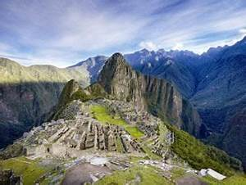
- Which continent is it in?
- What time is it in this country if it is 10:00am here?
- What is the currency in this country?
- What is the population of this country?
- How long will it take a post card to reach the country?
- What is the climate in this country?

Can you find out 2 more interesting facts about this country?
French / Science

We have been looking at animals and their habitats in science. Can you make a mini book of different animals and label them in both English and French.

Ext: Why not choose a third language such as Spanish, Italian or German
Lapin
(French)
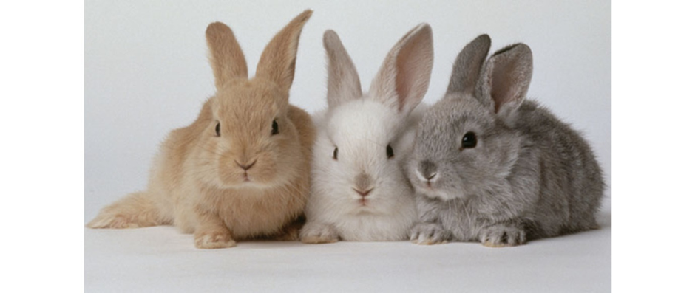
Conejo
(Spanish)

Other Activities

- Why not try Joe Wickes daily fitness video, it starts at 9:00a.m and lasts just 30 minutes. Even I have been doing this with my children so get your adults involved too.
- Look on You Tube and find a ‘Singing Hands’ video - can you learn a song using Makaton? What about ‘A Million Dreams’ or ‘I am the Music Man’.

