Class 4 Home Learning: Week Beginning 23rd March 2020
Please try to keep busy learning this week and do your best (as you always do for me in class!). DO NOT worry if you cannot complete all the suggested work.
English
This week, I would like you to try to write a non-chronological report for a new creature/plant that has recently been discovered (YOUR CHOICE! BE IMAGINATIVE) in the Amazon Rainforest biome.
A non-chronological report is the kind of text you would find in an information book, and tells the reader lots of different things, including:
- A clear introduction
- Habitat (where it lives – including climate details)
- Appearance (what it looks like – think about size, shape, animal classification, weight. What features does it have to be well-adapted to its environment)
- Diet (& hunting if it is a predator)
- Life Cycle (life expectancy & offspring)
- Conservation (How ‘at risk’ is it and why?)
Style: Formal with lots of technically specific vocabulary; mainly present tense; clear and concise information.
As you have the full week to complete this task, I would suggest the following:
- Monday: Find and read examples of information texts, then plan out your own.
- Tuesday-Thursday: aim to write a couple of sections per day.
- Friday: Proof-read, edit and improve your writing by reading it to an adult. Are there any questions they have? Could you make your information clearer?
Handwritten or typed is fine. It would also be fantastic if you could add a labelled diagram to accompany your non-chronological report!
I have included this week’s spelling lists for you to learn as normal at the end of this word document.
Mathematics:
The focus for this week is to try to improve your understanding in the following areas (Choose your level!):
- Finding fractions of numbers and amounts
- Equivalent fractions & comparing the size of fractions
- Adding, subtracting, multiplying and dividing fractions
Please use the resources on twinkl to find resources, problems and puzzles to practice these areas of fractions.
Another great resource to help you to learn about fractions is the bbc revisewise site for Key Stage 2.
Alternatively, I am aware that some of the Year 6 pupils have purchased SAT revision guides, so you may wish to use these instead for your studies this week.
Art:
- Produce an accurate copy of a painting by Claude Monet. Use paints IF YOU HAVE THEM, otherwise pencil crayons will also produce a good alternative.
Geography:
- As we have been recently trying to improve our understanding of the countries and capital cities of Europe, please label the countries on this map and try to learn as many capital cities as you can:

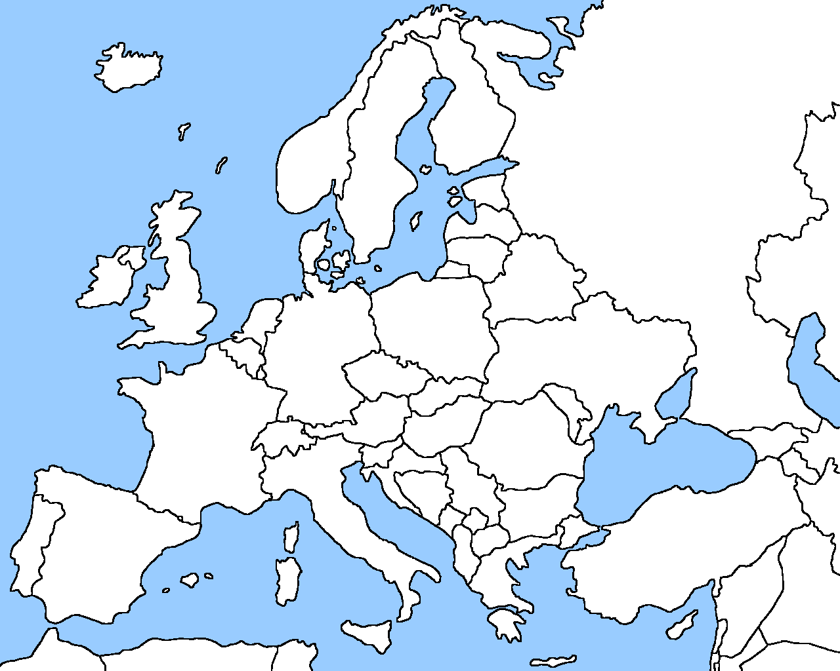

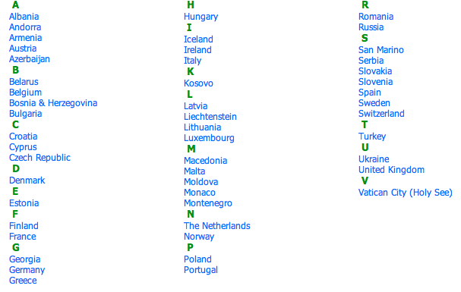

Weekly Spelling Lists
Class 4 spelling list for group 3: Week 24
After completing ‘look, cover write, check,’ please try to write 5 interesting sentences in your spelling homework book. You can use more than one word from your spelling list in each sentence.
Objective: To spell words from the Year 4 spelling list
Spellings | Look, cover, write, check
 | Monday | Tuesday | Wednesday | Thursday
appear
favourite
answer
forward
breath
breathe
grammar
imagine
build
pressure
history
probably
centre
increase
remember
certain
important
complete
different
difficult

Spelling score this week =

Class 4 spelling list for group 2: Week 24
After completing ‘look, cover write, check,’ please try to write 5 interesting sentences in your spelling homework book. You can use more than one word from your spelling list in each sentence.
Objective: To spell words from the Year 5 and 6 word lists.
Spellings | Look, cover, write, check
 | Monday | Tuesday | Wednesday | Thursday
according
sacrifice
apparent
stomach
awkward
restaurant
correspond
accompany
determine
according
determined
aggressive
temperature
government
through
vegetable
cemetery
vehicle
language
leisure

Spelling score this week =

Class 4 spelling list for group 1: Week
After completing ‘look, cover write, check,’ please try to write 5 interesting sentences in your spelling homework book. You can use more than one word from your spelling list in each sentence.
Objective: Words containing the letter-string ‘ough’
Spellings | Look, cover, write, check
 | Monday | Tuesday | Wednesday | Thursday
nought
drought
although
ploughing
coughing
toughest
toughening
roughened
throughout
thoughtfully
thoughtfulness
thoughtlessly
doughnuts
boroughs
overwrought
breakthrough
thoroughness
thoroughbred
afterthought
forethought

Spelling score this week =

