Class 4 home learning for week beginning Monday 30th March

Hello everyone!

I hope you had a good time at home last week and are keeping busy and safe at this time. How did the writing task go? It would be great to read some of your non-chronological reports when we return to school – you could also make Powerpoints of them if you’d like to.

Some ideas to keep your learning going for this week (one page a day is fine!):

English

Click on the link to the home learning packs for the following:

* Year 5: Fronted Adverbials pages 17-22.
* Year 6: Expanded Noun Phrases 33-38 (let’s see what you remember from our last week in school).

If you are unsure, don’t forget to look at the guidance and answers packs.

Mathematics

Again, we’re going to use the home learning pack this week:

* Year 5: Roman Numerals pages 1-7.
* Year 6: Rounding Numbers pages 2-7.

Reminder: I = 1 , V = 5, X = 10, L = 50, C= 100, D = 500, M = 1000.

Rules: 1) No more than 3 of the same symbol in a row: 45 = XXXXV is wrong! 45 should be thought of as 5 before 50 like this: VL.

2) The symbol used before another cannot be more than ten times less: For 99, you can’t do 1 before 100, so this is incorrect: 1C. Instead, make the 90, by putting X before C, then make the nine by putting I before X: 99 = XCIX.

If you are unsure, don’t forget to look at the guidance and answers packs.

Geography

How many countries and capitals of Europe did you learn last week? As part of our continuing theme based on rivers, this week I have thought of a creative task for you to complete. Firstly, try to complete the sheet on the next page to learn what each part of a river system is called. Next, I’d like you to have a go at making a 3D model of a river system (you choose the scale and materials).

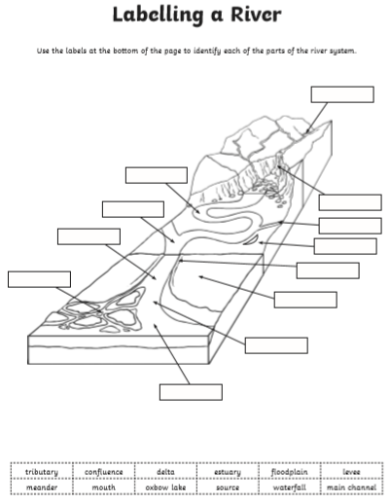Useful link: <https://www.twinkl.co.uk/go/resource/tg2-g-11-features-of-a-river-multi-click-hotspots>

Computing:

Use code.org to build your own sports game: <https://code.org/athletes>, or choose your own coding activity.

This week’s spelling lists:

**Class 4 spelling list for group 3: Week 26**

**After completing ‘look, cover write, check,’ please try to write 5 interesting sentences in your spelling homework book. You can use more than one word from your spelling list in each sentence.**

**Objective: To spell words with common letter strings but different pronunciations.**

|  |  |  |  |  |
| --- | --- | --- | --- | --- |
| **Spellings** | **Look, cover, write, check** | | | |
| **Monday** | **Tuesday** | **Wednesday** | **Thursday** |
| beard |  |  |  |  |
| cough |  |  |  |  |
| heard |  |  |  |  |
| enough |  |  |  |  |
| wear |  |  |  |  |
| ought |  |  |  |  |
| weary |  |  |  |  |
| brought |  |  |  |  |
| learned |  |  |  |  |
| plough |  |  |  |  |
| years |  |  |  |  |
| though |  |  |  |  |
| thought |  |  |  |  |
| pause |  |  |  |  |
| earning |  |  |  |  |
| through |  |  |  |  |
| because |  |  |  |  |
| search |  |  |  |  |
| through |  |  |  |  |
| appear |  |  |  |  |

**Spelling score this week =**

**Class 4 spelling list for group 2: Week 26**

**After completing ‘look, cover write, check,’ please try to write 5 interesting sentences in your spelling homework book. You can use more than one word from your spelling list in each sentence.**

**Objective: Words where the letters ‘ei’ follow a ‘c’ (and words where ‘ie’ comes before ‘c’)**

|  |  |  |  |  |
| --- | --- | --- | --- | --- |
| **Spellings** | **Look, cover, write, check** | | | |
| **Monday** | **Tuesday** | **Wednesday** | **Thursday** |
| thief |  |  |  |  |
| grief |  |  |  |  |
| brief |  |  |  |  |
| briefly |  |  |  |  |
| belief |  |  |  |  |
| relief |  |  |  |  |
| shield |  |  |  |  |
| friend |  |  |  |  |
| quiet |  |  |  |  |
| piece |  |  |  |  |
| deceit |  |  |  |  |
| deceive |  |  |  |  |
| ceiling |  |  |  |  |
| receipt |  |  |  |  |
| receive |  |  |  |  |
|  |  |  |  |  |
|  |  |  |  |  |
|  |  |  |  |  |
|  |  |  |  |  |
|  |  |  |  |  |

**Spelling score this week =**

**Class 4 spelling list for group 1: Week**

**After completing ‘look, cover write, check,’ please try to write 5 interesting sentences in your spelling homework book. You can use more than one word from your spelling list in each sentence.**

**Objective: Words where the letters ‘ei’ follow a ‘c’ (and words where ‘ie’ comes before ‘c’)**

|  |  |  |  |  |
| --- | --- | --- | --- | --- |
| **Spellings** | **Look, cover, write, check** | | | |
| **Monday** | **Tuesday** | **Wednesday** | **Thursday** |
| deceit |  |  |  |  |
| deceitful |  |  |  |  |
| deceive |  |  |  |  |
| deceived |  |  |  |  |
| deceiver |  |  |  |  |
| deceiving |  |  |  |  |
| deceivable |  |  |  |  |
| ceilings |  |  |  |  |
| receipt |  |  |  |  |
| perceive |  |  |  |  |
| received |  |  |  |  |
| receiving |  |  |  |  |
| receiver |  |  |  |  |
| conceived |  |  |  |  |
| misconceived |  |  |  |  |
|  |  |  |  |  |
|  |  |  |  |  |
|  |  |  |  |  |
|  |  |  |  |  |
|  |  |  |  |  |

**Spelling score this week =**

Whilst it’s important to keep your learning going, don’t forget to spend time on your own learning (like genius hour), **and also read a book**. You have a wonderful opportunity to learn new skills, spend more time with nature, and beat your family at board games!

Mr. Smith.