Home Learning for w/c 23.03.20

Maths
- Continue to practice your times tables.
- Colour in a fraction wall (lots available on the internet) and look for equivalent fractions. (Year 3) E.g. 3/5 is equivalent to how many tenths? Which is greater using <, >, = 2/4 or 3/6?

- Using free resources on Twinkl can the children write a fraction as a decimal (Year 4)
- Lots of fraction games on ‘Top Marks’ relating to ordering fractions, equivalent fractions and comparing decimals.

English
- Start a diary and write daily about how you are feeling, what you have been doing. Remember to write in the past tense and date each entry. Your diary will form a part of history. You could draw some pictures and write a caption.

IT
- Load ‘Scratch’ and go on create. Can you write your own story using at least 2 sprites and adding in a sound effect?

Art
- Be inspired by Andrew Goldsworthy – Can you research the artist and create some natural art in your garden?

Geography
- Play ‘Name a country’. Each player takes it in turns to name a country, starting with A, then B, then C, then D, etc. If you get stuck, look through an atlas and discover a new part of the world!
- Make the game more challenging by doing the same for capital cities and famous landmarks (quite tricky!), famous rivers, volcanoes, mountains, seas and so on.

Theme
- Can you crack the code using the Egyptian Hieroglyphics below and then write your own to a family member for them to crack?
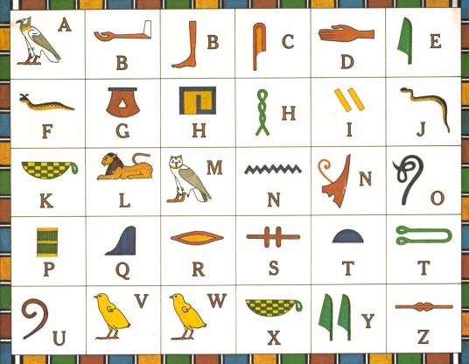

Other Activities

- Why not try some yoga as a family – Cosmic Yoga have some great videos that you can watch and follow.

Also attached are some amazing resources from Classroom Secrets, these cover all areas of the curriculum.

