What to do
Listening and Speaking
IMPORTANT Parent or Carer –
Please check that you are happy with any weblinks or use of the internet.

1. Listen to a story
‘We're Going on a Bear Hunt’ written and performed by Michael Rosen https://www.youtube.com/watch?v=0gyI6ykDwds
Listen together and join in with the repeating phrases and actions!

2. Respond to the story

- Which obstacles did the children tackle in the story?
- Make a simple map of the obstacles by drawing them on the line in the order they appear (e.g. grass, river, etc.). Draw and/or label them on Your Map. (There is a sample map below it to give you the idea!)
- Use the map to retell the story. Walk your fingers along the line. What sound did it make when they went through each obstacle?

- What other obstacles could they have found (nettles, ice, a steep hill, etc.). Choose one and add it to the map. Label it and add words which show the sound it would make (e.g. Slip slide, or heave ho, etc.). Tell the new bit of the story.
- Talk about what sort of animal you would go on a hunt to find and why.

Try these Fun-Time Extras

- Go on a bear hunt around your home. Encounter obstacles following the pattern of the story, e.g. “Uh oh, Lego! Sharp, pointy Lego. Can’t go over it. Can’t go under it. Oh no! We’ve got to go through it! Careful…Ouch! Careful Ouch!” etc.
- Find out about real bears with Cbeebies Andy’s Wild Adventures https://www.bbc.co.uk/iplayer/episode/b01cbn95/andys-wild-adventures-series-1-3-black-bears
- Play hide and seek around your home or garden. One person hides a teddy bear (or another soft toy) and sends someone else to hunt for it. You can give clues by saying ‘warmer’ or ‘colder’ depending on how close the hunter is to the bear.

Your Map

We’re Going on a Lion Hunt – An Example Story Map for a similar Story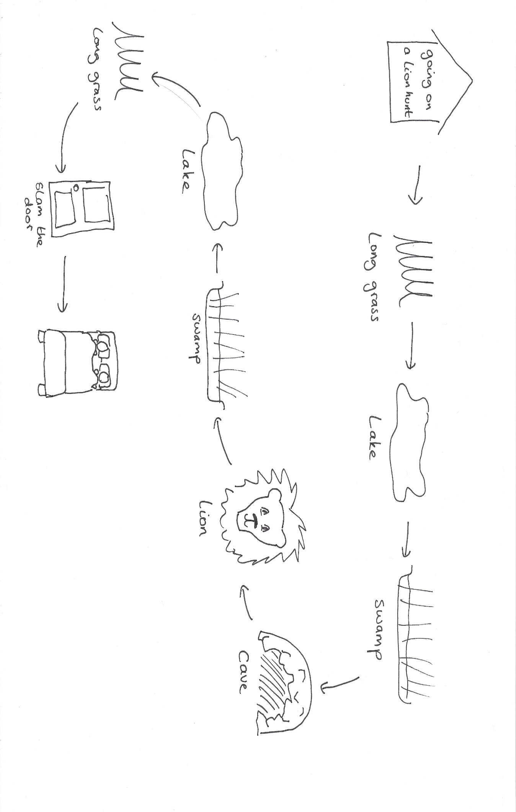
This example shows this story all the way to the cave and then back home, but we suggest you stop at the cave. There are plenty of obstacles on the way there to talk about!

