What to do
Reading
IMPORTANT Parent or Carer –
Please check that you are happy with any weblinks or use of the internet.

1. Read a story
Share and read together to enjoy Animal Upsets. Pause to discuss the pages which show the upsets created by the animals.
There will be parts of the book that your child will be able to read, but you will need to support with new words such as; delicate.

2. Respond to the story

- Which upset did we think was the funniest? Messiest? Most like things that happen in our house?
- Have you ever had a naughty animal cause trouble in your house, or do you know about someone else’s?
- Today we will imagine some things that might happen if we had a naughty animal in our home.
  - Look again at the story.
  - Choose a page showing one of the animals. Talk about what might happen if they came into your home? Repeat with another.
- Help your child to record some ideas on Animal Upsets at Home.
- OR you can record something that has really happened to you!

Try these Fun-Time Extras

- Pretend to be a naughty animal visitor. What might you get up to?
- Think of some rules for naughty animal visitors. Can you write one?
- Find a storybook and read it to a pet or cuddly toy to keep them out of trouble!

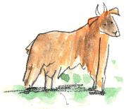
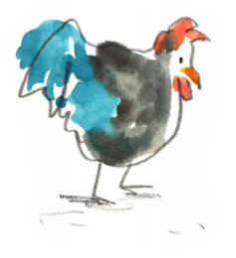
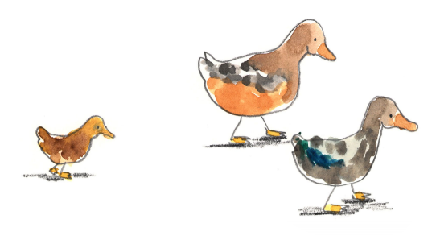
Animal Upsets at Home

