What to do
Speaking and Listening
IMPORTANT Parent or Carer –
Please check that you are happy with any weblinks or use of the internet.

Our focus today is speaking and listening – expressing ourselves in spoken language.
1. Listen to a story
‘The Farm Story’ is told by Wilf Merttens at https://www.youtube.com/watch?v=ZiPgmTvSU-w
Listen together and join in with the animal noises!

2. Respond to the story
- Which animals did the farmer bring into his home?
  - Make a list of the animals in the order in which they come into the house. Draw or write the animals
  - Now talk about which one you would hate most if it came into your home. Which one would you like?

- What quiet animal do you think you could bring into a one room house? What animal would make no noise?
Draw this animal on Your Drawings.

- What do you think would be the noisiest animal?
Draw this animal on Your Drawings and write the noise it makes.

Try these Fun-Time Extras

- Find out about the noisiest animals in the world at https://www.bbc.co.uk/newsround/39570897
- Listen to a whale https://www.youtube.com/watch?v=WabT1L-nN-E
- Listen to a tiger here https://www.youtube.com/watch?v=iT_flDZDp-k
- Listen to an elephant here https://www.youtube.com/watch?v=153xbn1k2H8

Your Drawings
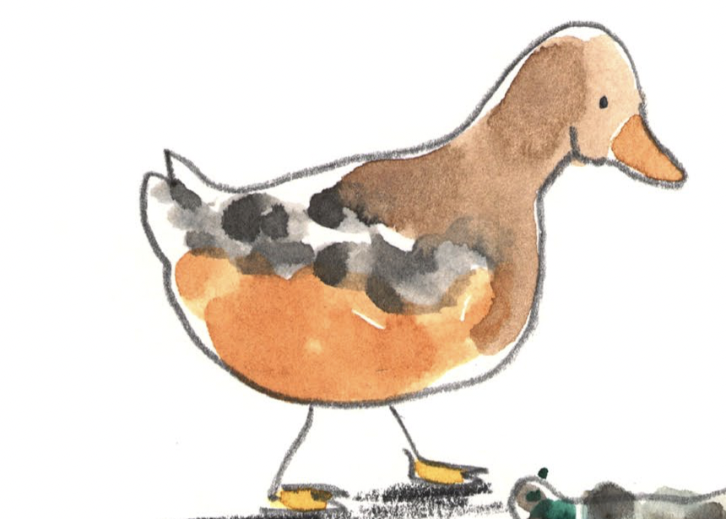
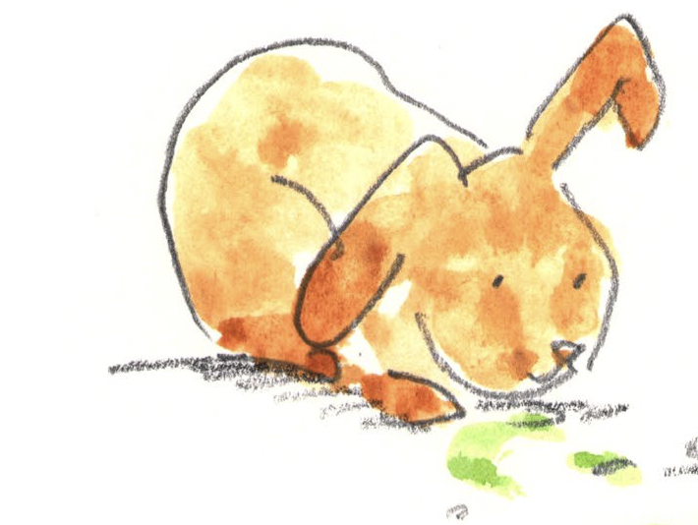

Animals that don’t make a noise | Animals that make a BIG noise

