What to do
IMPORTANT Parent or Carer –
Please check that you are happy with any weblinks or use of the internet.

1. Counting practice

  - Together, count to 20.
  - Now you are going to take turns to repeat this BUT you give each other a number they mustn’t say. E.g. Amit tells Mum she can’t say ‘six’…
  - Mum says, ‘one, two, three, four, five, , uh-oh, seven, eight, nine, ten, eleven, twelve, thirteen, fourteen, fifteen, uh-oh, seventeen…’, etc.
  - Now Mum tells Amit he can’t say four.
  - Play several times. Do you get good at not saying one number?

Extension
- Repeat the same activity but count from 30 to 50 not saying ‘six’, or from 70 to 90 not saying ‘five’, etc.

2. Working together

- Play Match My Number as outlined below
  - You need number cards 1 to 20, post-it notes or small blank pieces of paper, and felt-tips. Some counters would be good too
  - You need to lay out the line of cards face up from 1 to 20. Then follow the instructions below.

Try these Fun-Time Extras

- Look at a way of matching numbers to fingers really fast! How fast can you get? https://www.youtube.com/watch?v=jLs15gS1lX0
- Count from 20 to 1 and remember to say ‘Blast-off’…. Where are you going to go in your rocket?

Match My Number

You need number cards 1 to 20. Some sticky notes or blank pieces of paper.
Some counters – you can use Lego™ bricks or raisins!

How to play

- Lay the number cards in a row, 1 to 20.
- Now turn them all over so they are face down in the same places.
- Point at where 1 is. Turn it over. Then turn over 12.
- Each of you writes three numbers on the sticky notes or blank paper.
- You both place each of the numbers you have written on top of the card where you think it goes on the laid-out track. Place all three numbers.
- When you’re done, turn over the card numbers with sticky notes on them and see if the number matches the card beneath it.
- If it does, that person takes a counter. They get one for each correct number. (Maximum 3 each.)
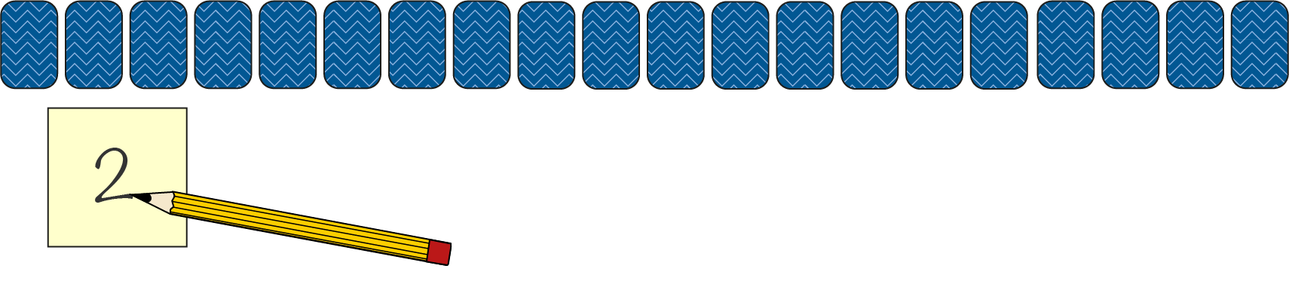

- Start again, but this time lay the number line out backwards, i.e. from 20 down to 1. Turn all the cards face down.
- Then each person writes three different numbers from last time. They place their sticky notes on the face-down cards which they think match.
- When you have both done this, turn over the cards. Do the numbers match? Take a counter for each correct match. How many counters have we each got?
- Play a third time, but this time lay out the cards in two rows, one below the other.

