What to do
IMPORTANT Parent or Carer –
Please check that you are happy with any weblinks or use of the internet.

1. Counting practice

  - Write numbers 1 to 10 on large scraps of paper. Place them around the floor.
  - Your child chooses a number to stand on.
- They must do actions to match that number.  - E.g. if they stood on 6, they may do six wing flaps!  - If they stood on 8, they might do eight bunny hops.  - Now they choose a different number to stand on.  - Then you have a turn. | 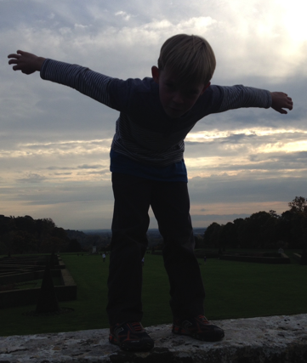

  - Keep taking turns and matching actions to numbers. Here are some good actions!
Hand claps
Head-over-heels
Bunny hops
Wing flaps
Legs apart, legs together jumps
Tongue outs

Extension
- They have to do one less action than the number they choose!

2. Working together

- Play Ten pegs on a Hanger as outlined below
  - You need a coat hanger and ten clothes pegs (see below for suggestions).
  - Arrange ten pegs on the hanger; follow the instructions as shown.

Try these Fun-Time Extras
- Make a clapping pattern – 3 fast claps, 2 slow, then 2 fast. Ask your children to count the number of claps. This is really hard!
- They create a clapping pattern for you to count. It’s not easy!
Ten Pegs on a Hanger

You need: number cards, 0 to 10 with two number 5s. Also, a metal coat hanger, ten clothes pegs and a tea-towel. (If you don’t have pegs, you can create the same effect by hanging paper clips or safety pins or even bracelets or hair ties from the coat hanger!)

How to play
- Lay out the number cards face up.

- Peg ten pegs along the coat-hanger. Count them along it, touching each one as you go. One, two, three, etc.

- Ask your child to turn around. Cover some of the pegs by hanging the tea-towel over it.

- The child must choose the number card to match the number of pegs hidden. They show you.

- Reveal the hidden pegs – were they correct?

- If so, they find the number card to match the pegs which were not hidden.
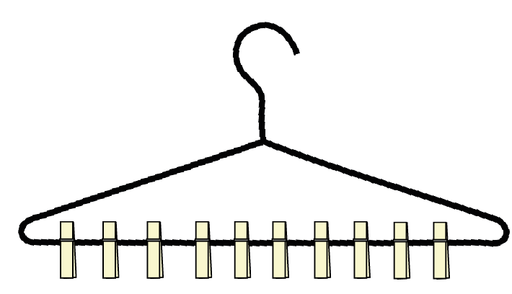
- Write a matching addition for these pegs, e.g. 6 + 4 = 10

- Now play again, with you hiding a different number of pegs.

- Keep playing like this, perhaps taking turns to hide the pegs.

