CLASS 2 Home Learning for w/c 20.4.20 New Topic: SPACE!

Welcome back after the Easter Break, I hope that you have all had the chance to enjoy the lovely weather – a nice bonus in these strange times – and that you are all well.

As before, below are outline ideas for your learning at home, if anyone requires anything further then please do use the office email to get in touch and I will try my best, Mr Cash.

Maths
This term we will be recapping all of the learning we have done over the year so far, starting this week with Place Value – where the position of a digit in a number determines its value e.g. in 43 the 4 represents 40 ( 4 tens) and the 3, 3 (3 ones).
- First of all, I would like you to create some numbers - a mix of 1-digit and 2-digit or 2-digit and 3-digit – depends how confident you feel. Using a dice, a pack of cards or even a spinner (dead easy to make with a piece of card and a pencil) can you create 5 numbers? Write the numbers on separate pieces of paper.

Can you read each number out? Can you put the numbers in order from the smallest to the largest and explain how you ordered the numbers? What is the middle number? The largest? The smallest? Which of your numbers are odd or even? (how do you know?!). Look at the smallest number and the next smallest – what numbers could come in between these two numbers? REPEAT THIS WITH A FEW SETS OF NUMBERS OF THE WEEK (you could increase or decrease the amount of numbers in a set if you want).

Investigation:
For this you could use bundles of straws or other objects to make the value of each digit, showing how it changes when the position changes in the number.

If you put 2 beads onto a tens/ones abacus you can make the numbers 2, 20 and 11 (shown in the picture)

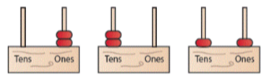

Can you do the same with 3 beads? How many different numbers can you make? How many different numbers can you make using 4 beads?

- Keep practising your times tables and mental arithmetic – can you add or subtract 1 to or from any number? Can you add or subtract 10 to or from any number? Can you add or subtract 5 to or from any number?

English
- In these times of not being able to visit family and friends keeping in touch is more important than ever. When I was your age the way we used to keep in touch quite often was by writing a letter.

Could you have a go at writing a letter to a family member or friend? Maybe you want to write a letter to someone working in the NHS to say thank you? It could even be to a favourite teddy, doll or even a pet, there are lots of reasons to write a letter.
In your letter remember to write who it is to with a greeting (Dear …..), tell them some things that you have been doing (including how those things made you feel) and remember to ask some questions so that the other person has more of a reason to write back. At the end of your letter sign it off (Love from, sincerely, from, best wishes etc).
You need to include capital letters and punctuation and make sure your writing is as neat as possible (it is a chance for you to show off and for the person getting the letter to be impressed with what it looks like).

If you are able to write a letter to a person and can actually send it (safely) it would be a lovely thing for them to receive and you might even get a letter back!

Geography/Art/Design
- Thinking about our new topic on space, could you find out about the different planets in the solar system and build a model to represent them? Maybe you could use different sized balls and some cardboard to show how the planets move around the sun, maybe you could go outside and use natural materials such as stones or piles of twigs? Can you write a name label for each planet?

- With the nice weather set to continue, if you can be outdoors, can you create a natural collage or sculpture of a rocket or something else to do with space (I’m thinking design your own alien)? I saw a fantastic idea in the newspaper last week where children were building models and taking a picture of themselves next to or in it – maybe you could be in your rocket or next to your alien?
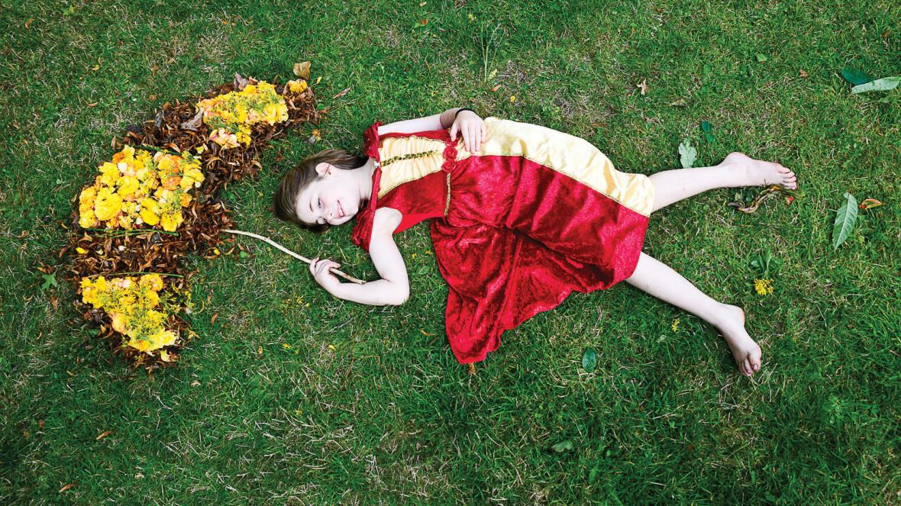

PHSCE
- At the moment we have a lot more time to think than we normally would have and it is nice to have the chance to reflect on what is important.
Some questions that you could think about:
- What do you think makes someone amazing?
- Does someone need to be famous to be great?
- How would you like people to describe you — smart, fast, funny, kind or something else?

Other Activities
  - Keep up with your PE by joining Joe Wicks LIVE every weekday morning from 9am for ½ an hour (or you can catch up anytime through his YouTube channel) https://www.youtube.com/playlist?list=PLyCLoPd4VxBvQafyve889qVcPxYEjdSTl
  - I know that a lot of people have been using their time in lockdown to do lots more baking – if you have or would like to, could you create your own recipe book of your favourite things to make or eat? Try to remember a balanced and healthy collection – not just cakes! (although they are so good!)
  - Keep adding to your nature diary – I have seen lots of different animals while I have been out on my bike doing my daily exercise including a buzzard (which came very close), deer, barn owls, geese and a stoat running across the road in front of me!

