Home Learning for w/c 30.03.20

Hello Class 3, I hope you have all had a good Easter and had lots of fun family time. I’m sure you will have enjoyed a few chocolate Easter treats – I know I did!

As many of you will know especially when my whiteboard won’t work I usually ask lots of you for IT support in the classroom! Well I have been busy with my own children and having lots of fun setting up ‘You Tube’ and if you follow the links below I have left you a message and a story. This is private so you won’t be able to search for me you need to follow the links below.

https://youtu.be/_d99FQ5lKQo
https://www.youtube.com/watch?v=YLOA8aVNIGI

Maths
- Continue to practice your times tables.
Money
  - The focus this week is on giving change. You can either be given an amount or add different amounts together. These amounts can range from buying an apple for 25p and getting change from £1 or buying a new football for £8.34 and paying with a £20 note. One method to work this out is to add on and you could use a blank number line to do this as per the picture below.
  - To extend the children for example – I received £13.24 change from a £20 note, after buying a magazine. How much was the magazine?
  - Use amounts that you are confident with this could be 50p to start with and then progress from there.
  - I have also attached some money word problems and answers. The number of stars determines how tricky the questions are. In school I often have a 5 way differentiation so please feel free to add in extra steps or change the numbers.

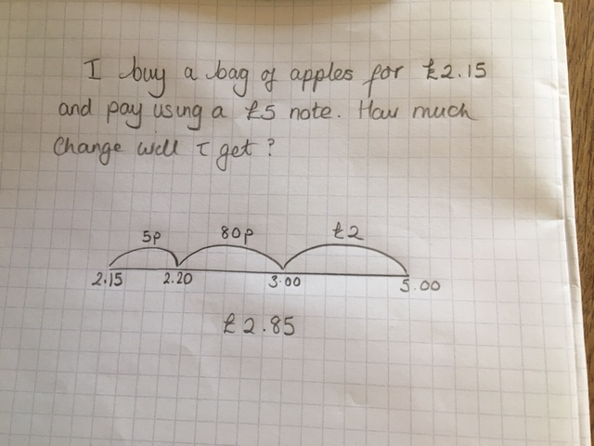

Check out White Rose Maths Home learning for some excellent activities for your children separated out by year group.

Top Marks Maths Games linked to money and times tables.

English
- Continue with your diaries and remember to include anecdotal things that people have said or how you are feeling. You can include some facts as well as technical vocabulary.
- I have also attached a SPAG mat for you to complete.

English / Theme
- Over the week can you complete a non -chronological report based on Tutankhamun. You can include information about who he was, when he became Pharoah, when he died, what he put in his tomb and why. You can then also find out who discovered his tomb and what happened to all the artefacts. There are many stories about a possible curse that would be placed on whoever found the artefacts – can you find information out about? In your non-chronological report can you include the following features:
    - Topic title
    - Brief introduction paragraph
    - Information organised into categories
    - Sub headings
    - Factual and descriptive language

Art
- Making the most of the lovely sunshine can you create a picture using the sun to cast a shadow? You could use a toy farm animal, Lego figure, Playmobil animal or any other toy you may have.
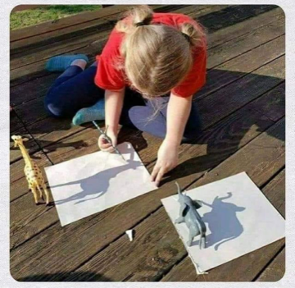

Science
- Over Easter I have been busy with my family planting some sunflower seeds and other flowers (any old seed packets we had hanging around) as well as ordering some established vegetables to continue growing. We have made a raised bed from old bits of decking. Can you plant some seeds and make observations as they start to germinate. Think carefully about what seeds need to make them grow.
- Can you label the part of the plants on additional sheet?

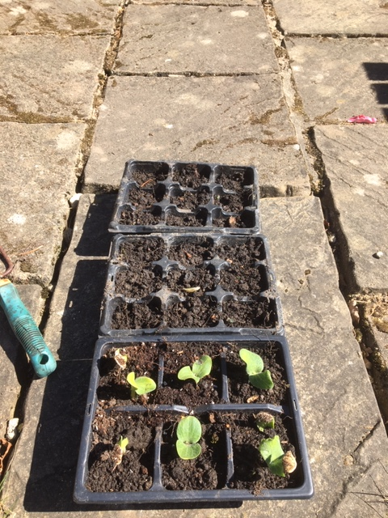
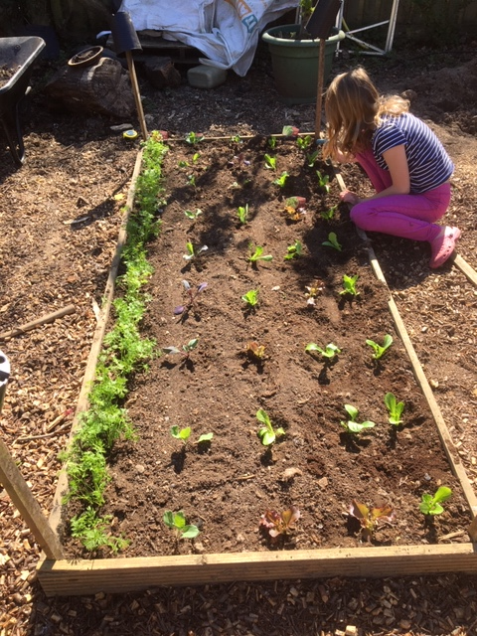

PE
- Can you create a circuit in your outside space for your family to complete with you? You could have 4 bases and do each base twice for 4 minutes. Bases could include:
  - Skipping, Sit ups, press ups, step ups, a target to aim for, running on the spot, bouncing a ball on a racquet, throwing a tennis ball and catching it in your good hand and then the other.

