Class 4 home learning for week beginning Monday 20th April
Hello everyone!
I hope you all had a great Easter and didn’t eat too many chocolate eggs. How did your 3D models of a water system turn out? I can’t wait to see them if you had a go. Remember that the following work is important to have a go at, but please feel free to do any extra bits at home – follow your own interests to stay busy! This week’s ideas for home learning:
Mathematics:
Year 5: Use pages 8 to 13 of the home learning pack on the Slingsby website to complete some multi-step problems.
Year 6: Use pages 8 to 13 of the home learning pack on the Slingsby website to revise your understanding of fractions and decimals.
You could also challenge your family to a game or two of Countdown: http://happysoft.org.uk/countdown/wordgame.php
English:
Before we went into lockdown, we looked at using punctuation for parenthesis (added information in a sentence using commas, brackets or dashes) so everyone could try pages 23 to 28 of the Year 5 home learning pack.
Your weekly spellings are at the end of this document and PLEASE try to read to an adult at home every day to keep your skills going. I’d love to have some more book recommendations to put on display too.
History:
This summer term at school at school we should be learning about the Ancient Mayan Civilisation, so I’d like you to do some research into the religion of the Maya and find out about their gods. The way you record your research is entirely up to you. You could make your own set of Maya god Top Trump cards, produce Powerpoint, or an information booklet.
Art:
Use the Powerpoint Presentation, posted on our website page, to learn about Mayan masks – then have a go at designing your own on the template below:

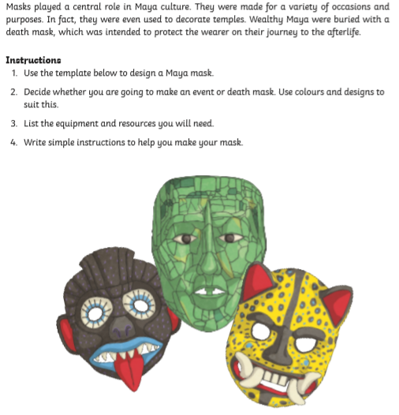

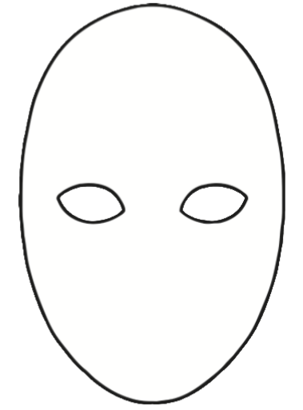

This week’s spellings:
Class 4 spelling list for group 3: Week 27
After completing ‘look, cover write, check,’ please try to write 5 interesting sentences in your spelling homework book. You can use more than one word from your spelling list in each sentence.
Objective: Revision of the prefix mis and re.
Spellings | Look, cover, write, check
 | Monday | Tuesday | Wednesday | Thursday
mistake
mistaken
mislaid
mistook
misuse
mistreat
misbehave
misunderstand
mischief
mistaken
misguided
research
rearrange
return
represent
review
recommend
remove
replace
reconstruct

Spelling score this week =

Class 4 spelling list for group 2: Week 27
After completing ‘look, cover write, check,’ please try to write 5 interesting sentences in your spelling homework book. You can use more than one word from your spelling list in each sentence.
Objective: Words beginning with im-
Spellings | Look, cover, write, check
 | Monday | Tuesday | Wednesday | Thursday
images
imagined
imply
imported
impossible
improved
imposed
impressed
impact
impacted
immense
impulse
imprison
imprisoned
implemented

Spelling score this week =

Class 4 spelling list for group 1: Week 27
After completing ‘look, cover write, check,’ please try to write 5 interesting sentences in your spelling homework book. You can use more than one word from your spelling list in each sentence.
Objective: Words beginning with im-
Spellings | Look, cover, write, check
 | Monday | Tuesday | Wednesday | Thursday
imagination
imaginatively
immediately
impressively
impression
impossibly
implications
improvement
implementation
importance
importantly
immune
immunity
imprisonment
impossibility

Spelling score this week =

That’s all for this week. Stay safe, have fun and don’t forget to help out where you can at home.
Mr. Smith

