Dear Year 5 & 6,
How did last week’s work go? Don’t forget to follow Mrs. Metcalfe’s advice on her videos (in this week’s newsletter) and get out in the garden if you can to pursue some of your own interests. Could you work on your mastery skills with large/small balls like we’ve done in our PE lessons? My family and I have been playing French boules, volleyball and badminton to try and keep physically and mentally fit. Joshua has also been given a challenge by his football coach to improve his score in doing kick-ups with a football. Mollie is just enjoying the sunshine and barking at everyone to tell them they should be staying indoors!
This week’s ideas for your home learning:
English
This week I’d like you to use your imagination and imagine you have built a time machine. If you could do this, where in time would you travel to? Would you want to know what the future holds; find out about mysteries from history; or try to change the past in some way?
Your task is to write an extended story based on time travel. You can write in the 1st or 3rd person narrative (your choice), but try to include description of character (including how they react and speak) and setting as your write. Don’t forget to plan your story first, as this really helps to know where you are going next in your writing.
You could even design a cover (including a blurb)!
Mathematics
Did you challenge anyone to a game of Countdown last week? How did you do?
This week, you could have a go at working your way through POWERLINES.
https://www.to14.com/game.php?id=4d486a5e6b424
It’s a VERY good idea to have a pen and paper to record your answers for each successful puzzle completion so you don’t have to do it in one go (it won’t save your progress if you shut your device down.

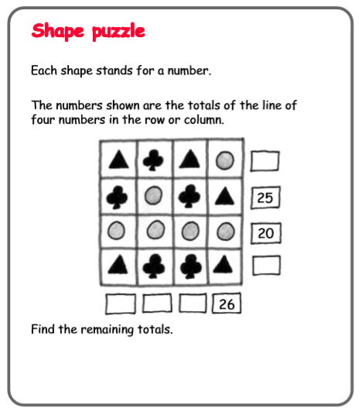
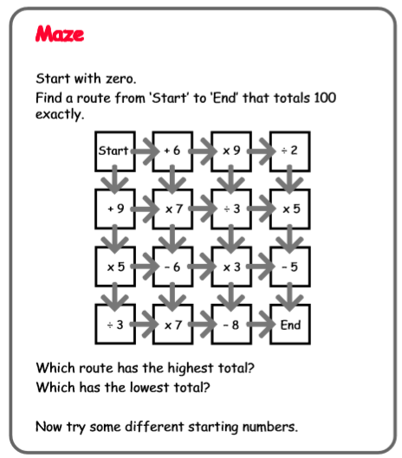
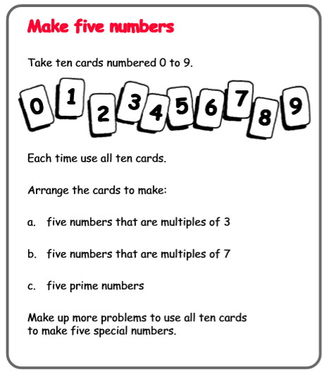
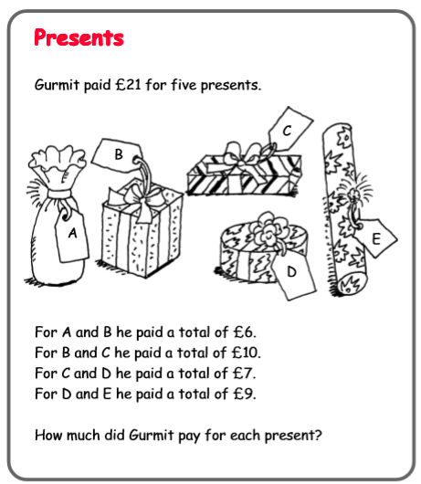
I also have a few puzzles/problems for you to work on:
History/Art
If you managed to design your own Mayan mask last week, why not try to make one out of paper mache and paint it?
Geography
Design your ideal garden for the lockdown. Can you use a plan (bird’s-eye) view?
This week’s spelling lists:
Class 4 spelling list for group 3: Week
After completing ‘look, cover write, check,’ please try to write 5 interesting sentences in your spelling homework book. You can use more than one word from your spelling list in each sentence.
Objective: Words ending in ion or ian.
Spellings | Look, cover, write, check
 | Monday | Tuesday | Wednesday | Thursday
action
section
station
relation
education
position
electrician
election
direction
mention
information
condition
production
magician
operation
collection
competition
population
communication
technician

Spelling score this week =

Class 4 spelling list for group 2: Week
After completing ‘look, cover write, check,’ please try to write 5 interesting sentences in your spelling homework book. You can use more than one word from your spelling list in each sentence.
Objective: Words beginning with the prefixes in- or irr-
Spellings | Look, cover, write, check
 | Monday | Tuesday | Wednesday | Thursday
indent
indented
inaction
correct
incorrect
credible
incredible
human
inhuman
inhumane
attentive
inattentive
direct
indirect
capable
incapable
reversible
irreversible
replaceable
irreplaceable

Spelling score this week =

Class 4 spelling list for group 1: Week
After completing ‘look, cover write, check,’ please try to write 5 interesting sentences in your spelling homework book. You can use more than one word from your spelling list in each sentence.
Objective: Words beginning with the prefixes in- or irr-
Spellings | Look, cover, write, check
 | Monday | Tuesday | Wednesday | Thursday
indentation
inactivity
irregular
irregularities
incorrect
independently
irresistible
irresistibly
incredibly
irrational
irrationally
inattentive
irrelevant
inhumanely
irrationally
irritated
irresponsibly
inconvenient
irreversible
irreplaceable

Spelling score this week =
That’s all for this week. Stay safe, have fun, and don’t forget to keep your home reading going: I’m looking forward to reading any book reviews that you have been able to write.
Mr. Smith.

