What to do
Speaking and Listening
IMPORTANT Parent or Carer –
Please check that you are happy with any weblinks or use of the internet.

Our focus today is speaking and listening – expressing ourselves in spoken language.

1. Listen to a story
Share and read Dear Postman as a storybook, enjoying the pictures and predicting what each animal in the picture will ask for, before reading the words which go with the picture. Discuss the meaning of the phrase, ‘it is in the post’.

2. Respond to the story
- Talk about the pattern of the story. Each animal asks for a different thing and then the postman/woman brings it. Talk about what Sam asked for. Why do you think the postman could not bring a tiger? What did he bring instead?
- Look back at each wrapped parcel illustration. Talk about what your child would ask the postman to bring them and why. Help your child to draw an outline of what they would ask for and then ‘wrap’ it by drawing wrapping paper and a bow on What will your parcel look like? below. They can label their parcel with their name. Write the address together.

Try these Fun-Time Extras

- Play a descriptive guessing game: I’ve got a present for you. It is smooth and round and bounces if I drop it. Etc.
- Visit a virtual zoo: https://www.zsl.org/videos/behind-the-scenes/keeper-diary-jessica-courtney-jones-animal-activities and listen to a keeper speaking about their work
- Listen and join in to the song We’re all going to the Zoo Tomorrow: https://www.youtube.com/watch?v=BBF1G4EDvqA

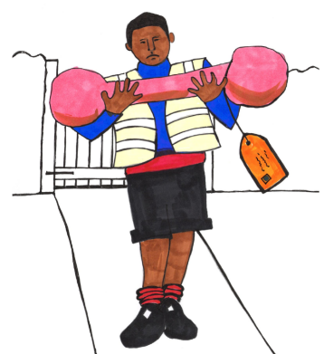
What will your parcel look like?

