What to do
Writing
IMPORTANT Parent or Carer –
Please check that you are happy with any weblinks or use of the internet.

Our focus today is writing

1. Discuss a letter from a story
Look at and discuss together the letter shown below from Dear Postman (read the story to your child first, if you have not shared it already).

2. Write a thank you letter
- Talk about the ticket. Why does the Postman deliver it? Can you imagine how Sam felt when he got the letter and ticket.
- How does it feel when someone is kind? Explain that saying thank you is very important and that a letter to say thank you can be a lovely way to show appreciation for help, kindness or a gift.
- Today you will write a thank you letter together, with your child writing some parts and you writing other parts with them dictating what to say. You can write on A Thank you Letter below or use special paper from a letter writing set.
  - Write a thank you letter from Sam to Postman, imagining that you are Sam and explaining why you are saying thank you, or
  - Write a real thank you letter to someone in your life who deserves a special letter thanking them.

NB. Getting young children to write is not easy! See Guidance and handwriting groups below.

Try these Fun-Time Extras
- Post your thank you letter or photograph it and send it digitally.
- Find different ways to thank people who help us, writing notes, letters, putting a poster in the window for delivery workers, etc.
- Imagine what letters your pets or toys would write if they could and to whom.

A Letter from Postman

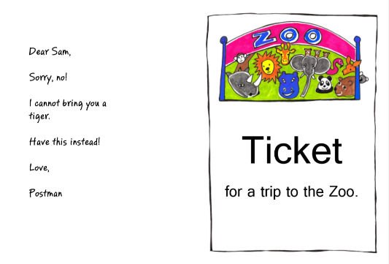

A Thank you Letter

Guidance for writing – some dos and don’ts

- DO focus on letter formation. See sheet below. It’s really important that children get into the habit of writing letters correctly – this is not about how the finished letter looks, it’s all about how they write it – what direction they move the pencil or pen. Bad habits are almost impossible to break – if they form letters wrongly, the finished letter may look good BUT in the long run, they are much less likely to be able to write fluently.

- DON’T write a word or a line for them to copy. If they can’t remember how to write a letter, demonstrate, forming it correctly, so that they can imitate you.

- DO give loads of praise. Writing is so hard, and children get discouraged easily. It may be that they have just written one or two words, but if you praise them, it may be four words next time!

- DON’T do ‘dotty’ letters for them to trace. It is much better for children to form their own letters. We are teaching them to write not trace!

- DO write for them sometimes. It is important that young children can express their ideas in written form, and sometimes it is really good to write down what they say so that their ideas are expressed in writing on the page. Sometimes you can take turns to scribe. You write a bit, then they write a bit.
