CLASS 1 Home Learning for w/c 11.05.20

Hello class 1!

Happy bank holiday weekend to you all and I hope you have been able to enjoy the sunshine. Remember to wear a sunhat and suntan lotion and to drink plenty of water as staying safe when playing out in hot weather is very important.
One of the male guinea pigs has now moved to his home in Coneysthorpe with Oscar and his family. They were extremely excited to welcome a new pet into their house and I’m sure they will all get along famously.
I have introduced the last male guinea to Hydra in our garden at home and they are getting along brilliantly! I’m so very pleased, as it gives Hydra a playmate and some company. They are so cute!

This week’s English learning uses an information text about birds. Now that the weather is warmer, birds are finding food easier, but they still have many chicks to feed so you may consider making a bird feeder.

Daily Challenge
- Throughout the week, use the 100 things to do indoors (photograph available on the website) to choose 5 challenges each week…
- I have included a frame for drawing a flowering plant that is growing in your garden. Just in case you didn’t get around to it last week.
- On page 5 of the Arboretum booklet there is a lovely idea about making seasonal art using collected natural items such as leaves, sticks and rocks.
- There is a board game in the maths ideas for this week. Is it different to the board game that you made last week? If you didn’t get chance to make one then maybe you could have a try this week instead.

DT challenge

Make a bird feeder using the step-by-step guide below (taken from the RSPB website).
Or make up your own design using a yoghurt pot, lard, seeds and string or other recycled materials.

Follow the link below for further activities.

https://www.rspb.org.uk/fun-and-learning/

Science
If you want to do some more plant learning this week, you could try
the following activities:
https://www.bbc.co.uk/bitesize/clips/z3wsbk7
Watch this clip about plant life cycles. It explains what a life cycle is and some new vocabulary like ‘germination’.
Then you could do the Sunflower Life Cycle activity (just choose one of the sheets to do).
There is also the ‘Plant Hunt’ file which I suggest you open on a tablet or smartphone to save paper and printing costs.

Step-by-step guide
- Cut a hole in the side large enough to allow a free flow of seeds, but in such a way that it won’t all fall out on the ground in the slightest puff of wind, and won’t get wet if it rains.
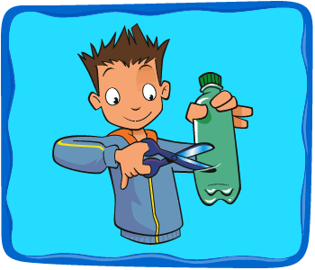
- Make a few small holes in the bottom of your feeder to allow any rainwater to drain away (ask a grown up to help with this if using scissors).
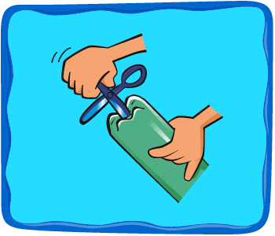
- Hang it with wire, or even strong string from a tree or your washing line.
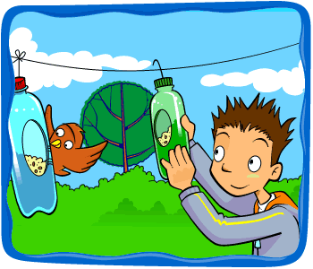
- If your feeder starts to wear out or the food in it goes mouldy, recycle it and make another one! Remember to keep your feeders well stocked, especially in winter. Birds come to rely on them and will go hungry if you forget.
