What to do
IMPORTANT Parent or Carer –
Please check that you are happy with any weblinks or use of the internet.

1. Counting practice

  - Together, count to 20.
  - Now you are going to take turns to repeat this BUT you give each other a number they mustn’t say, e.g. Padma tells Mum she can’t say ‘six’…
  - Mum says, ‘one, two, three, four, five, , uh-oh, seven, eight, nine, ten, eleven, twelve, thirteen, fourteen, fifteen, uh-oh, seventeen…’, etc.
  - Now Mum tells Amit he can’t say four.
  - Play several times. Do you get good at not saying one number?

Extension
- Repeat the same activity but count from 30 to 50 not saying ‘six’, or from 70 to 90 not saying ‘five’, etc.

2. Working together

- Make a Do this number of actions! ‘fortune teller’ as outlined below.
  - You need a square piece of paper and fat felt-tip pens. A thin pen would be good as well.
  - You need follow the instructions below on How to make a fortune teller.
  - Use this to count different actions, matching these to the spoken numbers.

Try these Fun-Time Extras

- Help someone else in your family make a fortune teller and have fun with it. https://www.youtube.com/watch?v=X1DArckNWdM - NB check this is suitable for your child – it is more grown up than the ones suggested below!

Make a Do this number of actions! fortune teller

You need a square piece of paper, fat felt tip pens and a good pen for writing.

How to make it

- Fold your piece of paper along the diagonals.  - Press down so the creases are sharp.  - Open up the paper and then fold each corner into the middle.  - All four corners are now in the centre and you have a smaller square. | 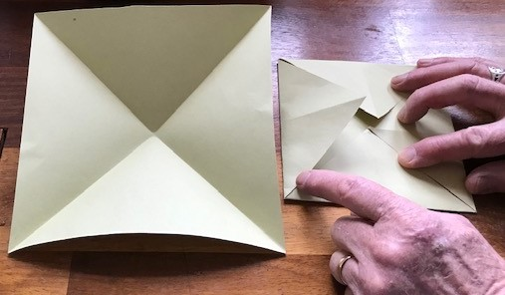
- Turn the smaller square over so the folds are underneath  - Repeat the above process, folding all the corners in to the centre.  - You should now have an even smaller square. | 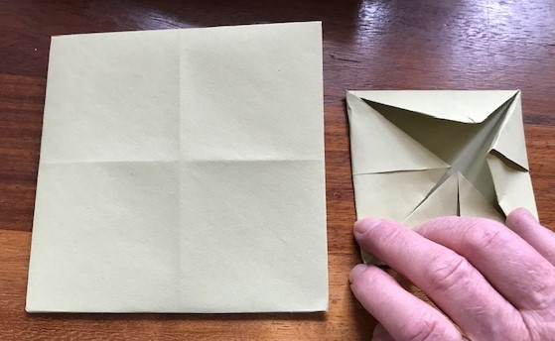
- Turn the square over so the folds are underneath  - Fold the square in half and press the fold down so it is a sharp crease.  - Fold the square in half the other way, and press the fold down. | 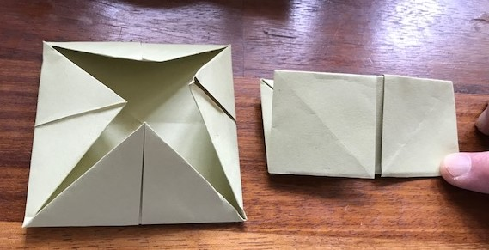
- You should now have a fortune teller. | 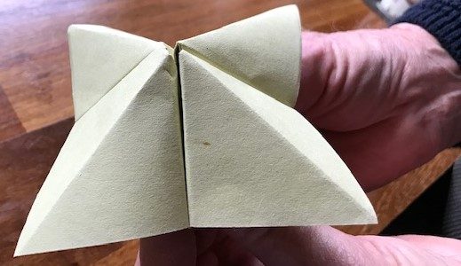

Instructions continued

- Place it flat on the table.  - Write numbers on the squares.  - Turn it over and colour the triangles.  - Each one should be a different colour.  - Now lift each triangle and write an action underneath it. Each one should have a different action.  - See suggested actions below…  - Fold it all back as it was, insert your thumbs and ask someone to choose a number. | 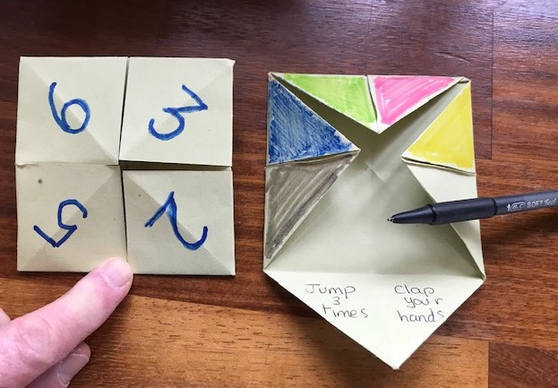
Suggested Actions

Jump 3 times Clap your hands 5 times Do 4 bunny hops

Do 6 wing flaps Stick out your tongue Wiggle your fingers

Take 8 steps on tiptoe Do a head-over-heels Hop 3 times

Say your name backwards Write your name backwards

Some sites which tell you how to use these are suggested below.
NB theirs are slightly different as they are used to ‘tell fortunes’.
Ours is just use to suggest actions which we can count!

https://www.youtube.com/watch?v=A42wubu8pJA

https://www.youtube.com/watch?v=BxyXk1sr2io

