What to do
IMPORTANT Parent or Carer –
Please check that you are happy with any weblinks or use of the internet.

1. Writing numerals - practice
  - On a piece of paper in front of you, write the numbers clearly from 0 to 9.
  - Turn your child round so they are facing away from you, but looking at the numbers you wrote.
  - Gently on their back, with a finger trace a numeral, e.g. 2.
  - Can they say what numeral you are writing with your finger?
  - Repeat with another numeral.
  - Let them write a numeral on your back. Can you say what number it is? (This is much harder as they may have trouble writing the numeral!)
  - Place rice or sand in a baking tray. With your finger, trace the number 2, showing how you start at the top and go round, down and then back along.
  - Let the child imitate you.
  - Repeat for another numeral.

2. Working together

- Work together to find out how much your hand is worth.
  - You need some coins, 1ps, 2ps and 5ps. About 10 coins in all, if possible.
  - You need a pen and paper to draw round your hand.
  - Use How much is my hand? – see below.

Try these Fun-Time Extras

- Watch this https://www.youtube.com/watch?v=dFzAU3u06Ps and learn about our coins.
- Now explore the feel of real coins.

How much is my hand?

You need about 8 to 10 coins, a mixture of 1ps, 2ps and 5ps. You will also need felt-tip pens and paper.

What to do

- Place your child’s hand, fingers together, and thumb as close to the rest of the hand as possible flat on a clean page.

- Draw round their hand using a fat felt-tip pen.

- Ask the child to take coins and place these to fill the outline of their hand with coins, all laid flat and side by side – not overlapping!

- Now we are going to work out how much their hand is!

- Take the coins, one by one, from their drawn hand.

- With each coin, ask your child to tap it to show the value. E.g. for a 2p coin, they tap twice. For a 5p coin, they tap five times. A 1p coin is just one tap.

- As they take each coin and tap it, you draw strokes to match the taps.
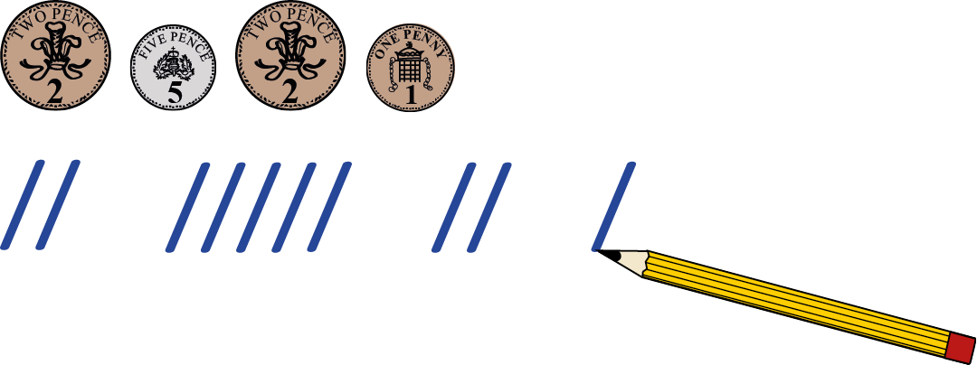

- So the child sees that the 2p is 2 taps, 2 marks. The 5p is 5 taps, 5 marks. And you are counting the value of each coin in turn.

- Finally, you can together count the total number of marks. This is the number of pence your hand is worth!

- If time, measure how much the grown-up’s hand is worth!

