CLASS 2 Home Learning for w/c 11.5.20

I know these are challenging times and some of you are finding being at home more quite tricky but please remember to BE KIND. This is a tricky time for grown ups too but it is so that EVERYONE can be as safe as possible. We will be back together soon but please be patient and BE KIND! Mr Cash x

Maths
This week we will be thinking about Multiplication. Again, having objects that children can physically handle can help with building concrete steps in this learning (pasta, Lego blocks, any other objects that can be arranged into groups or arrays – see the attached powerpoint).
Notes:
Year 1: Counting in steps of equal sizes is based on the big idea of ‘unitising’; treating a group of, say, five objects as one unit of five. Working with arrays helps pupils to become aware of the commutative property of multiplication, that 2 × 5 is equivalent to 5 × 2.
Year 2: It is important that pupils both commit multiplication facts to memory and also develop an understanding of conceptual relationships. This will aid them in using known facts to work out unknown facts and in solving problems. Pupils should look for and recognise patterns within tables and connections between them (e.g. 5× is half of 10×). The recognition of pattern in multiplication helps pupils commit facts to memory, for example doubling twice is the same as multiplying by four, or halving a multiple of ten gives you the related multiple of five.

- Have a look at the attached powerpoint as a starting point to remind you how we use arrays to help us work out multiplication questions. Counting the numbers of circles/counters/objects in each group really helps with remembering our times tables facts too.
When you have looked through the powerpoint and had a go at the examples, create some questions of you own – remember to challenge yourself and use an array each time (it might get quite big but it really does help train your brain into the process!).

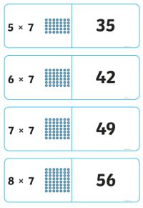
Some examples of the types of questions you might be expected to do for year 1 and year 2 are below – use these as a guide.
Year 1 | Year 2
3 x 2 = | 3 x 3 =
2 x 5 = | 4 x 10 =
3 x 10 = | 12 x 5 =
5 x 0 = | 3 x 8 =

- This is another great activity to use snap/memory cards for. You can create cards that have multiplication questions on and cards have the matching array on. A set with a few of these in is great for practising quick recall and times tables (remember that multiplication is commutative!). Something like the picture on the left, cut out (if you hover over the picture and follow the link you can go to an editable version and make your own that way).

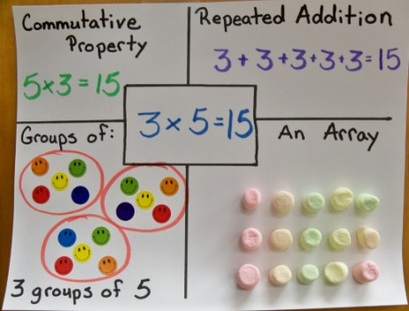
Extension: Can you create a multiplication poster for one (or more) of your questions like the one in the picture? You could also replace one of the sections with a multiplication word problem and picture.

English I have been so inspired by the many many pictures of rainbows and messages to the NHS.

Reading comprehension: Can you have a look at the Rainbows poem I have written that should be on the website. Get someone to read it to you, read it to yourself and then read it out loud. Have a go at answering these questions:
- What are the colours of the rainbow?
- What kind of treasure do people say you will find at the end of a rainbow?
- The poem says
‘In these strange times your colours inspire me –
New reasons to appreciate, new reasons to be better, to be kind.’
Why do you think I would write about new reasons to appreciate?
- I talk about ‘Building bridges to our future,’ – in what way might a rainbow represent a bridge?
- Can you think of any synonyms (words that mean the same as) for ‘heroes’?
- In the last line ‘We love you NHS, the treasure found!’ what do you think I mean by ‘the treasure found’?

Writing: I have seen some brilliant examples of story writing this week from a couple of you, keep it up!

I have been so inspired by the many many pictures of rainbows and messages to the NHS that I have seen in people’s windows. I was wondering whether you could use the rainbow and the NHS idea as a starting point for a poem? It could be an acrostic poem, it could use rhyme or not but make it something you care about and be creative.

SPAG: I have added the Year 1 and 2 High frequency and tricky word lists to the Class 2 page as I am aware that some children have completed the spellings that they have in their books. You can choose a selection of words from either or both of these lists and use them as an alternative. Once you have chosen the words to focus on, spend some time making sure children can sound out each word (stretching it out so you can hear each sound within the word), and that they know what each word means. Can they say it in a sentence? Can they write it in a sentence? Can they write the word in a tray of rice or sand? Can they write it in each colour of the rainbow?
There are some excellent spelling and grammar games on the brilliant Topmarks website suitable for year 1 and 2 https://www.topmarks.co.uk/english-games/5-7-years/words-and-spelling

Phonics (Year 1): If you want to be able to practice phonics then there is a fantastic resource on YouTube being introduced from 27/4 focussing on learning for the summer term with daily lessons being added. You can find the channel called ‘Letters and Sounds for Home and School’ in association with the DfE here https://www.youtube.com/channel/UCP_FbjYUP_UtldV2K_-niWw/featured?disable_polymer=1.

Science:
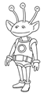
Everyday materials – Choose a material from: wood, plastic, glass, metal, water or rock.

Now imagine that some aliens have just landed in your garden and they don’t what these materials are like. How would you describe that material to them?

Write some sentences and draw some pictures to show what you would say to them. Some examples could be: ‘glass is smooth and hard’ or ‘water can be hot or cold’.

DT: I hope you enjoyed creating paper aeroplanes last week!! My dogs thought I was slightly mad (and probably the neighbours too) when I was in the garden testing a couple of my ideas.
Thinking about our science learning about materials and our theme of space, I would like you to have a go at being an inventor. Can you design a something that would allow you or me to take off from our own house and fly into space and then back?? A big ask I know, but I know that you are up to it! You may need to create a new material like the inventors Dunlop, Macintosh and McAdam did to solve a problem (look them up if you get chance, they are really interesting) or you might use things that are already available. What ever you choose, draw a diagram and label it with what you have used and why.

Art: More and more of the trees, plants and flowers are coming to life. If you want to have a go at some art this week, why not choose one of your favourite growing things and sketch/make a collage/paint/draw it?

Music/DT: I hope you enjoyed designing your dance last week – keep practising and making it better!

Fashion – can you turn into fashion designers and design different clothes, or costumes for your dance? You could investigate famous fashion designers or trends today and in the past. You could even try your hand at sewing some clothes!

Music – can you use your musical skills to create some music to go with your dance? What sounds and rhythms would match with your moves? Find out more at BBC bitesize music.

Other Activities
  - Keep up with your PE by joining Joe Wicks LIVE every weekday morning from 9am for ½ an hour (or you can catch up anytime through his YouTube channel) https://www.youtube.com/playlist?list=PLyCLoPd4VxBvQafyve889qVcPxYEjdSTl
  - Check out the 100 things to do at home ideas from the Scouts - some useful ideas.
  - Can you create a map of your house and garden? You could use the map to make a treasure hunt with clues!
  - Keep adding to your nature diary – add sketches and information boxes to really bring it to life if you haven’t already.

