CLASS 2 Home Learning for w/c 4.5.20 Topic: SPACE!

Maths
This week we will be thinking about Subtraction. Again, having objects that children can physically handle can help with building concrete steps in this learning (pasta, Lego blocks, bundles of 10 and individual straws). Other useful resources are a number line or hundred square which children can use to count on or backwards and a bar model (part:part:whole model).

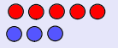
Note: Subtraction is understood by the children as the process of taking away objects from a group, for example, if I had 8 cakes and took away 3 then I would have 5 left (8 – 3 = 5). Subtraction can also be thought of as finding the difference between two sets of objects. An example could be, if there are 5 red cars and 3 blue cars then the difference is 2. This can be represented using objects such as counters and written as 5 – 3 = 2.

- Use some objects, a number line or hundred square to help you with these subtraction questions.

- 9 – 3 = | - 12 – 7 = | - 9 - 7 =
- 26 - 15 = | - 17 – 6 = | - 12 - ____ = 4

Can you create some questions of your own?

- Can you look at the objects below and use your subtraction knowledge to find the difference? Complete the bar model and write a number sentence for each one. I have done the first one as an example.

8
4 | 4
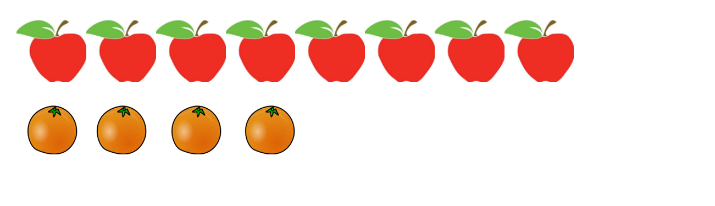
I can use the number sentence:
8 – 4 = 4
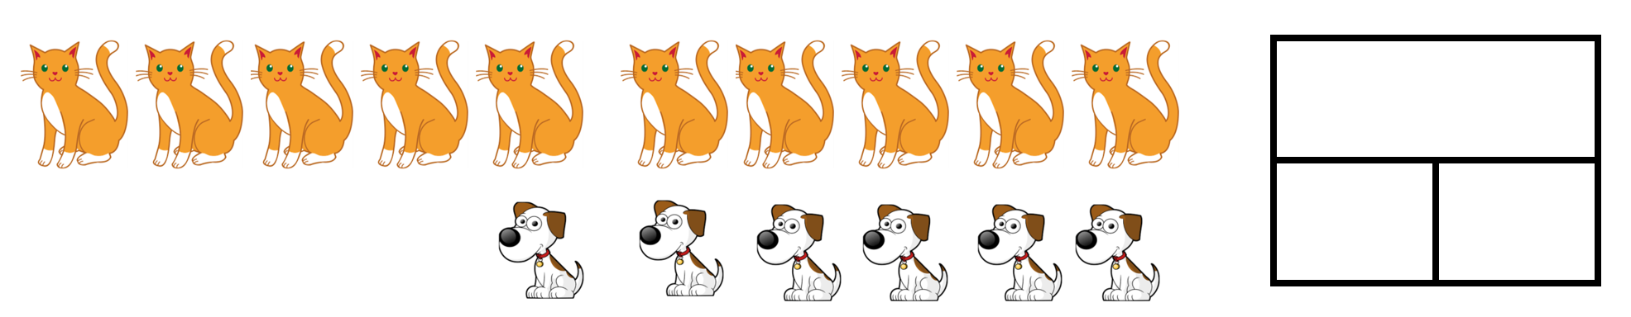
I can use the number sentence:

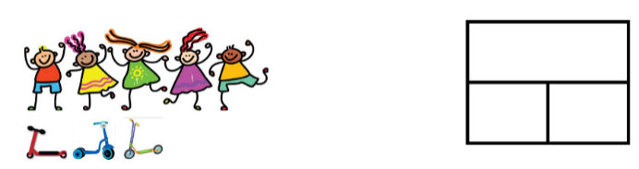
I can use the number sentence:

Create some examples of your own using your toys or objects from around the house (ask first!!) to make 2 sets and then find the difference between the two sets. Can you create a bar model and number sentence for each that you do?

Extension: Year 1 and Year 2 have earned some dojo points. There is a difference of 7 between their points. How many dojos might Year 1 and Year 2 have? Find as many different answers as you can!
Mental Maths Addition and Subtraction Practice:
Year 1: Focus on addition and subtraction facts to 20. Use objects, like counters or buttons, to help children work out, e.g. 14 + 5 = ? or 12 - 6 = ?
Year 2: Keep practising addition and subtraction facts to 20 but extend this to work out related facts up to 100, e.g. if 2 + 4 = 6, then 20 + 40 = 60.

English

Reading comprehension: read an extract or a chapter of a book that your child is reading, something from a children’s newspaper/magazine, a poem, or from any other source you think suitable. Read through the extract with your child, then ask your child questions to see how well they have understood what they have learnt. Questions starting with ‘who, what, where, when, how and why’ will allow them to show their understanding.

Writing: BBC iplayer have a fantastic selection of the Julia Donaldson stories that have been made into animations with some excellent narration by some well known celebrities. There is also an accompanying powerpoint (which I have attached), that I cannot take any credit for – thank you to an industrious colleague on Facebook, which has some brilliant writing activities broken down into daily tasks for each of the stories.

This week can you choose one of the stories to watch and then have a go at the linked writing tasks? I watched the Zog animation last week and had a go at writing a story about where I would go if I was taking off on the back of Zog – I have attached it for you to have a look at. Where would you go? What would you see? What amazing describing words can you use? Can you draw a picture to go with your story?

If you do not have access to iplayer, or want to try something different:
Could you have a go at creating a fact file? You could link it to our theme and maybe find out about Tim Peake or another astronaut such as Helen Sharman or Neil Armstrong. Maybe you could create a fact file about our moon, the sun or one of the planets? You could find out why we have day and night and create a fact file. Maybe you could create a fact file about one of the animals or plants that you have in your nature diary? Lots of possibilities.

SPAG: I have added the Year 1 and 2 High frequency and tricky word lists to the Class 2 page as I am aware that some children have completed the spellings that they have in their books. You can choose a selection of words from either or both of these lists and use them as an alternative. Once you have chosen the words to focus on, spend some time making sure children can sound out each word (stretching it out so you can hear each sound within the word), and that they know what each word means. Can they say it in a sentence? Can they write it in a sentence? Can they write the word in a tray of rice or sand? Can they write it in each colour of the rainbow?
There are some excellent spelling and grammar games on the brilliant Topmarks website suitable for year 1 and 2 https://www.topmarks.co.uk/english-games/5-7-years/words-and-spelling

Phonics (Year 1): If you want to be able to practice phonics then there is a fantastic resource on YouTube being introduced from 27/4 focussing on learning for the summer term with daily lessons being added. You can find the channel called ‘Letters and Sounds for Home and School’ in association with the DfE here https://www.youtube.com/channel/UCP_FbjYUP_UtldV2K_-niWw/featured?disable_polymer=1.

Science:
Everyday materials – Can you explore what common objects are made from (e.g. metal, plastic, wood, glass, rock, etc.), describe what these materials are like and group objects according to what they are made from? What material did you find the most of? Why do you think this is?
Explore why the characteristics of different materials make them suitable for some objects and not others, e.g. why it is better to use metal instead of wood for a saucepan. Also explore how the shapes of some solid objects can be changed by squashing, bending, twisting and stretching, e.g. sponges, plasticine, etc. (you can have a lot of fun with playdough with this activity!)

Art: Space is an amazing place full of some amazing phenomenon. One of these is a thing called a nebula, a giant cloud of dust and gas – they look better than they sound. Nebula also have some pretty cool names, based on what they look like e.g. the crab nebula, the eagle nebula, the cat’s eye nebula and the tarantula nebula!

Have a look at some pictures of a nebula on the internet (there are some amazing images taken by the Hubble telescope) or in a book. Can you have a go at creating your own nebula design? What could you make it look like? What could you call your nebula? This would work really well on some black paper with pastels if you have them.

DT: Can you create the best paper aeroplane? Use some paper from your recycling and create the fastest plane, the plane that glides for the longest or the biggest/smallest plane.

Dance: Can you explore some dance moves linked to our theme? There are some good ideas here https://www.bbc.co.uk/programmes/b03g6vs2

Imagine you are an astronaut; put on your space suit, making sure every part is correctly fastened. Start with the toes, rotating and tensing each section of your body, all the way up to putting on your helmet.

Once you are secure in your space suit, find a space and count down to blast off.
When you blast off, think of 3 different ways of jumping e.g.
• star jump
• bunny hop
• from crouching
• two feet together
• from foot to foot
• hop scotch
• jump to turn or change levels
• etc.

Maybe you create an alien dance?!

Other Activities
  - Keep up with your PE by joining Joe Wicks LIVE every weekday morning from 9am for ½ an hour (or you can catch up anytime through his YouTube channel) https://www.youtube.com/playlist?list=PLyCLoPd4VxBvQafyve889qVcPxYEjdSTl
  - Can you create a version of a board game such as snakes and ladders? Draw a grid and decorate it. You could even make your own dice – be creative!
  - Can you create a map of your house and garden? You could use the map to make a treasure hunt with clues!
  - Keep adding to your nature diary – I have seen lots of different animals while I have been out on my bike doing my daily exercise including a buzzard (which came very close), deer, barn owls, geese and a stoat running across the road in front of me!

