Rainbows

Rainbows of many colours,
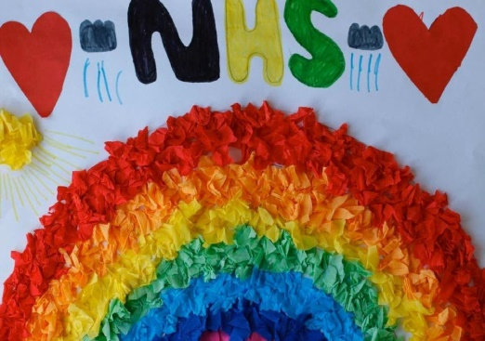
A sign of treasure to be found.
In these strange times your colours inspire me with
New reasons to appreciate, new reasons to be better, to be kind.
Building bridges to our future,
Our NHS are heroes, working to keep us all safe –
We love you NHS, the treasure found!

Be Better. Be Kind

Mr Cash

