Home Learning for w/c 11th May 2020
Hello Class 3
I hope you have all had another good week and stayed fit and well. I wonder if you did something special to celebrate VE Day? On our road we are having afternoon tea in our front gardens and then as a family we are going to make homemade pizzas and cook them in an outside oven to deliver to our neighbours, making sure we are washing our hands and keeping at a 2m safe distance; at all times. It will be a busy day!

This week we have a guest reader for the next few chapters of the story ‘The Twits’ just follow the link below to find out what happens next!

Did you complete your 2.6 / 26 challenge I wonder? I did 26 minutes on the trampoline and I was exhausted!

Look after one another, take care and stay safe.
Mrs Jordan
https://youtu.be/bQc8jt4YOP4

https://youtu.be/5R8lhiKelnk

https://youtu.be/JuuRPlX6JpI
Maths
- Continue to practice your times tables and when you feel confident with the one you are on feel free to move on to the next. The order would be 2, 5, 10, 3, 4, 6, 7, 8, 9, 11, 12.
- Shape
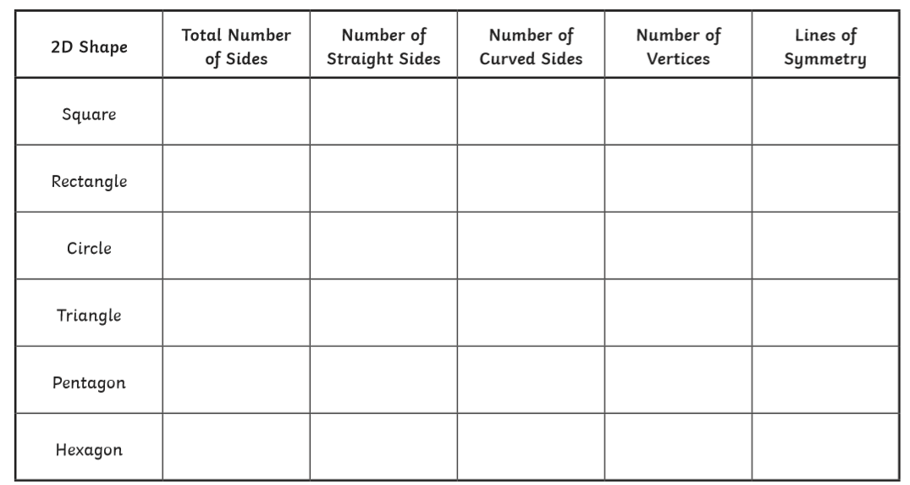
- This week we are going to be focussing on the properties of 2D shapes. An example of how you could lay this out is below, but this just shows you only half of the information I think you can find out about 2D shapes. You could also draw the shapes and complete as much information as you can about them. How many edges, sides or vertices does a shape have? Think about the angles in the shape are they acute, obtuse, or a right angle; does it have any parallel or perpendicular lines? How many lines of symmetry does it have? Also think about whether the shape is a polygon, quadrilateral and what type of triangle is it?

- Your second task is all about triangles - how many different types of triangles are there? Watch the link https://www.bbc.co.uk/bitesize/topics/zvmxsbk/articles/zggsfrd
- Can you draw the triangles, remember to use a ruler and name them and write their properties.
- Can you find out what a polygon is? How many different types are there? Add this information on to your table.
.https://www.bbc.co.uk/bitesize/topics/zvmxsbk/articles/z98n4qt

Maths challenge for multiplication and division

Can you work out your age in dog, cat, hamster and goldfish years?
To work out a dog’s age into human years you have to multiply it by 7, cat years are around 6 human years, hamsters are approximately 35 human years and gold fish around 10.
- Can you work out your parent’s / grandparents ages if they were a dog, cat, hamster or fish?
- Can you work out any of your pet’s ages in human years?

French

The focus for this week in French is - Vive le sport

I have attached a link below which shows some of the more popular sports that I think you all enjoy and how to pronounce the words and spell them.

https://www.bing.com/videos/search?q=french+sports+video+ks2&docid=608042535581122781&mid=2A462DC417DF8AD105792A462DC417DF8AD10579&view=detail&FORM=VIRE

Can you create a poster in French, a little bit like the one below to show all of your favourite sports?
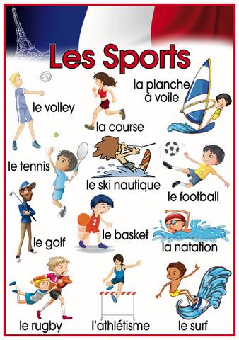

Theme / – Vikings

The letters of the Viking alphabet were called runes. Runes were often carved into stones as a memorial to a person or a special event. What can you find out about Viking runes and can you crack the code below? Can you then write your name in Viking runes and think about what Viking name you would give yourself and write this in runes. You could continue this outside and use sticks to write your name or a message.

PE

English / Geography
- Write a further week of your diary.
- Can you create a village guide for other children coming to your village, you could include:
- Five fun facts about your town or city.
- A map. This could be a simple street map or drawing
- Write a small page about the history of your village or even your house or about some interesting geographical features. What can you do in your village? Are there any clubs, activities or shops? Is there a church or a chapel, when were they built? Do you have a river or stream in your village or town?
- You could set this out as a brochure / leaflet folding a piece of A4 paper so each side has 3 sections. You could draw a picture of your house or other local features. Remember to use a title, sub heading as well as punctuation.
OR / AND
- Can you create a poem from magazines or newspapers? Think of a subject e.g. family, animals, school, chocolate, sweets, and sports and then look for words in a magazine that make you think of that subject. I have created one below and my subject was Class 3, I couldn’t find all the words I was looking for! Try and be as creative as possible, if you don’t understand any of the words why not use a dictionary to find out their meaning.

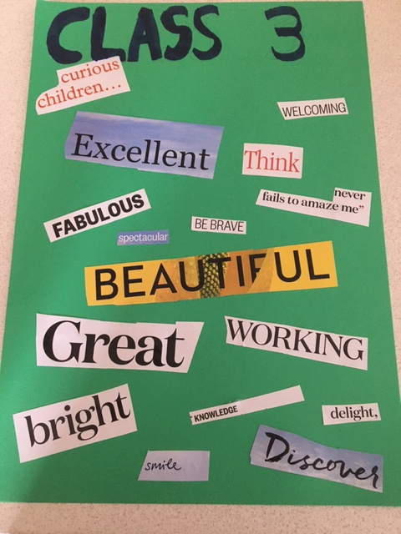

General

Why not use this extra time to earn a Blue Peter Badge, or if you have one already to earn a different one as there are 8 to collect. Why not follow the link below and see which one you think interests you the most. It would be amazing if we could earn a selection of badges across Class 3.

https://www.bbc.co.uk/cbbc/joinin/about-blue-peter-badges?collection=blue-peter-badges

