Home Learning for w/c 18th May 2020
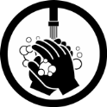
Hello Class 3
I hope you have all had a good week, stayed safe and enjoyed completing lots of the learning activities as well as spending time with your families and getting lots of fresh air.
I have read the next few chapters of ‘The Twits’; link below and I hope you all have another good week, be kind to each other and remember to help out as much as you can!
Mrs Jordan

https://youtu.be/jVO9wRAx_gs

https://youtu.be/LhlMUfUuA-s

Maths
- Continue to practice your times tables and when you feel confident with the one you are on feel free to move on to the next. The order would be 2, 5, 10, 3, 4, 6, 7, 8, 9, 11, 12.

- Task 1 - Shape
Watch the clip below and remind yourselves about the different angles and lines.
https://www.bbc.co.uk/bitesize/topics/zb6tyrd/articles/zg68k7h
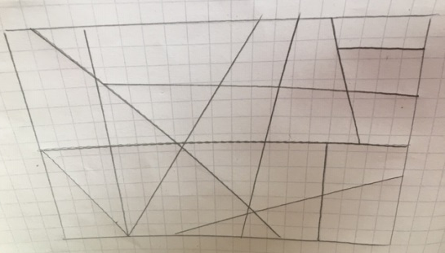
Create a drawing using a ruler and draw random lines like the one below. Can you label the angles? Are they obtuse, acute, reflex or a right angle? Can you see any parallel or perpendicular lines?

- Task 2

- How many 2D shapes can you think of that are symmetrical? What does symmetrical mean? Watch the clip below to help you understand. https://www.bbc.co.uk/bitesize/topics/zrhp34j/articles/z8t72p3
- Can you draw your own symmetrical picture?
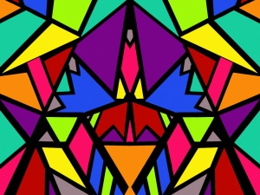
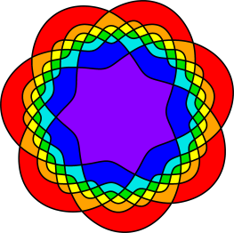
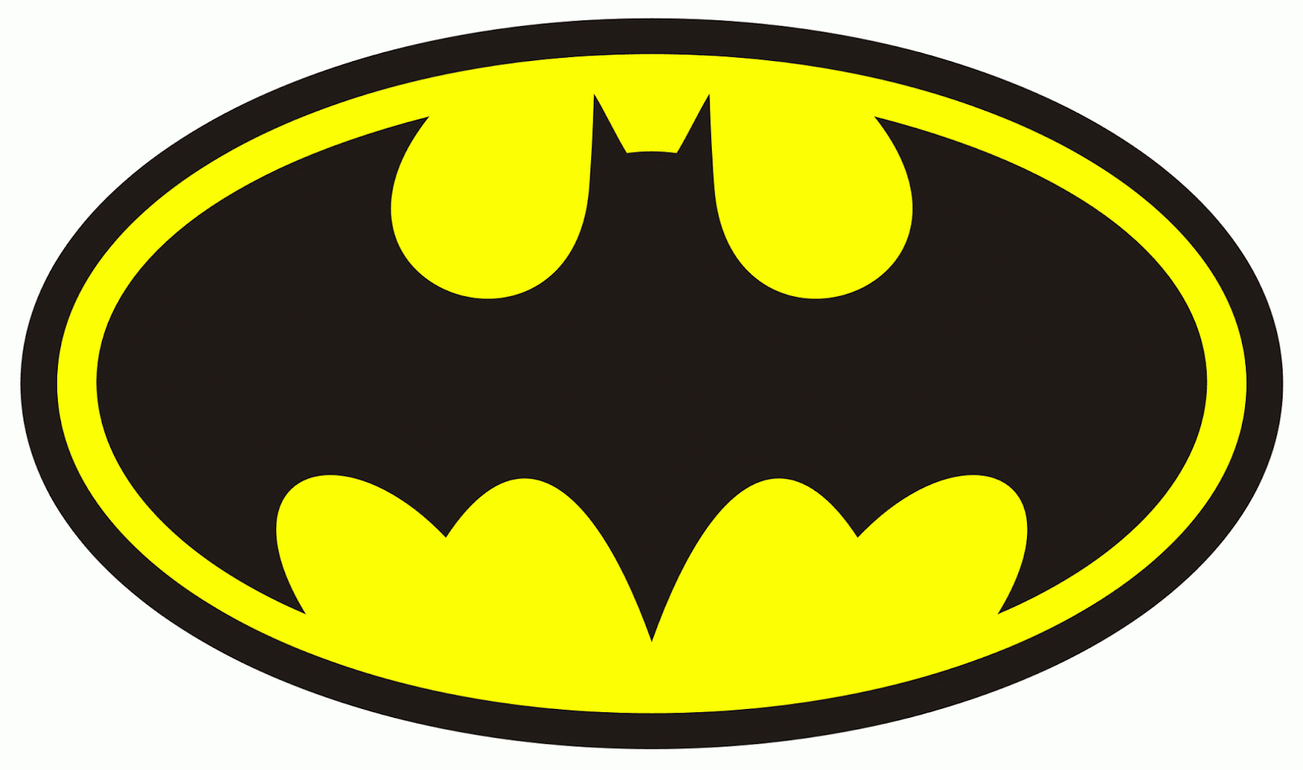

- Task 3 – 3D Shape spotting
  - Whilst out having your exercise or from your garden or inside your house what 3D shapes can you see? Can you remember their names? Can you draw the everyday items?

English / DT
- Please watch this short video below, this is a short award winning animation called ‘Soar’ and I think it fits in perfectly with our Slingsby School Values.
- https://youtu.be/UUlaseGrkLc
- After you have watched the clip can you write a character description about the girl? What do you think she is like? What qualities is she displaying? Can you describe her appearance, what facial expressions does she use, how does the girl move and how do you think she is feeling? After you have written your character description why not design and make a paper aeroplane. How far can you get it to fly, if you change a feature does it make it fly further or not? Can you get your paper plane to fly further than another family member’s plane?

- Remember to keep reading! Why not create your own dictionary and thesaurus. Every time you come across a word that you are not familiar with, find out what it means; write the definition down and then write the word in a sentence of your own. Can you think of a synonym for the word? This will help you build on your existing vocabulary and then when writing things like a description; you can make these descriptions more powerful and exciting for the reader.

Theme / – Vikings
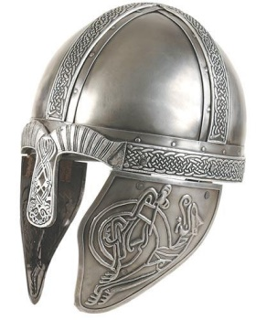
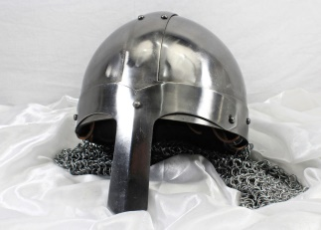
Watch the clip

https://www.bbc.co.uk/bitesize/clips/zfjqxnb

I wonder which you thought was correct.

Can you make your own papier mache Viking helmet?
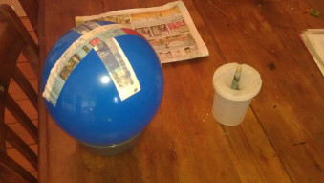
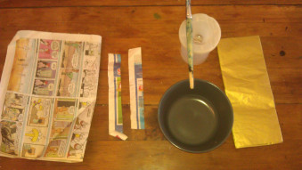

- Blow up the balloon and sit it on a bowl to keep it still.
- Tear up newspaper into strips. Glue the strips covering the balloon from the top until it starts to get too narrow to fit on your head.
- Now glue on another layer of newspaper strips going across the first layer.
- Let this dry.
- You may want to repeat this process with another two double layers to make the helmet strong enough.
- Then cut out an arch to make the ridge on the helmet and the eye and nose protectors.
- Now cover this with strips of gold paper or you could paint it with gold paint.
- Then pop the balloon if it hasn’t already shrivelled up.
- Give it another lick of glue inside and out to strengthen it then it’s done.
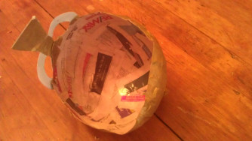

If you don’t have any balloons you could use a bowl but remember before you start; cover your bowl with cling film as this make it easier to remove once dry.

Science
Hoping for some more sunny weather I am challenging you to make your own sun dial.
Before we had clocks and watches people used sundials to mark the passing of time. A sundial measures time by the position of the sun and usually has markings for each hour of sunlight. Sundials have something in the centre which casts a shadow over the markings showing what the time is. There are lots of ways to make a simple sundial, you can draw around your shadow from the same central point at different times throughout the day, use stones or even just a simple straw or stick like we did.
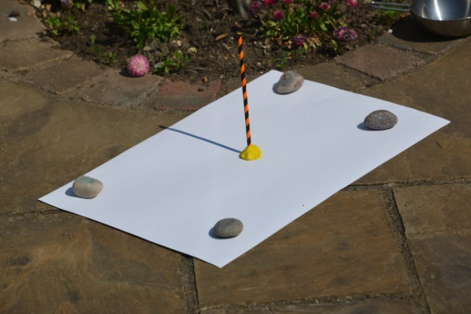
On a real sundial the central part (gnomon) usually sticks up at an angle from the dial plate (base of the sundial). It’s the shadow of the gnomon that moves around.

We started our recording at 12 noon and watched as the shadow of the straw changed over the afternoon, marking every hour. We were a bit late with one of our readings as you can see.
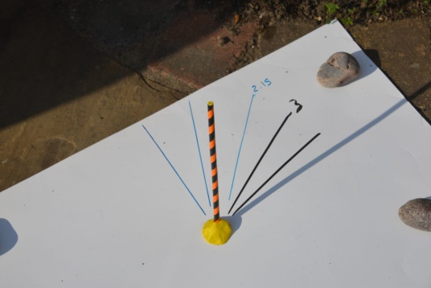

You could even use yourself as the gnomon, but remember to stand in the same place every time.
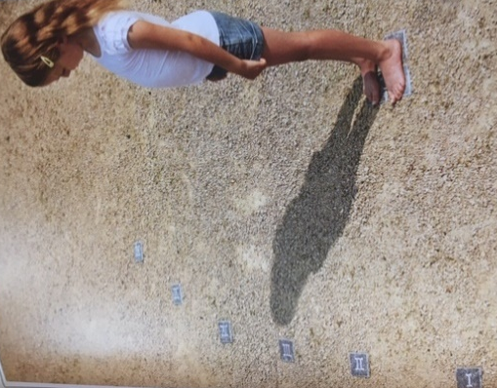

PE

Remember any exercise is good for you; this could be dancing to your favourite music or creating your own dance routine to your favourite song.

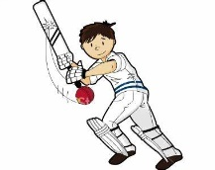
This week at home I have been practicing my throwing and catching skills with Oliver using a cricket ball or tennis ball, we have been using first two hands to catch and then one hand (both right and left). We have practiced throwing over arm and pulling our arms back before we throw rather than from the elbow. This will help with both your rounders and cricket skills when fielding the ball.

We have also been using our bikes a lot more and this is a great time to build up your confidence when on your bike.

General
The Scarborough Rotunda Museum is calling all young adventurous people as something is happening inside the museum and art gallery. Follow the link to the museum to find out more.

https://www.scarboroughmuseumstrust.com/whispers-from-the-museum/
