Home Learning for w/c 1st June 2020
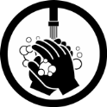
Hello Class 3
I hope you have all enjoyed half term and in particular the lovely weather that we have been having. I have been making the most of it by doing even more gardening, mainly weeding and getting out for exercise and fresh air with my family. We have also been busy in our garden moving a shed, painting it and then putting on a new roof, there has been lots of lifting, painting and hard work; but I’m pleased to say it is looking like new and in it’s new place in the garden.
I have read some more of ‘The Twits’ on the links below as well as the usual quick hello from the Bridestones trail in Dalby from myself. Missing you all, take care everyone and have a good week.
Mrs Jordan

https://youtu.be/J95cn7JxZg8

https://youtu.be/8zh7KEKxjUI

Maths
- Continue to practice your times tables and when you feel confident with the one you are on feel free to move on to the next. The order would be 2, 5, 10, 3, 4, 6, 7, 8, 9, 11, 12.

- Hopefully you have all spotted a range of 3D shapes as everyday objects and remembered some of their names as well as their properties. How many vertices, sides does the shape have? What 2D shapes make up the faces on the 3D shape? Can you complete the attached table either by printing it out or drawing the table on a piece of paper.

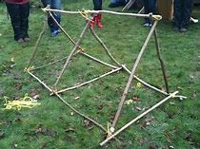
- Using either plastercine or salt dough to hold the sticks in place can you make some 3D shapes? You can use twigs or bits of strong card. Or you could make big ones using sticks in the garden and fasten them together using knots.
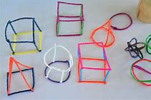

- Watch the BBC Bitesize clip below called ‘What are nets’
https://www.bbc.co.uk/bitesize/topics/zt7xk2p/articles/z247tv4

Can you draw and make some nets of different shapes. Why not make your own cubes and cuboids as well as a square based pyramid and make a street, you could have different houses, shops a church etc. Or you could make some animals.
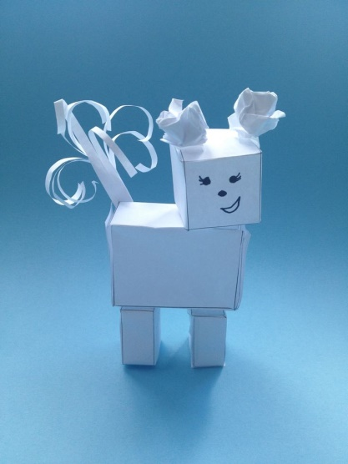

MFL

We have seen so many amazing rainbows and brightly coloured pictures. Can you draw a colourful picture maybe a flower, butterfly, insect or a rainbow and remind yourself about what the colours are in French. Can you then label them in a different language Spanish, Italian, Polish or German?

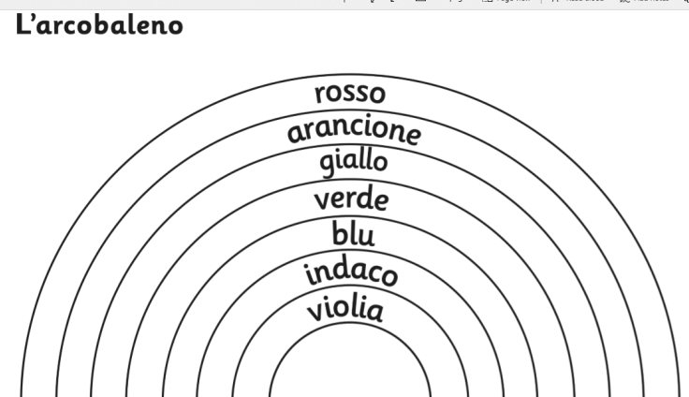
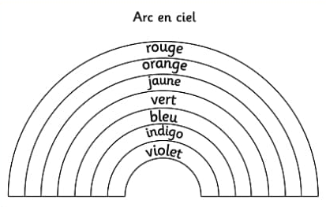

English
This week your English also includes some of your maths! We are going to be looking at the poem ‘What is it’ by David Harmer.

- First you will need to create your own matchbox size box by drawing your own net and then sticking it together.
- Then create your monster – this can be as big or as small as you like but it must be able to fit in your match box. Make sure you give him some unusual features.
- Then write your own match box monster poem using the features you have drawn. Remember to use adjectives, similes and alliteration. Don’t worry if your poem doesn’t rhyme. You can use the first two lines and the last four of the original poem.

- Can you have a go at the updated SPAG mat, remember you don’t need to print this out.
- If you have more time, can you choose your favourite book and write a review about it. Remember to include why it is your favourite book, a brief paragraph telling me what the book is about and who the main character is? Who would you recommend this book to and why? Lastly, what star rating would you give it.

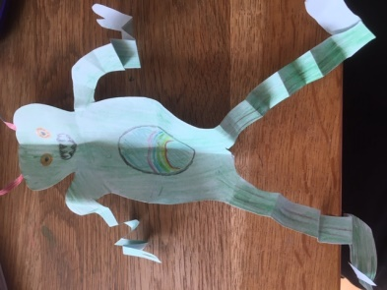
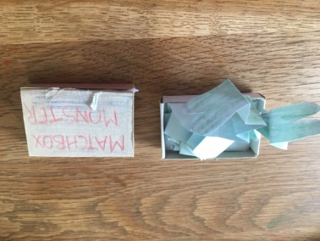
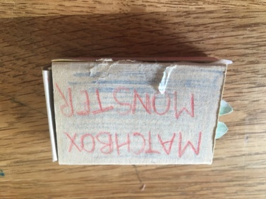

Theme / – Vikings

What did the Vikings Wear?

http://www.bbc.co.uk/learningzone/clips/viking-dress/466.html
Viking clothes were made from wool, linen and animal skins. The Vikings were skilful weavers and made their own clothes. Women, with the help of children, made the wool into yarn and used natural dyes from plants to give it colour. Men wore tunics and trousers and women wore a long dress with a pinafore over it. Their clothes were fastened with belts and brooches.
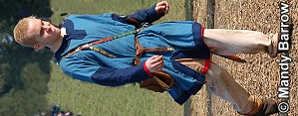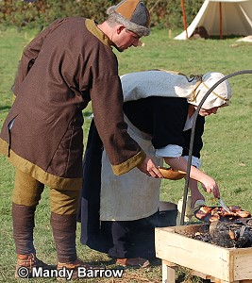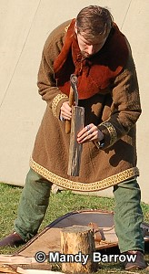

- Can you design your own Viking outfit – what would you wear if you were a Viking?
- Using an old tea towel, or white piece of cloth can you see what vegetables and plants you could use as a natural dye just as the Vikings would have done if they wanted colour on their clothes.
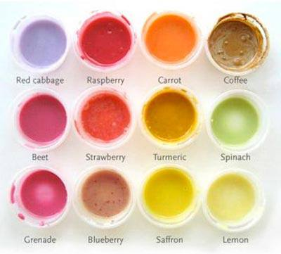
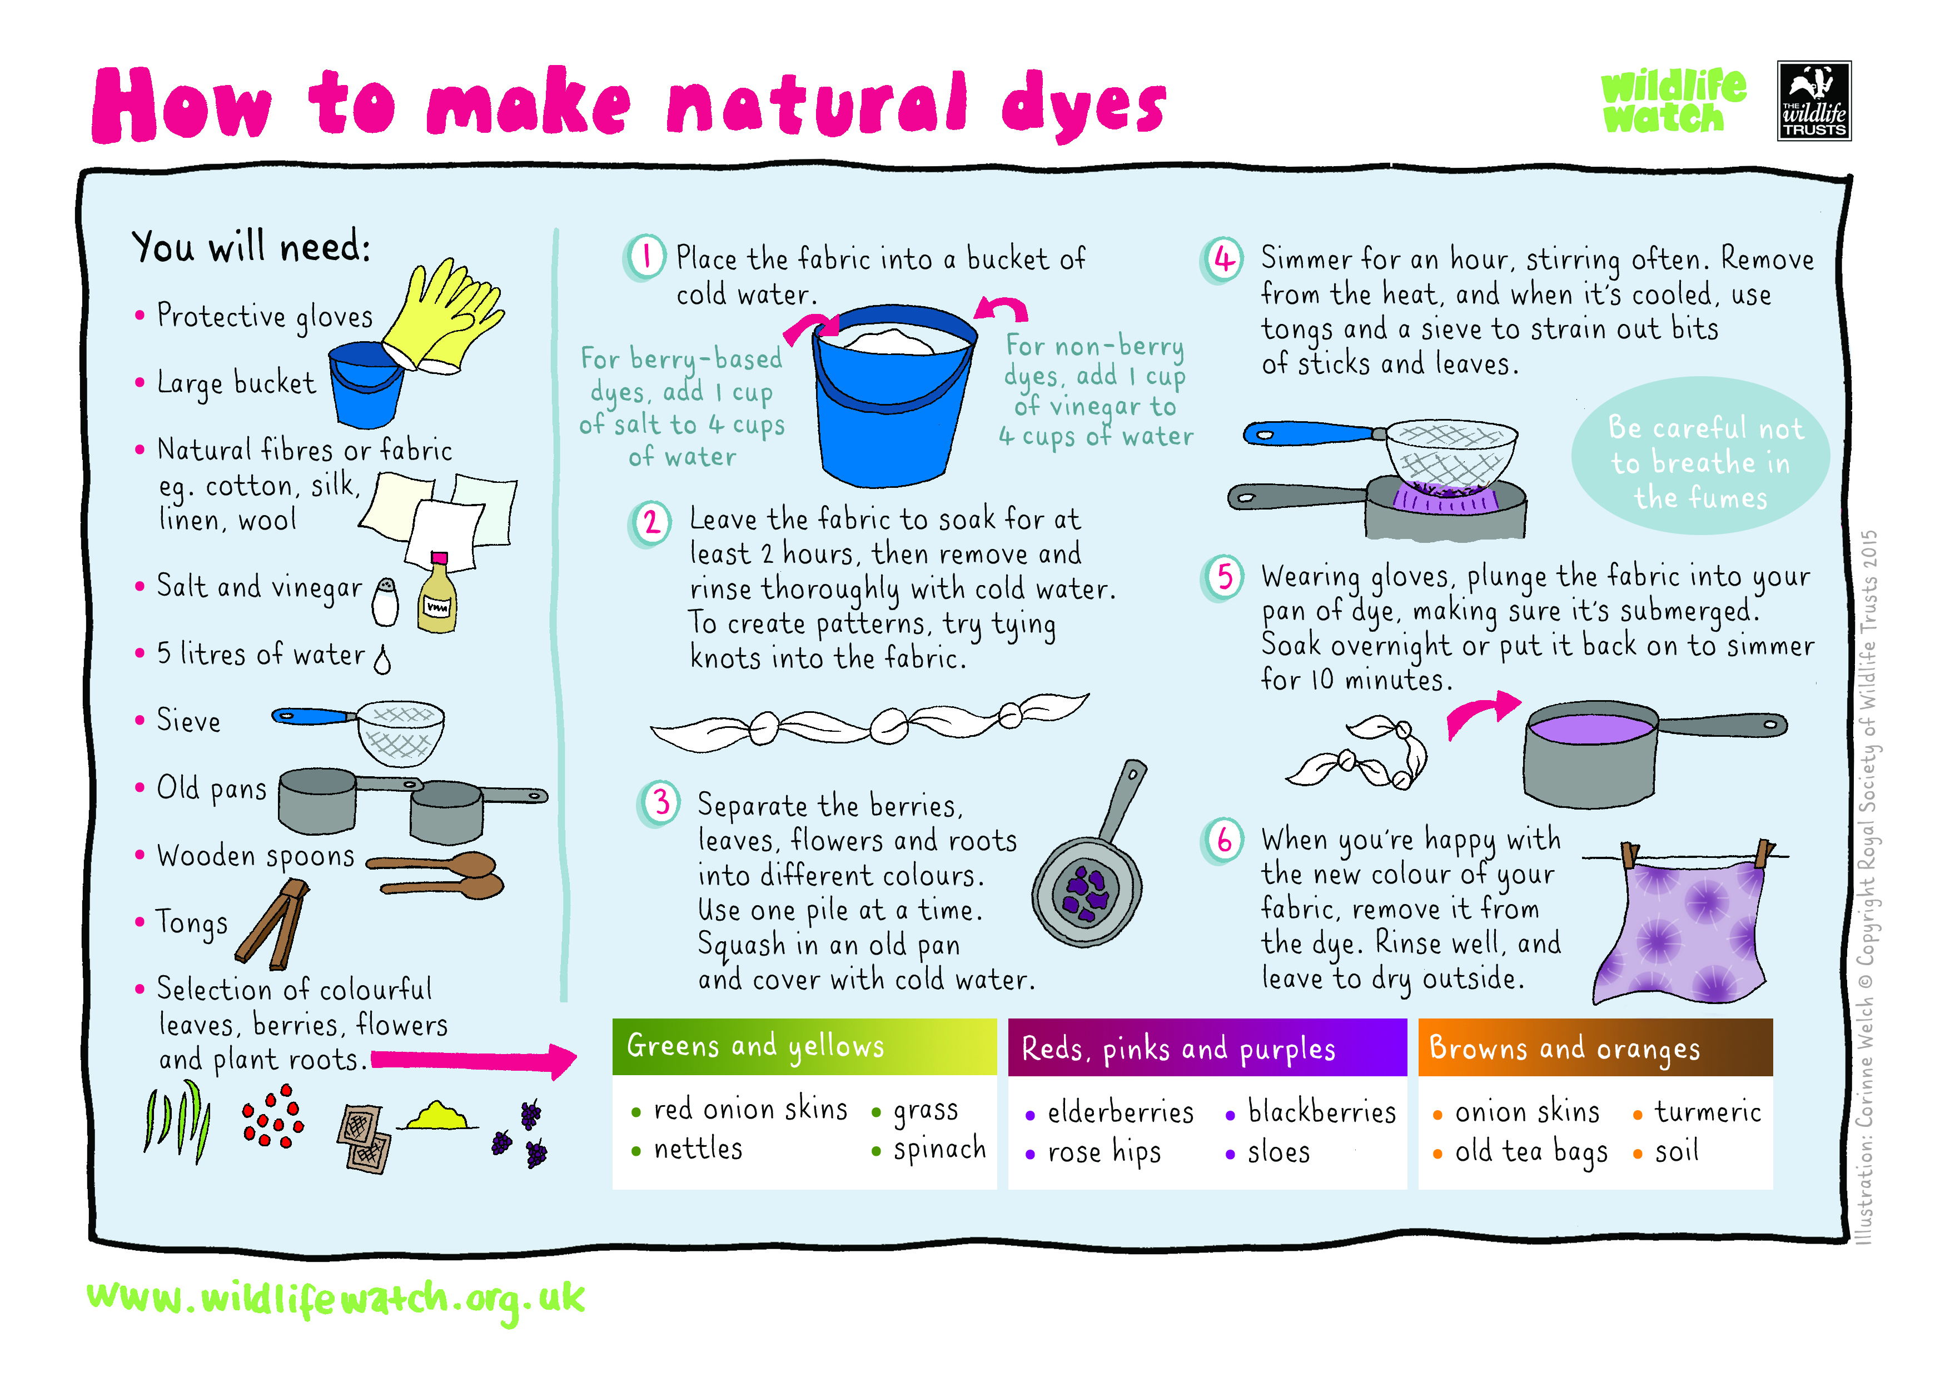

Rather than following the method below you could try rubbing the item onto the cloth and see what happens.

Science – Animals including humans
This week you are going to be learning about food chains. Can you find out what we mean by a producer, consumer and a predator?

https://www.bbc.co.uk/bitesize/topics/zbnnb9q/articles/zwbtxsg

- Choose a habitat and then draw your own food chain using the correct vocabulary.
  - Choose a different habitat and think about the animals that you might find in that habitat.

PE

Enjoy some outside time going for a walk, bike ride and a scooter ride make the most of the gorgeous weather we have been having.

Have a go at creating your own hopscotch or a chalk obstacle course like the ones below.
