Home Learning for w/c 4th May 2020

Hello Class 3
I hope you are all keeping safe and well and had a busy week doing lots of activities either linked to your learning or around the house and outside space. Have you seen the great gardening videos from Mrs Smurthwaite? I’m looking forward to hearing all about what you have been busy growing.
Take care of yourselves and your families.
Mrs Jordan
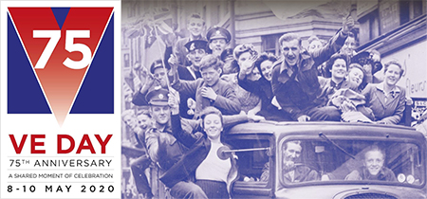
https://youtu.be/ANyw5KeV6ow

https://youtu.be/yCoGGUZLYQA

General

The Royal British Legion calls on the nation to mark the 75th anniversary of VE Day from home.
On Friday 8 May we will pay tribute to the service and sacrifice of the entire Second World War generation, from British, Commonwealth and Allied Forces to evacuees and those who served on the home front. On the Royal British Legion website there is a page of information and ideas for home activities.

https://www.britishlegion.org.uk/get-involved/remembrance/teaching-remembrance

Maths
- Continue to practice your times tables and when you feel confident with the one you are on feel free to move on to the next. The order would be 2, 5, 10, 3, 4, 6, 7, 8, 9, 11, 12.
  - This week we are looking at capacity and volume and again another practical week of activities.
  - What’s the same and what’s different about capacity and volume?
  - What does capacity mean? What does volume mean?
  - What do we measure capacity and volume in?
  - What unit of measure (ml or l) would we use to measure ____ ?
  - How much liquid is in the container?
  - What is the scale going up in?
- Choose a selection of containers and see how much water they hold, order the containers, and predict what they will hold.
- Attached are a selection of power points that you can work through and then some reasoning questions for you to try linked to mass and capacity, you can just write the answers and check them, you don’t need to print the sheet. Although capacity is typically a year 3 objective I would cover this as revision with my year 4 – therefore where possible children in year 4 should be working on the questions marked GD.
- Additionally to this (if you want more) it is always good to practice your mental maths skills, roll a dice and generate a 2 / 3 digit number can you work out in your head what you would need to get to 100 / 500 or a 1000. Practice adding 2, three digit numbers together in your head.

Check out BBC Bitesize daily lessons they are extremely good and easy to follow and understand. There are further games on Top Marks to practice these skills.

Art

- Can you draw / paint a family picture. You can draw your whole bodies or just the head and shoulders. Some examples below.
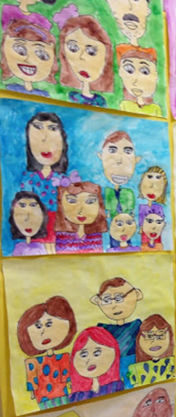
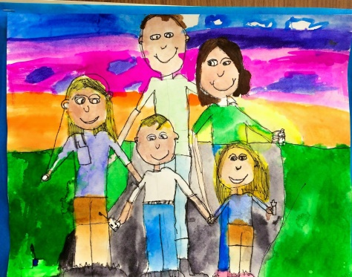
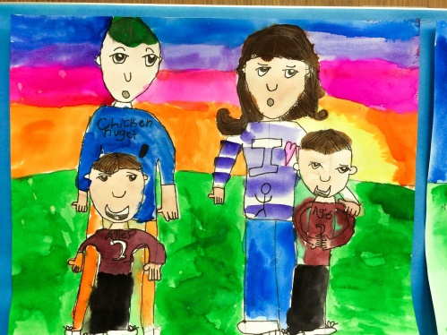

DT / Food Tech / Science

- Stop Food Waste Day 29th April 2020
- Stop Food Waste Day is an international day of action in the fight against food waste which is a serious and growing problem.
- Roughly one-third of the food produced globally is either lost or wasted every year.
- Can you create a poster to give people ideas of how they can reduce food waste? (There are lots of ideas on the internet if you need more.)
- Can you create a menu for the week for your family? What could you use up from the fridge for this? How would you ensure that you had included bits from all the food groups? Do you know what the 5 main food groups are? Can you draw a plate of food to show what a balanced meal might look like?
Theme / IT – Vikings
What can you find out about the Viking Gods and Goddesses? If you have access to Power Point why not make a short presentation about one of them or alternatively create a fact file on either Thor, Odin, Freya, Liko, Tyr, Baldur and Valkyries.

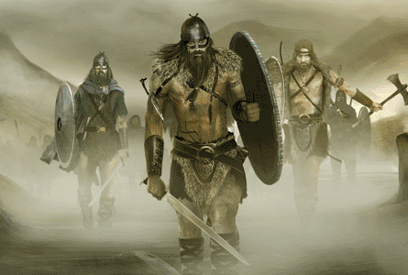

PE

- Why not complete the 2.6 challenge. On Sunday 26th April thousands of people would have been running the London Marathon to help raise money for a charity. Some of the suggested activities include doing 26 laps of your outside space, 26 star jumps, skip for 26 minutes, hula hoop 26 times, walk up and down the stairs 26 times, put on some music and dance for 26 minutes. Maybe you could do one of the activities once a day you could then give your pocket money to a charity or do a thoughtful gesture for someone you know.
- My aim is to bounce on the trampoline for 26 minutes without stopping.

- Continue with Joe Wicks – 9:00a.m every morning for a 25 minute exercise routine.

English
- I wonder how many of you are writing a diary. If you are still keep going, include your feelings what are you enjoying, missing, finding frustrating and have you learnt anything new? Remember to include it.
- I have also attached a SPAG mat for you to complete this does not need printing you can complete this verbally.
- Choose a story or a chapter to read to an adult. After reading answer a range of questions focussing on

- Can you carry out an interview on either someone living with you or face time / call a grandparent or a relative. Some ideas for questions are below, can you think of two more?
    - When and where were they born?
    - What was there favourite thing to do when they were growing up?
    - What were there parents name?
    - What schools did they go to?
    - What did they do when they left school?
    - Who was the most influential person in their lives?
    - What was their favourite Christmas or Birthday present?
    - What was the most major world event that they remember

