Hello Class 4!
I hope you are all doing well and have enjoyed your half term. The weather has been absolutely beautiful and we are so lucky that it hasn’t been raining all the time. Here are this week’s home learning ideas to keep your brain and skills going. Remember that I am trying to plan work that you can complete without too much extra support and that I hope you find interesting: do not worry about achieving perfection, just try your best like you always do in class.
English
Please spend time looking at your spelling list and researching the meaning of each word by recording the dictionary definition for each one, then use it correctly in a sentence.
Following on from the diary that I asked you to try in the week before half term, I would like you to try to write a newspaper front page report about your rescue. It would be great if you could type it up in a newspaper style too!
Things to remember to include:
- A clear and bold headline e.g.: MISSING FAMILY FOUND SAFE
- Your opening paragraph should focus on: What? When? Who? Where?
For example: The mystery of missing flight 56A Florida was finally solved yesterday when The Smith family from Norton, York were located and rescued from a tiny deserted island 50 miles east from Bermuda.
- The next paragraphs should give more detail about the history of events leading to the rescue; the rescue itself and include statements and quotes from those involved.
- You could include quotes from your family, the rescue team, the airline and scientific experts. Remember to use different levels of formality depending on who is speaking. If you are a little unsure about the style to write in, spend time reading some newspaper reports first.
- Photos/illustrations with captions
- Use of time conjunctions to link paragraphs
Optional extra: Produce a ‘news style’ TV video report that could go on a nightly televised news programme – you could even put on your best clothes so you look the part!
Mathematics:
Did you show your family the 6 and 8 x table videos on Youtube? I hope you enjoyed sharing them and you could also have fun learning the lyrics to the 4 x table ‘I’m Still Standing’ this week – it’s a great tune! https://www.youtube.com/watch?v=8QU_E0u-tP4. Please also spend time revising your 12 x tables: https://www.youtube.com/watch?v=uMbTpW-v0t4
This week I would like you to write a song for the times tables of your choice. You could use an existing tune like the ones we use in class, or your own choice. Alternatively, you could write it in a rapping style to a simple beat!
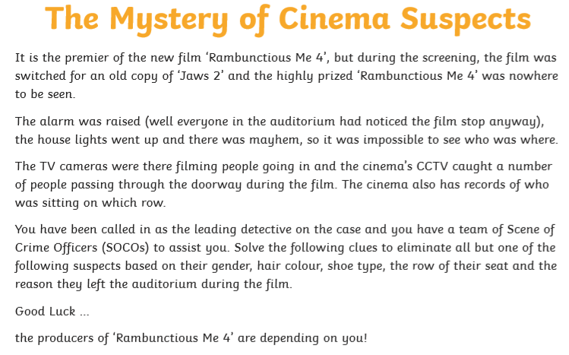
I have also included some interesting maths puzzles for you to solve (linked by PDF for this week’s work):

The Mystery of Cinema Suspects:
Some of you may not yet be confident in using long multiplication and division so you could use a calculator for the questions you are really struggling with.

Science:
Identify the wildlife (animal & plants) in your garden. Produce a sketch or take a photo; write one interesting fact; explain how you identified it; and think of how it is adapted to survive in its habitat.
A great source of information is the Woodland Trust:
Whilst clearing out a corner of my garden this week, I found and rescued (from Mollie) a family of beautiful frogs – even though one was a ‘super-frog’ and managed to jump out of a deep bucket! Then I transported them to a nearby lake so they would be a little safer from being pawed to death.
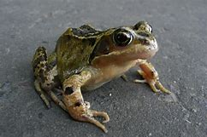
Species: European Common Frog (Rana temporaria)
Amphibian: Smooth, slick, can breathe in water or in air.
Adaptations: Strong hind legs for powerful jumping; can breathe through its skin; camouflaged skin to avoid detection from predators; eyes on side of head give 360˚ view and enable the frog to remain perfectly still; and webbed feet for powerful swimming.
Diet: Carnivorous and survive on a diet of invertebrates, such as flies, worms, snails and slugs, although they have been known to eat smaller amphibians. They use their long, sticky tongue to catch their prey. Their tadpoles feed on algae in the water.
You could do a similar write-ups for ANY living thing you find, or see if you can produce an A to Z of things you find living in your garden or whilst out on a nature walk.
French:
I thought it would be fun to link some language work to your science this week. Have a go at finding these and learning their French names:

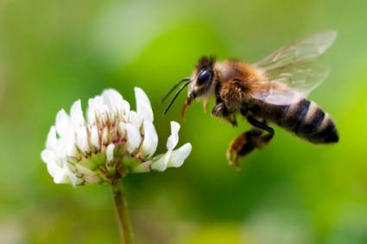
Insects (Les Insectes)
Ant - la fourmi (lah foor-mee)
- Bee - l'abeille (lah bay-uh)
- Beetle - le scarabée (luh skah-rah-bay)
- Butterfly - le papillon (luh pah-pee-yohn)
- Caterpillar - la chenille (lah shuh-nee-uh)
- Cockroach - le cafard (luh cah-fahr)
- Cricket - le criquet (luh kree-kay)
- Firefly - la luciole (lah lu-see-yol)
- Grasshopper - la sauterelle (lah so-trel)
- Ladybug - la coccinelle (lah ko-see-nel)
- Mosquito - la moustique (lah moo-steek)
- Praying mantis - la mante religieuse (lah mahnt ray-lee-juhs)
- Snail - l'escargot (les-car-go)
- Spider - l'araignée (lah-rayn-yay)
- Worm - le ver (luh vehr)

History & Food Technology:
Learn how the ancient Mayans ate by reading through this week’s Powerpoint and have a go at making your own tortilla. Please make sure you are working with an adult if using the cooker!

This week’s spelling lists:
Class 4 spelling list for group 3: Week 32
After completing ‘look, cover write, check,’ please try to write 5 interesting sentences in your spelling homework book. You can use more than one word from your spelling list in each sentence.
Objective: To practise extending, and compounding words through adding parts, e.g. ly.
Spellings | Look, cover, write, check
 | Monday | Tuesday | Wednesday | Thursday
happily
speedily
quietly
generally
strangely
curiously
normally
secretively
exactly
jokingly
daily
especially
ghostly
luckily
easily
absolutely
surely
angrily
certainly
definitely

Spelling score this week =
Class 4 spelling list for group 2: Week 32
After completing ‘look, cover write, check,’ please try to write 5 interesting sentences in your spelling homework book. You can use more than one word from your spelling list in each sentence.
Objective: Revision of the suffixes –ible and –able.
Spellings | Look, cover, write, check
 | Monday | Tuesday | Wednesday | Thursday
enjoyable
enabled
miserable
dependable
disable
incapable
reasonable
probable
reliable
table
breakable
notable
memorable
portable
comfortable
desirable
payable
valuable
agreeable
forgivable

Spelling score this week =

Class 4 spelling list for group 1: Week 32
After completing ‘look, cover write, check,’ please try to write 5 interesting sentences in your spelling homework book. You can use more than one word from your spelling list in each sentence.
Objective: Revision of the suffixes –ible and –able.
Spellings | Look, cover, write, check
 | Monday | Tuesday | Wednesday | Thursday
unacceptable
miserable
laughable
dependable
fashionable
unreasonable
identifiable
unpredictable
respectable
desirable
valuable
debatable
unforgivable
honourable
dishonourable

Spelling score this week =

Have a great week with your family!
Mr. Smith

