English
I hope you enjoyed learning about the Bermuda triangle last week – there have been some VERY mysterious happenings going on there over the years!
This week I would like you to imagine that you and your family were on your way to a holiday in Florida. When your plane entered the air-space above the Bermuda triangle, the lights in the aircraft stated to blink and flicker, then everyone on board – apart from you and your family – froze in time, then faded into nothingness! There was a brilliantly bright flash and you all awoke laying on the sand of a beautiful, tropical island.
Your task is to write a diary of how you survive until you are rescued. You will need to split your diary into several days. Think about:
- Describing, in detail, what you feel and see when you awaken.
- The human body needs water and food to survive. These will be your priorities but where and how will you find them?
- Another priority is shelter. What will you use to build your shelter? Where will be the best place to build it? You could illustrate each part and label the resources you used.
- Will you explore the island? Could you draw a map with symbols on it like we have done in our geography lessons?
- How will you hope to be rescued? Do you have a plan about how you can signal for help?
Mathematics
I hope you enjoyed your coordinates work last week and scored lots of points on ‘Who Wants to be a Mathonnaire?’ This week, I would like you to complete the questions set out in the packs I have posted from Classroom Secrets. The focus this week for both year groups is number.
I would also like you to have a go at teaching the rest of your family the 6 and 8 x tables songs that we use in class from YouTube! Here are the links:
https://www.youtube.com/watch?v=e7rYbk9PNuM (6 x tables)
https://www.youtube.com/watch?v=z_BJjR9rdwA (8 x tables)
Art & design
This week looks like it’s going to be nice weather again so I am going to set you the challenge of creating outdoor art and sculpture from natural or recycled sources. One of the inspirational artists for this type of work is Andy Goldsworthy. You can find lots of ideas if you search online for Andy Goldsworthy images!
Andy Goldsworthy produces artwork using natural materials (such as flowers, mud, ice, leaves, twigs, pebbles, boulders, snow, thorns, bark, grass and pine cones).
Much of his work is made outside and is meant to be temporary. He photographs the artwork and then allows it to remain in the natural environment and decay at its own rate. Sometimes he photographs the same work in different conditions.
Goldsworthy says he ‘works with nature as a whole’ and sometimes he often doesn’t use man-made tools to produce his sculptures.

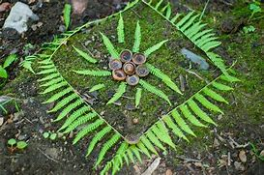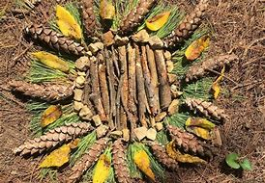
Geography
A simple one this week! I would like you to test how many capital cities of Europe you can remember. 10 is good score, but if you can remember 20+ you’re pretty amazing!
Can you find out which countries these flags belong to?
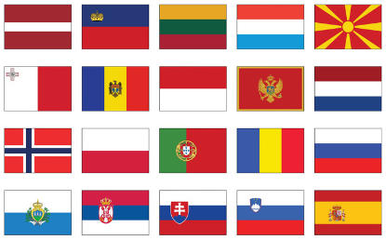
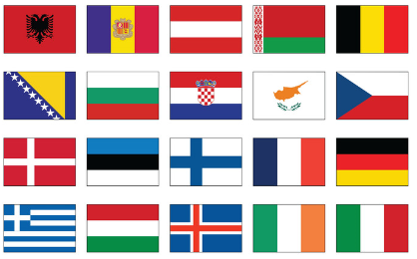

See next page for Science

Science
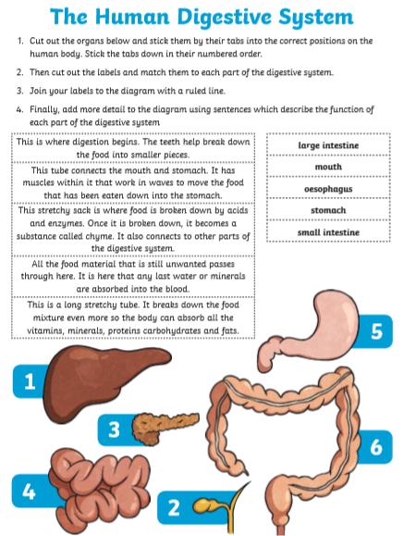
Please read through the Powerpoint presentation I have posted for this week, then have a go at completing this activity. If you cannot print out at home, have a go at drawing and labelling your own digestive system (with labels) and try to learn everything you can about the organs of the human body.

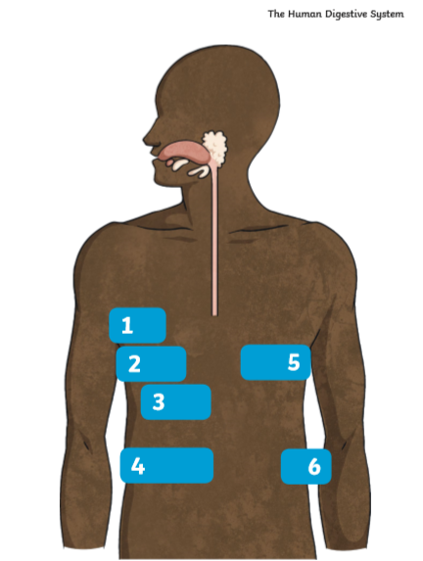

This week’s spelling lists:
Class 4 spelling list for group 3: Week 31
After completing ‘look, cover write, check,’ please try to write 5 interesting sentences in your spelling homework book. You can use more than one word from your spelling list in each sentence.
Objective: To recognise and spell the suffixes: -ible, -able.
Spellings | Look, cover, write, check
 | Monday | Tuesday | Wednesday | Thursday
sensible
terrible
visible
horrible
invisible
possible
credible
incredible
edible
inedible
enjoyable
miserable
probable
adorable
suitable
reliable
breakable
agreeable
valuable
forgivable

Spelling score this week =

Class 4 spelling list for group 2: Week 31
After completing ‘look, cover write, check,’ please try to write 5 interesting sentences in your spelling homework book. You can use more than one word from your spelling list in each sentence.
Objective: Revision of the suffixes –ible and –able.
Spellings | Look, cover, write, check
 | Monday | Tuesday | Wednesday | Thursday
impossible
terrible
visible
invisible
feasible
divisible
horrible
convertible
compatible
flexible
digestible
sensible
incredible
edible
audible

Spelling score this week =

Class 4 spelling list for group 1: Week 31
After completing ‘look, cover write, check,’ please try to write 5 interesting sentences in your spelling homework book. You can use more than one word from your spelling list in each sentence.
Objective: Revision of the suffixes –ible and –able.
Spellings | Look, cover, write, check
 | Monday | Tuesday | Wednesday | Thursday
irresistible
irresponsible
legible
inaccessible
feasible
plausible
irreversible
compatible
compatibility
indestructible
indefensible
inedible
inaudible
incomprehensible
manageable
available

Spelling score this week =

And that’s all for this week! Remember to do as much as you can but do not worry if you cannot get everything done. Remember to keep reading too! Stay safe.
Mr. Smith

