Hello Class 4!
Another week in lockdown dawns and I hope you are all still doing well and keeping busy. Mrs. Metcalfe has shown me pictures of some of the work you’ve been doing, and I am massively proud of you all! Remember not to worry if you cannot do everything I set, and if you want to do ‘extras’ there are now some really good activities to browse through on the BBC Revise-wise website, so have a look. The work that I am planning for you reflects what we should be doing in school this term.
English/History
I hope you had a go at writing your own time travel story last week; it would be really interesting to see where/when you decided to travel to.
This week, I’d like you to have a go at writing a diary/notebook from the point of view of John Lloyd Stephens and Frederick Catherwood. You’ll need to use the internet to do a little bit of research, but they were two of the early explorers of the Maya Civilisation. Where did they go? What did they find? What sketches did they draw?
You can split your diary up into as many different days as you’d like. You could plan to do some fact-finding on Monday, then write a dairy entry per day with illustrations if you wish to.
This is an example of part of a real account of events, written by Stephens, to give you an idea of the style, but use YOUR own style if this is too challenging:
In his incidents of Travel in Central America, Chiapas and Yucatan, Stephens writes of his first impressions of Copan:
Diverging from the base, and working our way through the thick woods, we came upon a square stone column, about 14 feet high and three feet on each side, sculptured in very bold relief, and all four sides, from the base to the top. The front was the figure of a man curiously and richly dressed, and the face, evidently a portrait, solemn, stern, and well-fitted to excite terror. The back was of a different design, unlike anything we had ever seen before, and the sides were covered with hieroglyphics. This our guide called an `Idol' and before it, at a distance of three feet, was a large block of stone, also sculptured with figures and emblematical devices, which he called an altar.
The sight of this unexpected monument put at rest at once and forever, in our minds, all uncertainty in regard to the character of American antiquities, and gave us the assurance that the objects we were in search of were interesting, not only as the remains of an unknown people, but as works of art, proving, like newly discovered historical records, that the people who once occupied the Continent of America were not savages.
source: https://www.ancient.eu/article/419/early-explorers-of-the-maya-civilization-john-lloy/

Mathematics:
How did you do with last week’s maths problems? Here are the answers:
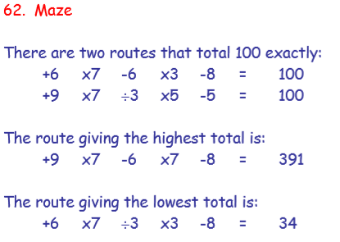
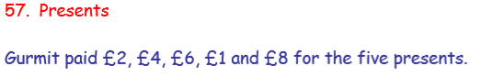

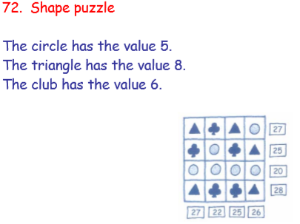

If you found these to be a little too challenging, this week I have split some problems into easier and harder. They are all designed to test your mathematical thinking and resilience, so don’t worry about only doing one per day – that is why I’m only choosing 4 per week.
You could also challenge your family members to a game of Banana Hunt this week; and have a go at your own + - x and ÷ sums (you choose the numbers, but don’t make them too easy).
Link to Banana Hunt: https://mathslinks.net/links/banana-hunt/
This week’s problems on next page. . .

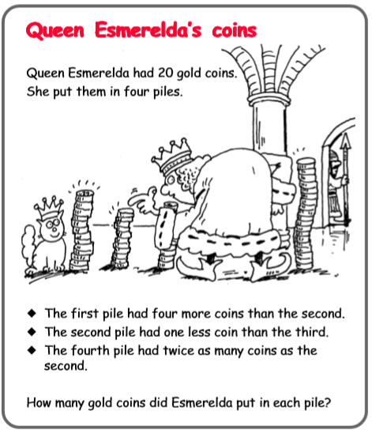
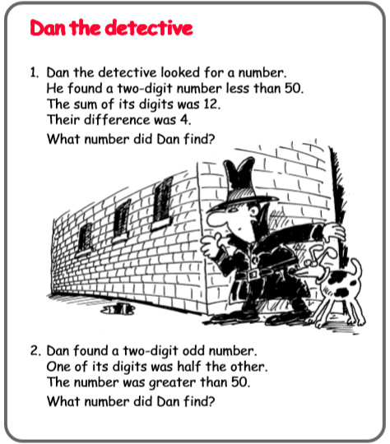
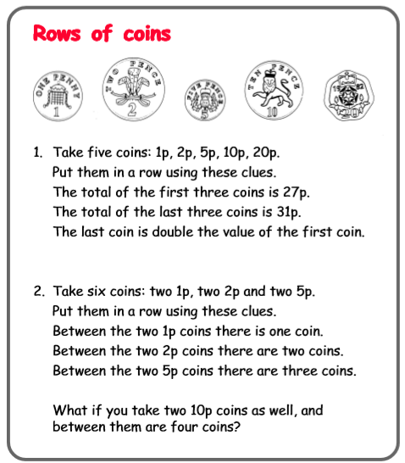
Easier:
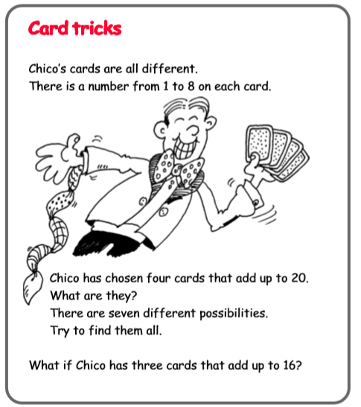

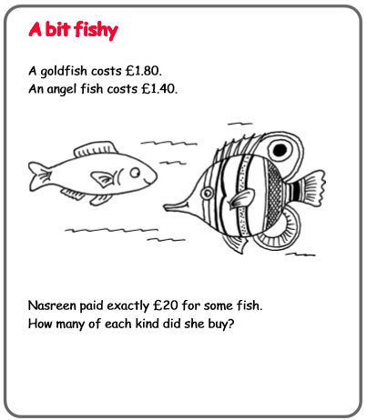
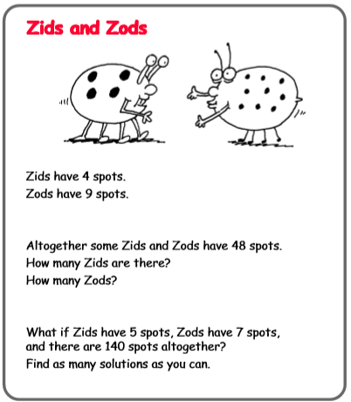
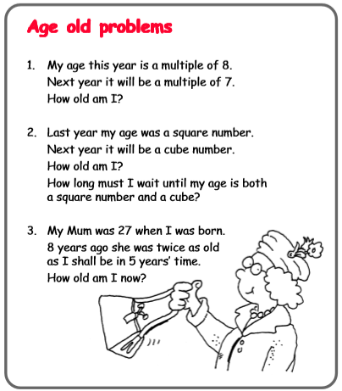
Harder:
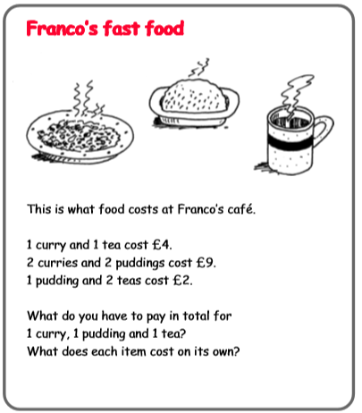

Science:
This week I would like you to keep a diary of EVERYTHING you eat and drink; and note down each time which food groups you have been consuming. Part of the curriculum is to recognise which food groups there are and how much of each you need to stay healthy; and hopefully this may also keep you from eating everything in the house (like my two boys at home!).
You may want to follow this format, but feel free to design your own!
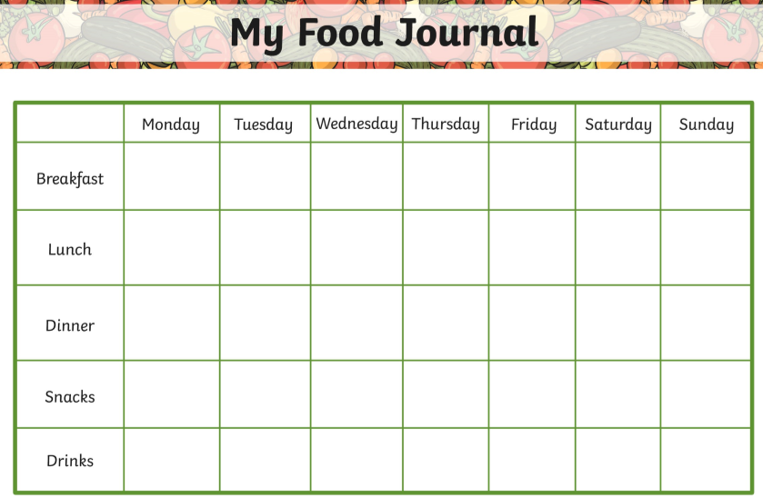
I have also included links to two information Powerpoints which will help you to identify which group each food belongs to on our website.
You could also design your own healthy, balanced menu for a new restaurant!
Technology
Have a go at building your own Mayan temple!

This week’s spelling lists:
Class 4 spelling list for group 3: Week 29
After completing ‘look, cover write, check,’ please try to write 5 interesting sentences in your spelling homework book. You can use more than one word from your spelling list in each sentence.
Objective: To investigate compound words and recognise that they can aid spelling even where pronunciation obscures it.
Spellings | Look, cover, write, check
 | Monday | Tuesday | Wednesday | Thursday
anyone
everyone
football
playground
tablecloth
cupboard
outside
daydream
downstairs
airport
handkerchief
earthquake
fingerprint
grandparents
hairdresser
hideaway
neighbourhood
masterpiece
goalkeeper
thunderstorm

Spelling score this week =

Class 4 spelling list for group 2: Week 29
After completing ‘look, cover write, check,’ please try to write 5 interesting sentences in your spelling homework book. You can use more than one word from your spelling list in each sentence.
Objective: Words beginning with pro-
Spellings | Look, cover, write, check
 | Monday | Tuesday | Wednesday | Thursday
project
projected
provide
provided
propose
proposed
proclaim
proclaimed
provoke
provoked
proceed
proceeded
provoked
provoking
professor
produce
producer
produced
process
processed

Spelling score this week =

Class 4 spelling list for group 1: Week 29
After completing ‘look, cover write, check,’ please try to write 5 interesting sentences in your spelling homework book. You can use more than one word from your spelling list in each sentence.
Objective: Words beginning with pro-
Spellings | Look, cover, write, check
 | Monday | Tuesday | Wednesday | Thursday
projectiles
prohibit
prohibited
proposal
proclamation
probation
proactively
procedure
proceeded
processor
processes
propeller
profession
professional
professionally
production
productivity

Spelling score this week =

Stay healthy, stay safe and be kind to those you love.
Mr. Smith

