English
For this week, I would like you to investigate something that always fascinated me as a child: the mysteries of the Bermuda Triangle. After you have researched and taken a few notes, I’d like you to write a theory explaining what you believe to be the cause of the mysterious happenings that occur there. I’m looking forward to seeing what you think!
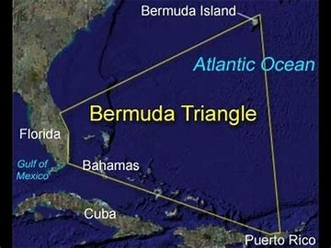
Don’t forget to keep reading too please.
Mathematics
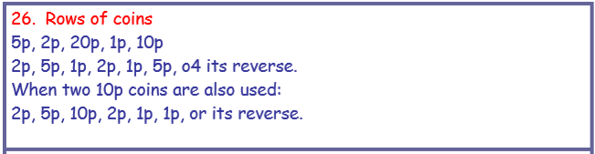
How did you do with last week’s maths problems? Here are the answers:
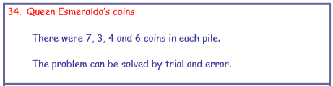
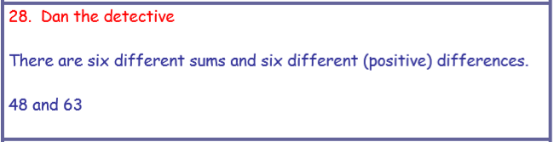
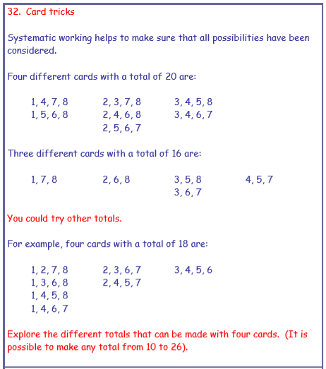
Easier

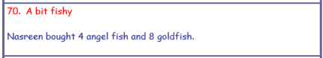
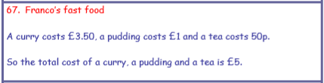
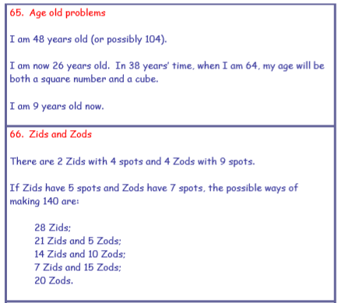
Harder

This week’s mathematics:
All pupils in Year 5 & 6 should be able to have a good go at completing the co-ordinates section of the YEAR 6 Home Learning Pack – pages 14 to 19. Remember to go along the corridor, then up the stairs (or down the stairs if there are four quadrants and the second number is negative). Feel free to extend your learning further by looking at other online resources for co-ordinates activities if you enjoy doing these.
This week, you could also have a go at the Mathonaire game on counton.org. It’s a version of the popular TV show ‘Who Wants to be a Millionaire’ and is a lot of fun. I would definitely begin on level one though, as level two starts to introduce KS3 maths. Also, you’ll need to reload the page when you want to play a second time to get your lifelines back! Good luck.

Science:
Did you keep a food diary for last week? How much sugar are you eating – not too much I hope (although you’re probably burning it off running around your garden in this beautiful weather!). Remember that eating lots of vegetables and fruit helps your body to absorb the vitamins it needs in order to stay healthy, so if your food pyramid is a little unbalanced, think about healthier choices and don’t be secretly raiding the kitchen for snacks like my sons keep trying to do!
For this week, I’d like you to draw and lable an accurate diagram of the human heart and design a poster to educate people about how to keep their heart healthy. The heart is a kind of muscle (cardiac) which is very special because it never gets tired (unlike your arms and legs).
There is also a short video that I’d like you to watch on the bbc revisewise site which explains how the heart pumps blood around the body: https://www.bbc.co.uk/bitesize/clips/zncg9j6

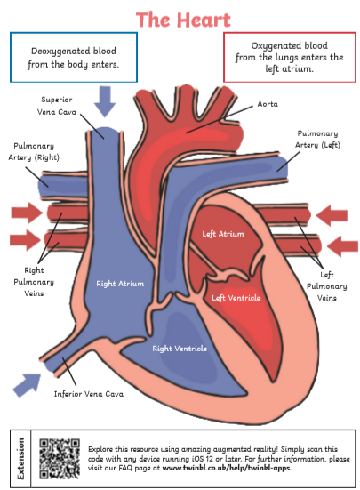

Art
I would like you to get out and observe the wonders of nature this week and have a go at producing some observational pencil drawings of plants and flowers in your garden. Try to use shading to add depth and different lines to show the textures of what you are drawing. Alternatively, you could produce a landscape drawing or painting of your garden.
History (Optional extra)
Continue your studies of the Maya Civilisation by looking at their writing system and write a secret message in Mayan symbols.
This week’s spelling lists:
Class 4 spelling list for group 3: Week 30
After completing ‘look, cover write, check,’ please try to write 5 interesting sentences in your spelling homework book. You can use more than one word from your spelling list in each sentence.
Objective: To recognise and spell the suffixes: -ible, -able.
Spellings | Look, cover, write, check
 | Monday | Tuesday | Wednesday | Thursday
sensible
terrible
visible
horrible
invisible
possible
credible
incredible
edible
reversible
flexible
responsible
impossible
indestructible
audible
invincible

Spelling score this week =

Class 4 spelling list for group 2: Week 30
After completing ‘look, cover write, check,’ please try to write 5 interesting sentences in your spelling homework book. You can use more than one word from your spelling list in each sentence.
Objective: Words beginning with sus- and al-
Spellings | Look, cover, write, check
 | Monday | Tuesday | Wednesday | Thursday
aloft
aloof
alive
alerted
alarmed
already
although
altogether
suspect
suspicion
suspicious
suspend
suspended
suspense
sustain

Spelling score this week =

Class 4 spelling list for group 1: Week 30
After completing ‘look, cover write, check,’ please try to write 5 interesting sentences in your spelling homework book. You can use more than one word from your spelling list in each sentence.
Objective: Words beginning with sus- and al-
Spellings | Look, cover, write, check
 | Monday | Tuesday | Wednesday | Thursday
aloft
aloof
suspicion
suspicious
suspiciousness
suspecting
suspension
suspense
sustained
susceptible
sustainable
alighted
alliteration
alarmingly

Spelling score this week =

Enjoy your week with your families, and don’t forget that I do not expect you to complete everything that I set; but try to do as much as you can to keep your learning going.
Mr. Smith

