What to do
Reading
IMPORTANT Parent or Carer –
Please check that you are happy with any weblinks or use of the internet.

Our focus today is reading.

1. Read a rhyming book.
Share and read together Dogs eat frogs. As they spot the rhyming pattern, give your child time to predict what the animals might eat, using the rhyme. This is tricky but fun.

2. Respond to the story.
- Discuss the book. Explore the question and answer pattern. Who is asking the questions? - The cat. Look back at the questions. Notice that the questions end with a question mark. Trace it with your fingers on the screen. Make a question mark in the air with your finger. How can we show questions with our voices?
- Ask your child to read some of the questions. You read the corresponding answer in the role of the different animals. What will happen when they question the wolf?!
- Discuss some of the answers. Is this a fact book? Are the answers true? Do bears really eat chairs? Agree that this is a funny book which uses rhyme to make up funny sentences (a bit like Oi Dog in the Speaking and Listening activity).
  - Say that the cat was very curious. What other questions could he have asked?
  - Talk about other animals that he could have asked a question about what they eat. Say the question sentences together using ‘question voices’.
  - Record some of the questions on Questions for Animals below. You can write for your child or you could write together. The focus is on thinking of questions rather than writing them. (You could ask all sorts of animal questions – follow your child’s interests.)

Try these Fun-Time Extras

- Find out what some animals really eat. Use books and websites, such as https://www.bbc.co.uk/bitesize/topics/z6882hv/articles/z96vb9q
- Play a rhyming matching game using the Funny Pairs cards below.
Questions for Animals

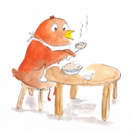
Funny Pairs
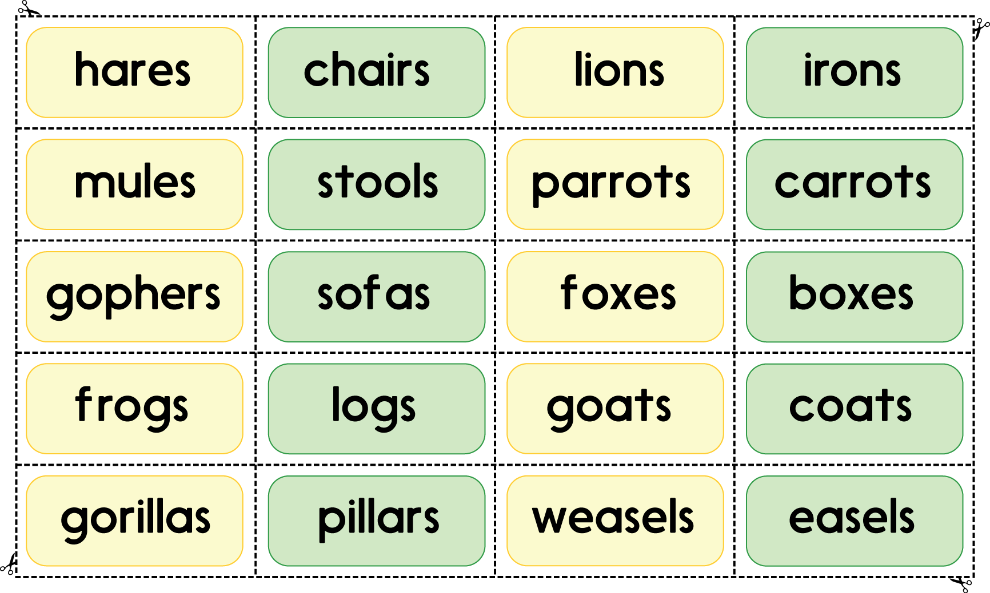

- Cut out each word.
- Read each word together. (Most can be sounded out but some you may need to read to your child.)
- Match pairs of rhyming words.

