What to do
Reading
IMPORTANT Parent or Carer –
Please check that you are happy with any weblinks or use of the internet.

Our focus today is reading.

1. Read a non-fiction book about dinosaurs
Look at the front cover of the Hamilton Group Reader Owls and Dinosaurs. Do you recognise any of the dinosaurs? Why are there owls? Read the book together. Why was the book called Owls and Dinosaurs?

2. Respond to the book
- Discuss the book. Who is talking at the beginning? Ben and Mummy Owl. Why does Mummy Owl say that birds are special? They are related to dinosaurs. Talk about what this might mean at the right level for your child.
- Look at the pages where different dinosaurs are shown and named. Read the names together (your child may know the names, but most cannot be sounded out) and the text below it. These pages are bit like Ben and Mummy are sharing an information book. Discuss which dinosaur in the book is your favourite and why.
  - Talk about what facts are in this book. What can we find out by reading this book (and any others you have shared)?
  - Choose a Dinosaur Facts page (see below) and write a key fact (or two) that you have learnt from your reading. It is fine to share the writing or write with your child dictating. You could choose a different dinosaur and create your own fact page.
  - You can also add labels for the dinosaurs, just like a non-fiction page in a book (horn, leg, teeth, plate, mouth, head, neck, claw, etc.)

Try these Fun-Time Extras
- Say the names of the dinosaurs you know, clapping out the syllables.
- Read the poem Dinosaur Den together and enjoy (see below).
- Read other dinosaur stories.
Dinosaur Facts
Spinosaurus

Dinosaur Facts
Stegosaurus

Dinosaur Facts
Tyrannosaurus Rex

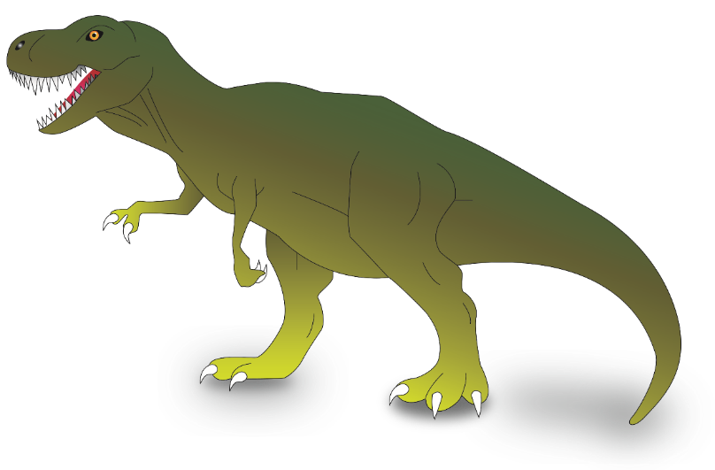

Dinosaur Facts
Triceratops

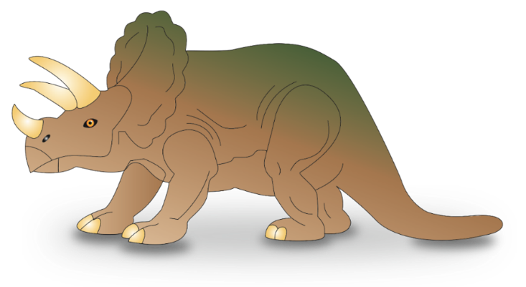

Dinosaur Den

Step inside the Dinosaur Den,
And as if by magic, become one of them.

The sleepy Stegosaurus snoring on the bus
Annoys the Allosaurus who starts to make a fuss.
The helpful Hadrosaurus, so gentle and so kind
Wakes the Stegosaurus and says, ‘Sorry do you mind?’

The bossy Brontosaurus tells them to be quiet
‘You’re far too noisy on the bus and we don’t want a riot.’
The dippy Diplodocus says, ‘I’ve missed my stop, I’m late.’
The driver says, ‘I’m sorry, but you’ll just have to wait.’

‘Sorry,’ says the driver, ‘it's more than my job’s worth,
To be seen with all you dinosaurs on prehistoric earth.’

By Adam Guillain

