What to do
Writing
IMPORTANT Parent or Carer –
Please check that you are happy with any weblinks or use of the internet.

Our focus today is writing.

1. Discuss ideas in a book.
Listen to or re-listen to enjoy Oi Frog, by Kes Gray and Jim Field (https://www.youtube.com/watch?v=oPDyXsSbxOY&t=88s). Discuss the questions: How is the cat deciding on the rules? Are they sensible? Are they true? etc.

2. Write new ideas for a rhyming book.
- Could we think of some new sentences for the book? They will need to rhyme. Talk about how words which rhyme end with the same sound.
- Then do either activity – the first gives more support and needs less writing.
  - Look at Oi! Finish the Sentence below. Read the beginning of each sentence. Talk about rhyming words which could end it. Encourage your child to use sounding out to write some of the words.
or
  - Look at Oi! Think of some Rhymes. Choose an animal together. Think of a word to rhyme with it. Try out the rhyming sentence by saying it aloud. Have fun with this. Some animals are hard to rhyme, and you may end up with nonsense words. Write some of your favourites together.

NB. Getting young children to write is not easy! See Guidance and handwriting groups below.

Try these Fun-Time Extras
- You could cut out the writing and use to make a book, putting each rhyming sentence on a new page and drawing funny pictures.

Oi! Finish the Sentence

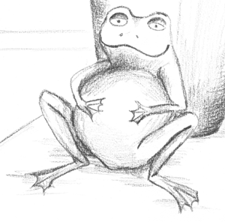Frogs sit on
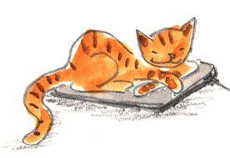Cats sit on
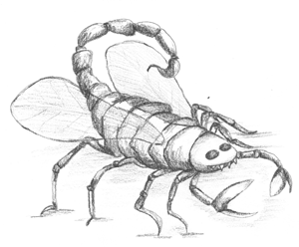 Bugs sit on
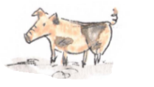 Pigs sit on
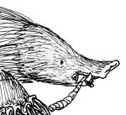Moles sit on
Bees sit on

Oi! Think of some Rhymes

sit on
sit on
sit on
sit on
sit on
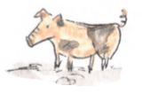
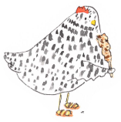
Guidance for writing – some dos and don’ts

- DO focus on letter formation. See sheet below. It’s really important that children get into the habit of writing letters correctly – this is not about how the finished letter looks, it’s all about how they write it – what direction they move the pencil or pen. Bad habits are almost impossible to break – if they form letters wrongly, the finished letter may look good BUT in the long run, they are much less likely to be able to write fluently.

- DON’T write a word or a line for them to copy. If they can’t remember how to write a letter, demonstrate, forming it correctly, so that they can imitate you.

- DO give loads of praise. Writing is so hard, and children get discouraged easily. It may be that they have just written one or two words, but if you praise them, it may be four words next time!

- DON’T do ‘dotty’ letters for them to trace. It is much better for children to form their own letters. We are teaching them to write not trace!

- DO write for them sometimes. It is important that young children can express their ideas in written form, and sometimes it is really good to write down what they say so that their ideas are expressed in writing on the page. Sometimes you can take turns to scribe. You write a bit, then they write a bit.

