What to do
Writing
IMPORTANT Parent or Carer –
Please check that you are happy with any weblinks or use of the internet.

Our focus today is writing.

1. Discuss a family story.
Share either Boris and Sid are bad! by Ruth Merttens or Five Minutes' Peace by Jill Murphy. Who are the characters? Where does the story happen? What goes wrong? Which bits are funny? Does it remind you of things that can happen in your family?

2. Write a funny story about your family.
- Talk about funny things that have happened or could happen. Discuss lots of ideas and get your child really enthused by the humour.
- Choose or create a story to write together. Talk about what happened at the beginning, middle and end. Draw a simple sketch for each part.
  - Build some sentences verbally. You are aiming for a sentence for each part of the story, e.g. Mum fell asleep in the armchair. The cat hopped on her lap. It made her jump and she spilled her tea.
  - Build one sentence at a time, saying it until you have a great sentence and then writing each word, sounding out the letters, together.
  - Write your story on Funny Family Stories below or make a story book by folding pages of plain paper and writing and drawing your story inside.

NB. Getting young children to write is not easy! See Guidance and handwriting groups below.

Try these Fun-Time Extras
- Write some tips for Boris and Sid to help them keep calm.
- Share funny stories from your own childhood.

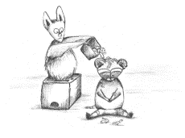
Funny Family Stories

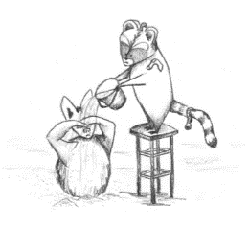

Guidance for writing – some dos and don’ts

- DO focus on letter formation. See sheet below. It’s really important that children get into the habit of writing letters correctly – this is not about how the finished letter looks, it’s all about how they write it – what direction they move the pencil or pen. Bad habits are almost impossible to break – if they form letters wrongly, the finished letter may look good BUT in the long run, they are much less likely to be able to write fluently.

- DON’T write a word or a line for them to copy. If they can’t remember how to write a letter, demonstrate, forming it correctly, so that they can imitate you.

- DO give loads of praise. Writing is so hard, and children get discouraged easily. It may be that they have just written one or two words, but if you praise them, it may be four words next time!

- DON’T do ‘dotty’ letters for them to trace. It is much better for children to form their own letters. We are teaching them to write not trace!

- DO write for them sometimes. It is important that young children can express their ideas in written form, and sometimes it is really good to write down what they say so that their ideas are expressed in writing on the page. Sometimes you can take turns to scribe. You write a bit, then they write a bit.

