CLASS 2 Home Learning for w/c 15.6.20

This last week some of us have been back in school and working on the same things that you have been doing at home. We have enjoyed working on fractions and creating our own magazines as well as finding out about the countries in the United Kingdom and even trying to find some of the different counties. I hope you are all well and keeping safe.
Mr Cash.

Maths
This week we are going to be thinking about time for year ones and money for the year twos as part of our measurement learning.
Notes:

Year 1: Pupils should be taught to:
- tell the time to the hour and half past the hour and draw the hands on a clock face to show these times
- remember that the big hand shows the minutes and the little hand shows the minutes

Year 2: Pupils should be taught to:
- Solve simple problems in a practical context involving addition and subtraction of money of the same unit, including giving change

Year 1:
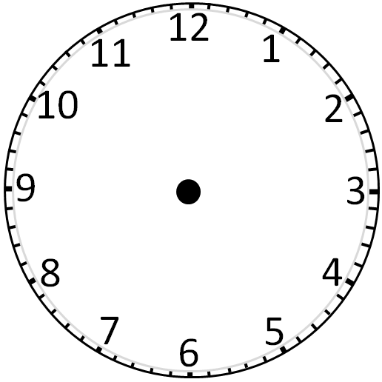
Activity 1: On this blank clock can you label where the big hand would point to show ‘o’clock’ and where the big hand would point to show half past? Can you colour each side of the clock in a different colour to show the minutes past zone and the minutes to zone?

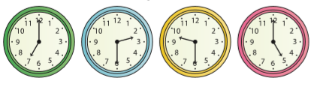
Activity 2: Draw lines (or draw your own clocks and write the matching times) to match the clocks to the correct times.

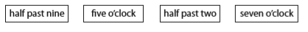

Activity 3: Sam leaves for school at 8 o’clock. Jay leaves half an hour later than Sam. Circle the clock which shows when Jay leaves for school.
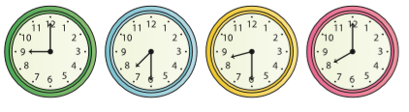
Explain your reasoning:

Circle the times which are shorter than 1 week:

1 year 1 day 1 minute 1 hour 1 month

Activity 4:
Draw nine o’clock on this clock face:  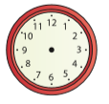 | Draw half past one on this clock face:  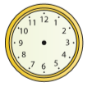

Extension:
Nadim walks to school every day. On Monday his journey takes 10 minutes. On Tuesday he walks more slowly. Does his journey take more or less time than on Monday?
Explain your answer.

On Wednesday it takes Nadim 8 minutes to walk to school. On which of the 3 days does he walk quickest? On which of the 3 days does he walk slowest?
Explain your reasoning.

Year 2:

Activity 1: Can you find one of each of all of the coins (or if not draw one of each and cut them out) and arrange them in order from the smallest value to the largest value – say out loud what each coin is worth.

Can you add together the value of all of the coins?

If you arrange the coins in order from smallest value to largest value again, can you work out the difference between each coin? For example the difference between 1p and 2p would be 1p

Activity 2:
- Holly uses a £1 coin to buy a pack of stickers. Here is the change she was given.
How much did the pack of stickers cost?

- Amy buys one pear for 35p. She pays with a 50p coin, how much change does Amy get?
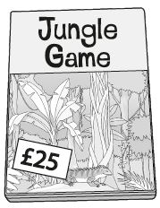
- Ben has £19

A game costs £25

How much more money does Ben need to buy the game?

Your go: Can you create some change or money problems of your own?

Activity 3:
Collect up these coins to help you.
How could you make up the same total amount using just one type of coin?

Using all of the different coins, how many different ways can you find to make 25p?

Activity 4:

Sid says, ‘I have bought 2 items for my holiday. One item cost £9 more than the other.’ What items might Sid have bought? The ______ and the ______ or the ______ and the ______ .

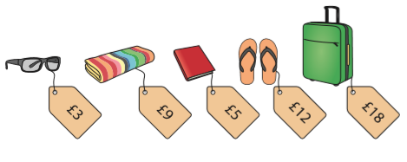

Make up your own problems using the holiday items.

Extension:

Sam says I can make 97p using just four coins. Is he correct?
Explain your reasoning.

English
Reading: Can you share a story with a parent or a sibling each day this week? It is wonderful to read out loud and you can really use your voice to bring the words to life.
To listen to a story you can access hundreds of books FOR FREE on Audible here: https://stories.audible.com/start-listen

Reading comprehension: During the story reading or listening above, use questions starting with ‘who, what, where, when, how and why’ to allow them to explain what they are reading or listening to. I like to get them to describe what they can see in their heads at various point using ‘I wonder what that would look like…?’. There are also some really good reading and phonics games on the Oxford Owl website.

Writing: The children in school have really enjoyed being journalist and editor of their magazines over last week – there have been some very creative pages written included fact sheets, quiz pages, word searches and cartoon strips about the theme of the magazine. If you want to, you can carry on with your magazine this week until you have finished.
If you have finished then this week I would like us to go back to our creative writing. I have included two pictures below for you to have a look at – you could come up with your own ideas from what you can see or you can use the thinking ideas that are next to each picture – up to you.
Be creative, remember to use your describing words to paint a picture in the reader’s mind.
ROCKET SCIENCE  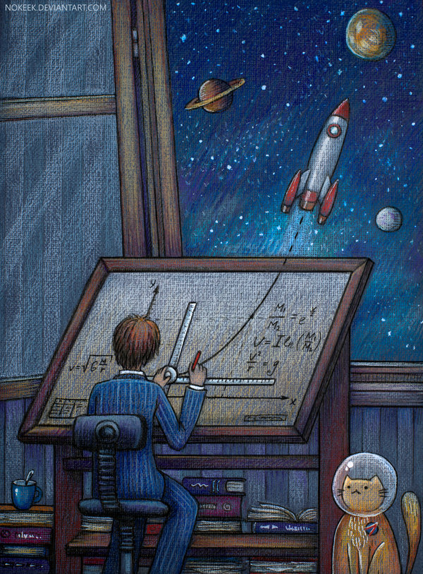 | Use these questions to help you:  - What is the boy doing?  - Describe the boy’s personality. What do we know about him?  - Why is the cat wearing a helmet and a badge? What does the badge mean?  - Write about their adventures. Will they make it into space? Where will they go? What will they find?  - Research famous astronauts. Find out about their childhoods and what inspired them to become astronauts.  - Link to the book ‘The Darkest Dark’ by Chris Hadfield  A story starter you could continue:  ‘Young Chris is an astronaut. A very busy astronaut. Saving the planet from aliens is much more important than taking baths or going to bed. Because at bedtime the worst sort of alien appears – darkness. But when Chris watches the first televised moon landing, he discovers that there is a dark out in Space that is much darker than he’s used to. It’s the darkest dark ever, and he realises that the unknown can be . . . exciting!’

SAID THE STARS | Use these questions to help you:  “Look up,” said the stars, “and all your dreams will reveal themselves.”  This image and sentence could be used as a standalone prompt – let children lead a discussion, generate their own questions, or write freely and creatively.  - What can you see?  - What makes this image so beautiful?  - Who is the person?  - Why are they holding a bike? Where have they come from? Where are they going? Why aren’t they riding the bike? Why have they stopped?  - Why is the person looking up?  - Are the stars speaking?  - What are the person’s dreams? How will they reveal themselves?  Broader questions:  - If the stars could speak, what sort of things do you think they might say? Would they tell stories, give advice/warnings, ask questions?  - What are dreams?  - Do you have any dreams?  - How is a dream similar/different to a goal or a wish?  - Can you do anything to help yourself to achieve your dreams?  Science link: stars, space, earth & rotation, night & day, aurora borealis

SPAG: I have added the Year 1 and 2 High frequency and tricky word lists to the Class 2 page as I am aware that some children have completed the spellings that they have in their books. You can choose a selection of words from either or both of these lists and use them as an alternative. Once you have chosen the words to focus on, spend some time making sure children can sound out each word (stretching it out so you can hear each sound within the word), and that they know what each word means. Can they say it in a sentence? Can they write it in a sentence? Can they write the word in a tray of rice or sand? Can they write it in each colour of the rainbow?
There are some excellent spelling and grammar games on the brilliant Topmarks website suitable for year 1 and 2 https://www.topmarks.co.uk/english-games/5-7-years/words-and-spelling

Phonics (Year 1): If you want to be able to practice phonics then there is a fantastic resource on YouTube being introduced from 27/4 focussing on learning for the summer term with daily lessons being added. You can find the channel called ‘Letters and Sounds for Home and School’ in association with the DfE here https://www.youtube.com/channel/UCP_FbjYUP_UtldV2K_-niWw/featured?disable_polymer=1.

Competition Time:
The Friends of Slingsby School (FOSS) have come up with some exciting challenges for you to have a go at – the ‘Decorate a Duck’ and ‘Family Challenge’. The details are the end of this weeks home-learning (below) and all the forms are attached for you to have a go – there are some excellent prizes and it will help to raise funds for the school in the absence of the events that are usually run at this time of year. Have a go!

Science:
Can you have a look at Activity 1 of the attached ‘The Magic of Light’ pack about light sources? Answer the questions remembering that a light source, natural or artificial, is something that makes light.

If you finish that activity then you can explore some of the other activities linked to light – there are some excellent experiments.

DT/Art:
I hope you enjoyed designing new meal ideas for the International Space Station! I would love to find out what you came up with.

This week if you have some paper plates (or some cardboard to cut out) can you have a go at creating an alien invasion? Use the plates to make the alien spacecrafts and then create your own alien characters to fly on them. Maybe you could put a few of them together to create a scene similar to the one below.

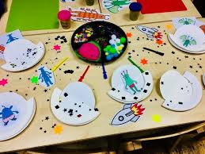

Geography:
Can you create a fact card about one of the planets of the solar system? Make it colourful, think about a title, sub-titles, pictures, fact boxes, questions and things that catch the readers’ eye. You could include things like – the planets size, what the weather is like, the number of moons it has, distance away from the sun etc etc.

As an extra activity, you could have a go at designing your own planet. Think about the colour of the planet, the size, number of moons, who lives there (be creative), what the surface of the planet looks like or is made out of. Have fun with it!

PSCHE: Summer is coming!! Can you create a ‘Little Rays of Sunshine’ poster and write all over it what summer means to you? Write all of the things that you are looking forward to doing or places you are looking forward to going on your poster. Write all of your favourite summer things on it (after the lockdown that we have had I am sure there will be plenty of things that you are wanting to do that you haven’t been able to do recently).
Make it bright and bold and put it up somewhere in your house to remind you of all the wonderful things you like to do and places you like to go.

Other Activities
  - Keep up with your PE by joining Joe Wicks LIVE every weekday morning from 9am for ½ an hour (or you can catch up anytime through his YouTube channel) – We have been loving doing this in class this week https://www.youtube.com/playlist?list=PLyCLoPd4VxBvQafyve889qVcPxYEjdSTl
  - Check out the 100 things to do at home ideas from the Scouts - some useful ideas.
  - Keep adding to your nature diary – add sketches and information boxes to really bring it to life if you haven’t already.
  - Take a tour of a coral reef – and you don’t even need to get wet! https://www.youtube.com/watch?v=J2BKd5e15Jc
What animals did you see? What have you learned that you didn’t know before? Why are coral reefs important habitats?
  - Can you learn to say goodbye in 5 different languages?

FOSS
As many of you know, FOSS have had to cancel two of our biggest school fundraisers this year which has left a huge gap in the amount we historically donate at the end of the academic year. So, we have put our thinking caps on and have come up with, not one but two virtual fundraisers we hope you will enjoy and support to raise some much-needed funds. Details of each competition are in the attached leaflets detailing how to enter and donate money to the Friends of Slingsby School Just Giving page. We know it is a very challenging time for each and every family and hope that each fundraiser offers your children the opportunity to have some fun whilst learning at home. The closing date for both events is Sunday 12th July with the winner of each to be announced in school's final newsletter on Thursday 16th July.

