CLASS 2 Home Learning for w/c 1.6.20

I hope that everyone had a fantastic half-term. We were very blessed with some beautiful weather for the week and it was so nice to get out and about with the dogs a bit more. I think life feels like it is starting to change back to something more like normal and I know that I am ready for that. Mr Cash.

Maths
This week I would like us to think about Geometry.

Notes:
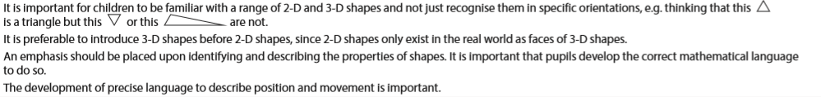
Year 1:
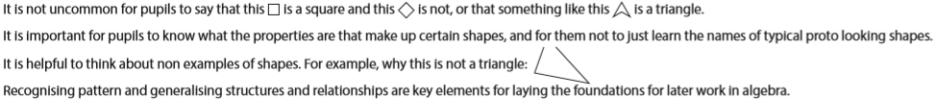
Year 2:
- When we covered shape in school earlier in the year I was very impressed with your knowledge of shape names and confidence in describing properties – especially symmetry.
- What shapes are there in your house and garden? Could you do a shape survey to see how many of each shape you can find? Maybe you could use a tally chart and create a bar chart of the results to show the most frequent shape. Which shape did you find the most of? Why do you think that is?

- Can you sort a range of 3D objects into groups?

Explain how you have sorted them using mathematical names for the shapes.

- Cut a square piece of paper as shown in the picture below. Rearrange the pieces to make as many different shapes as you can. What different shapes can you make?
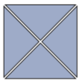
Describe the properties of the shapes you make using edges, corners and line of symmetry.
Can you make some shapes that have at least one line of symmetry?

Extension: Always, sometimes, never.
Is it always, sometimes or never true that when you fold a square in half you get a rectangle?
English
Reading: Can you share a story with a parent or a sibling each day this week? It is wonderful to read out loud and you can really use your voice to bring the words to life.
To listen to a story you can access hundreds of books FOR FREE on Audible here: https://stories.audible.com/start-listen

Reading comprehension: During the story reading or listening above, use questions starting with ‘who, what, where, when, how and why’ to allow them to explain what they are reading or listening to. I like to get them to describe what they can see in their heads at various point using ‘I wonder what that would look like…?’. There are also some really good reading and phonics games on the Oxford Owl website.

Writing: This week I would love us to have a go at writing a news report. I have had a couple of instances this last week of a sneaky squirrel getting greedy on my bird table and it made me think about a news report to let people know about his antics.

There has been lots of different things happening in the news recently that you could write your report about including the Space X mission to the International Space Station. Maybe you have a mischievous visitor to your garden that you could write about, maybe it could be something that a brother or sister or mum or dad has got up to, maybe you could write a news report about something to do with one of your toys.

I have attached my news report as an example of what yours could look like. You need to include a headline that clearly describes the story to the reader (you can use alliteration to make it even more catchy). Use an introduction to set the scene and the rest of the report to explain the details. You could use quotations to add more information (writing down what somebody said using speech marks “ ” . For example “Put a quotation in to add more information” Mr Cash said.). A picture helps to bring the story to life too, but include a caption to describe what is happening in the picture.

You could create a ‘Wanted’ poster to go with your news report – use it to make it clear what has happened and who was responsible!

SPAG: I have added the Year 1 and 2 High frequency and tricky word lists to the Class 2 page as I am aware that some children have completed the spellings that they have in their books. You can choose a selection of words from either or both of these lists and use them as an alternative. Once you have chosen the words to focus on, spend some time making sure children can sound out each word (stretching it out so you can hear each sound within the word), and that they know what each word means. Can they say it in a sentence? Can they write it in a sentence? Can they write the word in a tray of rice or sand? Can they write it in each colour of the rainbow?
There are some excellent spelling and grammar games on the brilliant Topmarks website suitable for year 1 and 2 https://www.topmarks.co.uk/english-games/5-7-years/words-and-spelling

Phonics (Year 1): If you want to be able to practice phonics then there is a fantastic resource on YouTube being introduced from 27/4 focussing on learning for the summer term with daily lessons being added. You can find the channel called ‘Letters and Sounds for Home and School’ in association with the DfE here https://www.youtube.com/channel/UCP_FbjYUP_UtldV2K_-niWw/featured?disable_polymer=1.

History:
Space X launched a very special rocket into space this weekend. There have been lots of changes to rockets I my living memory. I wonder if you could find out how rockets have changed since the first adventures in to space. Maybe you could create a picture timeline to show the changes.

Science:
Could plants grow in space? Why or why not?

Could you design your own type of plant the could grow in space? What would it look like? (draw me a picture) What would it need to survive? What would grow on your plant?

DT/Art: Imagine that you are on the International Space Station (ISS). If you looked out of the window, what would you see? Could you create a chalk or pastel ‘space window’ picture?

Maybe you have to go outside the space station or even land on the moon – could you design and create the equipment you might need. Would you need a special backpack or even a moon buggy!?

Languages: I hope that you enjoyed finding out the French for food names and creating a menu.

I wonder if you could try to find out some French words based on our theme. Can you find the French names for the planets? Could you find the French for ‘moon’, ‘star’ and ‘galaxy’? What other space theme words can you find the French for?

PSCHE: This weekend new astronauts will have arrived at the ISS.
What do you think it takes to be a good team mate, someone able to work well with others?
Could you draw a picture of a person in the middle of a page and write all the things that you would need to be a good team mate around the outside?

Other Activities
  - Keep up with your PE by joining Joe Wicks LIVE every weekday morning from 9am for ½ an hour (or you can catch up anytime through his YouTube channel) https://www.youtube.com/playlist?list=PLyCLoPd4VxBvQafyve889qVcPxYEjdSTl
  - Check out the 100 things to do at home ideas from the Scouts - some useful ideas.
  - Keep adding to your nature diary – add sketches and information boxes to really bring it to life if you haven’t already.
  - DO SOMETHING KIND FOR SOMEONE – Can you pay them a compliment, make them something or help them with a task?

