CLASS 2 Home Learning for w/c 22.6.20

I hope that everyone has had a busy and productive week. We have had a busy week in school (especially doing our daily Joe Wicks PE sessions!!) creating some stories from the space pictures and going on to create some instructions. We have enjoyed learning about time in maths and have been busy getting creative in the afternoons and learning about light in science. We have also watched Mr Mortimer’s Assembly and been practising our greetings and goodbyes in French.
Mr Cash.

Maths
This week we are going to be thinking about statistics, which is all to do with collecting information and then showing it in different ways.
Notes:

Pupils should be taught to:
- Interpret and construct simple pictograms, tally charts, block diagrams and simple tables ask and
- Answer simple questions by counting the number of objects in each category and sorting the categories by quantity
The Big Ideas:
  - Data need to be collected with a question or purpose in mind.
  - Tally charts are used to collect data over time (cars passing the school, birds on the bird table).

Activity 1:
A brilliant way to record information quickly and in an organised way that is easy to count is in tally groups. Remember that when you are recording tally points, they are written in groups of 5 so that they are easier to count when you have finished – like in this example tally table:
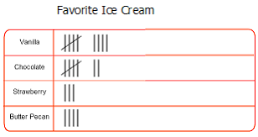

Your Turn:
Count the coloured dots. Draw a tally chart to show how many dots there are of each colour.
Using your tally chart, answer the following questions. Which colour is there the most of? Which colour is there the least of? How many green dots are there?

Activity 2:
Can you complete this tally chart to record how many star jumps each of the members of your family can do in 20 seconds? Add up the tally marks in groups of 5 and put that in the total number column.
Name | Tally | Total number

To make the results of your data collection clearer we can show them in a bar chart – this is quite a tricky thing to draw but I know that you have had a go before and did a brilliant job – I believe in you!
Below are the results from my family – use your tally information to create a bar chart of your own. Don’t forget to give it a title and label the axis to explain what information is being shown.

Activity 3:
Follow this link to an Nrich problem called ‘Ladybird Count’ https://nrich.maths.org/2341 – use the information on the page to make a graph or pictogram to show how many ladybirds each child had.

Activity 4:
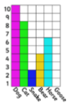
An important part of statistics is being able to interpret the information presented (looking at what a chart is showing you and being able to work out questions). Looking at the bar chart to the right can you answer these 3 questions?
- How many people liked dogs the most?
- Which was the least favourite animal?
- How many cats and dogs are there all together?

Henry is making the bar chart below using cubes. He says ‘The higher the tower of cubes, the more common the type of transport.’
Do you agree? Explain your answer.
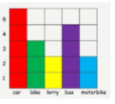

Extension:
Which letter is used most in our names?

Conduct a survey of your family to find out which letter appears most in your first names. Work out how to collect the data and then present it in a graph.
Answer the questions below:
- Which letter appears the most?
- Which letter appears the least?
- How many times does the letter ‘a’ appear?

English
This week I want to focus all of the areas of English on the picture below:

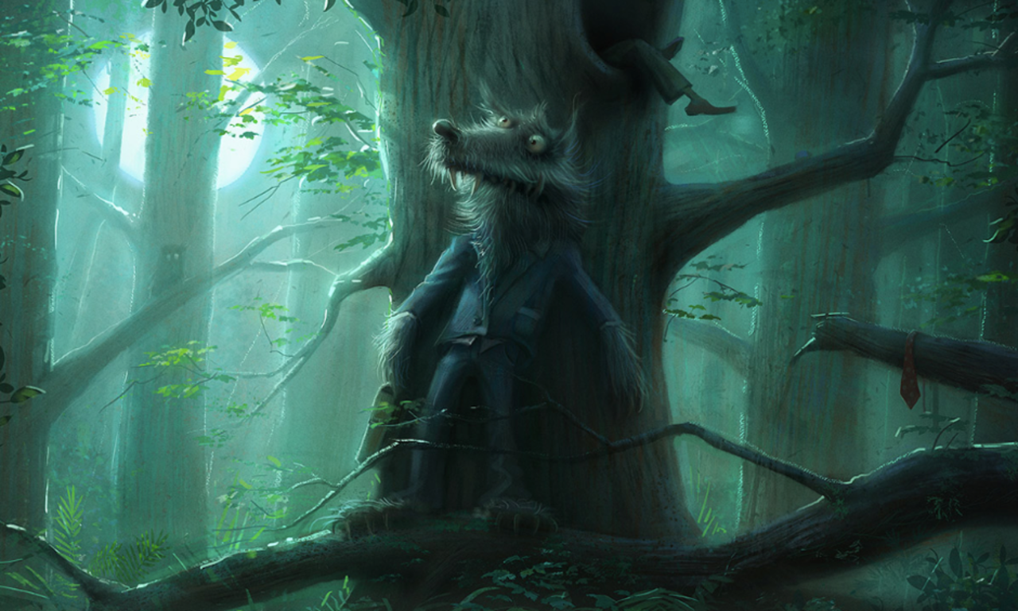

Reading comprehension:

- Where is the person trying to escape Mr. Wolf?

- Who is he/she and why are they being chased?

- What kind of character do you think Mr. Wolf is?

- How do you think Mr. Wolf found the person?

- Why is he dressed in a suit?

- What is it like inside the tree? How is the person feeling?

- If you were inside the tree, how would you escape?

Writing:

‘In the deepest, darkest depths of the forest, Mr. Wolf waited.

His disguise hadn’t worked, but that didn’t concern him. Now, the boy thought he was safe. Mr. Wolf didn’t think he was. Mr. Wolf knew exactly where he was. He could sense him. He could smell him. He could almost taste him…’

Can you continue the story about the wolf?

SPAG: A noun is an object, place or person (for example ‘Mr Wolf’). An adjective is a word that is used to describe a noun (for example ‘mean’ Mr Wolf). A verb is an action word that is used to describe or indicate an action (for example Mr Wolf ‘ran’). An adverb is a word that describes a verb (for example Mr Wolf waited ‘silently’).

These sentences are ‘sick’ and need help to get better. Can you use nouns, adjectives, verbs and adverbs to help them?

- The wolf has eyes and teeth.

- Mr Wolf had fur and wore a suit.

- The owl sat on the branch.

Other

There are some excellent spelling and grammar games on the brilliant Topmarks website suitable for year 1 and 2 https://www.topmarks.co.uk/english-games/5-7-years/words-and-spelling

Phonics (Year 1): If you want to be able to practice phonics then there is a fantastic resource on YouTube being introduced from 27/4 focussing on learning for the summer term with daily lessons being added. You can find the channel called ‘Letters and Sounds for Home and School’ in association with the DfE here https://www.youtube.com/channel/UCP_FbjYUP_UtldV2K_-niWw/featured?disable_polymer=1.

Reading: Can you share a story with a parent or a sibling each day this week? It is wonderful to read out loud and you can really use your voice to bring the words to life.
To listen to a story you can access hundreds of books FOR FREE on Audible here: https://stories.audible.com/start-listen

Competition Time:
The Friends of Slingsby School (FOSS) continue to need your help and have come up with some exciting challenges for you to have a go at – the ‘Decorate a Duck’ and ‘Family Challenge’. The details are at the end of this weeks home-learning (below) and all the forms are attached for you to have a go – there are some excellent prizes and it will help to raise funds for the school in the absence of the events that are usually run at this time of year. Have a go!

Science:
If you haven’t already, can you have a go at the colour wheel activity in the attached ‘The Magic of Light’ pack? TOP TIP – Make sure you colour in the sections really well – it will work better if you have no white showing.

We have tried it in class and it worked really well for exploring how different colours mix to make other colours.

If you have already had a go at this activity then maybe you could try making some different wheels with different colour combination – maybe try blue and yellow, or yellow and red – experiment and see what happens.

I wonder what happens if you mix all the colous of the rainbow in a colour wheel and spin it?!

Geography:
With the passing of the summer solstice this weekend, I would like you to find out what the summer solstice is and how it happens. You could also try to find out about why some people celebrate it.

There are is a useful video here https://www.youtube.com/watch?v=SVzkVsWQBR8 and some information on this page https://mocomi.com/summer-solstice/

How will you show your learning? A poster. A fact sheet. A video news report. You decide.

DT/Art:
Bring the summer solstice to life by creating your own sunshine art.

You could have a go at creating a Waldorf inspired sun catcher like this one:  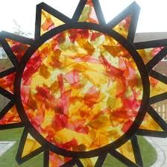 | Or, you could have a go at weaving your own sun like this one:  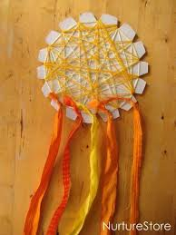

Whatever you decide, make it bright and colourful to celebrate the brightness and happiness of the season.

PSCHE:
Have a watch of Mr Mortimer’s assembly on courage here https://www.youtube.com/watch?v=0n236sCVC5U&feature=youtu.be

Can you describe a time when you have had to show courage? What is the difference between courage and being ‘brave’?

Can you create your own courage jar? What sort of things, that you need courage for, would you need to put inside?

Other Activities
  - Joe Wicks is only going to be live on Monday, Wednesday and Saturday this week. You can still access all the old PE sessions though so no excuse for not getting some daily movement in your life!
https://www.youtube.com/playlist?list=PLyCLoPd4VxBvQafyve889qVcPxYEjdSTl
  - Check out the 100 things to do at home ideas from the Scouts - some useful ideas.
  - Keep adding to your nature diary – add sketches and information boxes to really bring it to life if you haven’t already.
  - Take a virtual tour of a museum – there are loads that you can explore and a few are listed on this website as ideas for parents and carers https://www.goodtoknow.co.uk/family/best-virtual-tours-for-kids-536089
One of my favourite is the Natural History Museum’s virtual tour of the life of a blue whale – have a look here https://www.nhm.ac.uk/bluewhale/
  - I hope you have remembered the French days of the week! We have been practising them in class this last week at the end of every day.
This week can you have a go at learning the 12 months of the year – I know, 12 words is a lot – but you are up to it!!

FOSS
As many of you know, FOSS have had to cancel two of our biggest school fundraisers this year which has left a huge gap in the amount we historically donate at the end of the academic year. So, we have put our thinking caps on and have come up with, not one but two virtual fundraisers we hope you will enjoy and support to raise some much-needed funds. Details of each competition are in the attached leaflets detailing how to enter and donate money to the Friends of Slingsby School Just Giving page. We know it is a very challenging time for each and every family and hope that each fundraiser offers your children the opportunity to have some fun whilst learning at home. The closing date for both events is Sunday 12th July with the winner of each to be announced in school's final newsletter on Thursday 16th July.

