CLASS 2 Home Learning for w/c 29.6.20

I hope that everyone enjoyed the beautiful weather that we had last week – so hot!! In class we really enjoyed our writing based around the ‘Mr Wolf’ picture. We have written some excellent stories, have become sentence doctors to help make sick sentences better and have created a ‘Wanted Poster’ to tell the world about some of the crimes we created for Mr Wolf. We have been collecting data and creating bar graphs in maths, being creative with sun-themed art to celebrate the summer solstice and in science have continued exploring colour. Very busy and I hope you have been too with your choices. Don’t forget the FOSS competition entries!
Mr Cash.

Maths
This week we are going to be thinking about our practical problem-solving skills and reasoning.
Notes:

‘The national curriculum for mathematics aims to ensure that all pupils:
‘Can solve problems by applying their mathematics to a variety of routine and non-routine problems with increasing sophistication, including breaking down problems into a series of simpler steps and persevering in seeking solutions.’

Activity 1:
If you get chance I would like you to have a go at this outside problem:
Find 4 sticks and arrange them in a pattern like this:
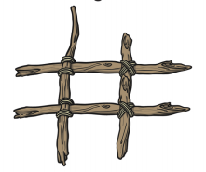
Collect some natural objects to use. Put different amounts of objects in each row and column. Can you make each row and column add up to 10? Challenge yourself and make the amount in each square different?
Extension: make the row/column total add up to 20 (or a total of your choice).

Activity 2:
Another outdoor activity revisiting our statistics learning from last week (or can be adapted to indoor if the weather is not playing!!).
Collect a variety of different natural objects. Using chalk, if you have some (or use a pencil and paper), make a tally chart using the objects that you have found.
Which object did you find the most of? Which object was the hardest to find? Could you show your findings in a different way?

For the next 2 activities, the following is a good approach to follow.
Simply 'having a go' is a great way to make a start on a mathematical problem. Whatever happens, you will have learnt more about the situation and can then tweak your approach. This is known as the 'trial and improvement' way of working.

Activity 3: Eggs in Baskets
There are three baskets, a brown one, a red one and a pink one, holding a total of ten eggs.
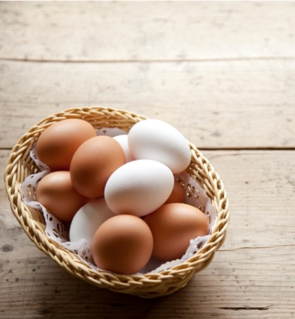
The Brown basket has one more egg in it than the Red basket.

The Red basket has three fewer eggs than the Pink basket.

How many eggs are in each basket?

Tip: You could start by imagining that the brown basket has one egg in it. How many would be in the red and pink baskets?
Try other numbers of eggs in the brown basket.
You might find it helpful to draw pictures or jot some things down on paper.

Activity 4: Four Colours
Kate has eight multilink cubes. She has two red ones, two yellow, two green and two blue.

She wants to fit them together to make a cube so that each colour shows on each face just once.
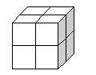

Is it possible?
If so, how?
When you've found a way, is there another way?

If you want more of a challenge, have a look at this problem:
Nine Colours

Extension: 4 Dom
Use these four dominoes to make a square that has the same number of dots on each side. (it would be useful to use actual dominoes if you have any – or if not, you could print and cut out these – it helps with the trial and improvement)
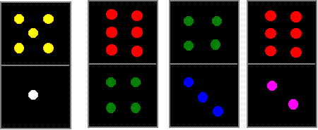

I would love to see pictures of your completed square and also tell me what you did to try and solve the challenge.

Mental Maths:

Don’t forget to be practising your mental maths skills!!

Use the games such as Hit the Button at https://www.topmarks.co.uk/maths-games/hit-the-button to practise your number bonds, times tables and doubles/halves etc.

If you have digit cards or dice you can choose two cards or roll your 2 dice. Then quickly add them together, work out the number bond to 20 as quickly as you can or multiply the numbers together.

Ask a parent or carer to write a number sentence for each of the four operations + - x and ÷ and have a go at solving them – don’t forget to use the practical resources if it helps.

English
I really hope you enjoyed working from the Mr Wolf picture last week – we certainly did in our bubble.

Reading: Can you share a story with a parent or a sibling each day this week? It is wonderful to read out loud and you can really use your voice to bring the words to life.
To listen to a story you can access hundreds of books FOR FREE on Audible here: https://stories.audible.com/start-listen

Reading comprehension: During the story reading or listening above, use questions starting with ‘who, what, where, when, how and why’ to allow them to explain what they are reading or listening to. I like to get them to describe what they can see in their heads at various point using ‘I wonder what that would look like…?’. There are also some really good reading and phonics games on the Oxford Owl website.

Writing: Summer Poetry

You could use the words from your ‘Little Rays of Sunshine’ poster (if you did one) to help you with this.

I would love you to continue thinking about the joys of summer and create a piece of poetry to celebrate. The style of your poem is up to you. You could have a go at an acrostic (where each line starts with the first letter of a word of your choice, such as ‘Summer’) or it could use rhyming pairs to form 4-line verses, or a nonsense poem, or a style of your choice.

Tools of the trade: -
• Rhyme and rhyming couplets - Words that have the same ending rhyme. If a line of your poem rhymes with the next one it is a couplet.
Tip: Not all poems have to rhyme.

• Powerful verbs and strong adjectives - Use powerful doing/ being words (verbs). Example: strode, staggered and fluttered. Use strong adjectives. Example: glistened, shimmered and

• Similes - A simile says things are like each other. Example: “As big as…”, “Red like the sun.” “as quiet as a mouse.”.

• Alliteration - Alliteration repeats the same sound and usually start with the same letter. Example: “The tremendous tiger” or “Several squirrels scampered sharply”.

• Onomatopoeia - When a words sounds a bit like the noise they are describing then it is an onomatopoeia. Example: “screech”, “smash”, “crunch”.

• Use senses - You can add to your poem by powerfully describing your senses. Example: “I felt the bitter winter frost sting my tomato red cheek”.

• Use other poetic devices - You can use metaphors (saying something is something else) and personification (giving something a human feature).

• Have fun - be creative and enjoy it!

SPAG: This week I would like you to have a go at using adjectives to describe nouns.

Remember: A noun is an object, place or person (for example ‘Mr Wolf’). An adjective is a word that is used to describe a noun (for example ‘mean’ Mr Wolf). A verb is an action word that is used to describe or indicate an action (for example Mr Wolf ‘ran’). An adverb is a word that describes a verb (for example Mr Wolf waited ‘silently’).

Expand the Noun Phrases
Are you ready for some acting? Read the sentences below to a family member, but put two adjectives in the gap which describe the noun. Can you read it with actions? Here is an example:

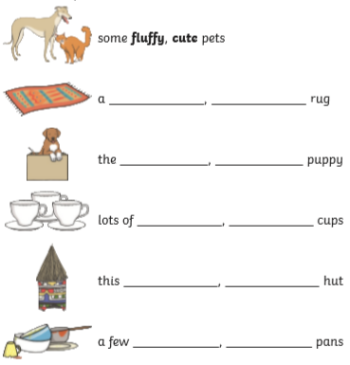

Challenge: Can you sound out your adjectives and write them in the gaps?

Expand the Noun Phrases 2
Use scissors to cut up these simple noun phrases – or write them out - and expand them using adjectives. Can you use two adjectives, separated by a comma, to describe each noun in the sentence?

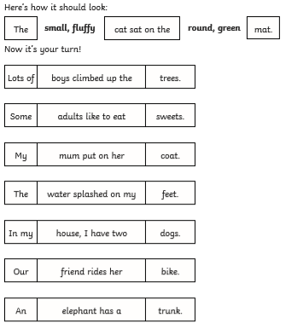

Challenge: Can you rewrite one of your sentences using a conjunction to add extra detail?
Other

There are some excellent spelling and grammar games on the brilliant Topmarks website suitable for year 1 and 2 https://www.topmarks.co.uk/english-games/5-7-years/words-and-spelling

Phonics (Year 1): If you want to be able to practice phonics then there is a fantastic resource on YouTube being introduced from 27/4 focussing on learning for the summer term with daily lessons being added. You can find the channel called ‘Letters and Sounds for Home and School’ in association with the DfE here https://www.youtube.com/channel/UCP_FbjYUP_UtldV2K_-niWw/featured?disable_polymer=1.

Reading: Can you share a story with a parent or a sibling each day this week? It is wonderful to read out loud and you can really use your voice to bring the words to life.
To listen to a story you can access hundreds of books FOR FREE on Audible here: https://stories.audible.com/start-listen

Competition Time:
The Friends of Slingsby School (FOSS) continue to need your help and have come up with some exciting challenges for you to have a go at – the ‘Decorate a Duck’ and ‘Family Challenge’. The details are at the end of this weeks home-learning (below) and all the forms are attached for you to have a go – there are some excellent prizes and it will help to raise funds for the school in the absence of the events that are usually run at this time of year. Have a go!

DT/Art:
In class this week we have had a go at creating sunshine pendants using clay – we are going to be painting them next week.

Could you have a go at creating your own sunshine pendant using clay, plasticine or playdough?

The ideas below might help you get started.

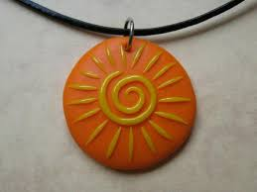 | 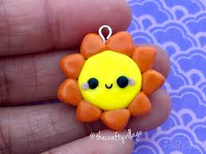 | 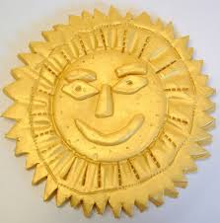

Science:
This is an activity that we have done in class before, but while we have been thinking about colour recently I thought it would be a nice one to revisit at home. Try the alternative methods and compare what happens.

COLOURFUL SKITTLES EXPERIMENT

This skittles experiment is easy, low cost and provides lots of investigative opportunities. Try using different temperatures of water, white vinegar or even lemonade to discover what happens.

WHAT YOU NEED:
A plate or container – preferably white
Skittles, other coated sweets work too
Water

INSTRUCTIONS
Place your skittles or sweets into a white container, try to alternate the colours.

Carefully pour water into the container, if the skittles move, just push them back into place quickly.

Watch what happens..

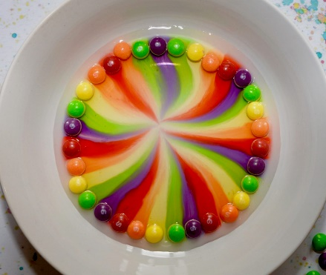

WHY DO THE COLOURS SPREAD?
Skittles are coated in food colouring and sugar. When you pour water over the skittles the coloured coating dissolves spreading through the water.

The colour and sugar dissolve into the water and then diffuse through the water, making it the colour of the skittle.

EXTENSION IDEAS
Can you time how long the colours take to reach the centre of the plate using cold and warm water? Which do you think will be faster?

Try using other sweets (Smarties might be a good alternative?), can you find any that work as well as skittles?

QUESTIONS TO ASK AND THINK ABOUT:

Why do you think the colours don’t mix?

Can you spot the ‘S’ from the skittles? What happens to it?

How could you speed up the reaction?

Music:
This week in school our bubble is going to be learning the song Mr Mortimer used in his singing assembly Youtube video. Explore the layers of the song ‘Bring the noise’ and learn the words to sing along at home too.

You can have a go too by using the brilliant resources on BBC Play It!
Get started with Play It! using the link below and explore the different elements that make up a song, play or clap along with the music and make then listen back to your own version of songs.

https://www.bbc.co.uk/games/embed/bring-the-noise?exitGameUrl=http%3A%2F%2Fbbc.co.uk%2Fteach%2Fbring-the-noise%2Feyfs-ks1-music-play-it-bring-the-noise%2Fz4sq92p

PSCHE:
Can you create a certificate or rosette for someone special in your life?

- Why are they special to you?
- What is it that they do for you?

Make it bright and special and maybe present it to the person next time you see them.

Other Activities
  - Joe Wicks is only going to be live on Monday, Wednesday and Saturday this week. You can still access all the old PE sessions though so no excuse for not getting some daily movement in your life!
https://www.youtube.com/playlist?list=PLyCLoPd4VxBvQafyve889qVcPxYEjdSTl
  - Check out the 100 things to do at home ideas from the Scouts - some useful ideas.
  - Keep adding to your nature diary – add sketches and information boxes to really bring it to life if you haven’t already.
  - Blue Peter have started their ‘6 Badges of summer’, every week there will be a different theme to the badges ranging from sport, to helping save the environment, music, thank you as well as a final silver badge. You can download a wall chart to keep track of how you're doing and you can even apply for the badges themselves. There is definitely something for everyone so have a look and get stuck in! - https://www.bbc.co.uk/cbbc/joinin/six-badges-of-summer

FOSS
As many of you know, FOSS have had to cancel two of our biggest school fundraisers this year which has left a huge gap in the amount we historically donate at the end of the academic year. So, we have put our thinking caps on and have come up with, not one but two virtual fundraisers we hope you will enjoy and support to raise some much-needed funds. Details of each competition are in the attached leaflets detailing how to enter and donate money to the Friends of Slingsby School Just Giving page. We know it is a very challenging time for each and every family and hope that each fundraiser offers your children the opportunity to have some fun whilst learning at home. The closing date for both events is Sunday 12th July with the winner of each to be announced in school's final newsletter on Thursday 16th July.

