CLASS 2 Home Learning for w/c 8.6.20

I am looking forward to seeing some of you back in school this week, although it will definitely feel different to normal because of the new rules that we have to follow to keep each other safe. I have been impressed with some of the learning I have seen from a few of you and it is nice to hear that you are enjoying your home learning.
Mr Cash.

Maths
This week we are going to be thinking about fantastic fractions! You can find some information on BBC Bitesize here https://www.bbc.co.uk/bitesize/topics/z3rbg82
Notes:

Year 1: Pupils should be taught to:
- recognise, find and name a half as one of two equal parts of an object, shape or quantity
- recognise, find and name a quarter as one of four equal parts of an object, shape or quantity
The Big Ideas: Fractions express a relationship between a whole and equal parts of the whole. Ensure children express this relationship when talking about fractions. For example, ‘If the circle (where the circle is divided into four equal parts with one part shaded) is the whole, one part is one quarter of the whole circle.’ Halving involves partitioning an object, shape or quantity into two equal parts. The two parts need to be equivalent in, for example, area, mass or quantity.

Year 2: Pupils should be taught to:

The Big Ideas: Fractions involve a relationship between a whole and parts of a whole. Ensure children express this relationship when talking about fractions. For example, ‘If the bag of 12 sweets is the whole, then 4 sweets are one third of the whole.’ Partitioning or ‘fair share’ problems when each share is less than one gives rise to fractions. Measuring where the unit is longer than the item being measured gives rise to fractions.

Activity 1: Gather together an even number of objects. You could use counters, pasta, teddy bears, blocks of Lego etc etc. Can you share the objects in to 2 equal groups to make two halves? Can you share the objects into 4 equal groups to create four quarters? Is there a group number where you can’t share the objects equally?

Activity 2: Can you have a look around your home for some real-life examples of fractions? Have a look at your windows – how many pieces make up the whole window? What fraction would one part of the window be? Can you cut up an apple into four equal pieces for a snack and talk about the fractions – what fraction would each of the four pieces be? What fraction of the apple will you have eaten if you eat 2 pieces? If you eat 3 of the pieces, what fraction of the apple is left? Can you find a box of eggs? How many eggs would be the whole if the box were full? Can you write the number of eggs in the box as a fraction? e.g if the box held 6 eggs altogether and there were 3 eggs in the box you could write 3/6 to show that there are 3 out of the 6 that make up the whole. How else could you write this fraction?
How many other examples of fractions can you find around the house?

Activity 3: Mrs Cash has been busy in the kitchen and has made a white chocolate cheesecake…Yum! If she cuts the cheesecake into 8 equal pieces and the family eat 4 of the pieces, what fraction of the cheesecake is left?
Can you write your own fraction questions that involve a type of food?

Activity 4:
Year 1:  - Shade a half of each object.  - Find ½ of 8  - Mario has a shape that is split into 4 equal parts. He shades in 2 parts and says “I have shaded half of my shape.” Do you agree? Explain why.  - Matthew is finding halves. He says, “It is hard to find half of an odd number.” Do you agree? Explain why.  - If you made a tower out of 12 blocks, how many blocks would you need to make a tower half the size? Create some examples of your own? | Year 2:  - What fraction of the shape below is shaded?  - Amy is picturing two fractions. She says I think ¼ will be bigger than ½ because 4 is bigger than 2. Can you draw these fractions to prove that she is wrong?  - Pat is organising her teddy bears. She donates 1/4 of them to charity. How many bears did she have left?  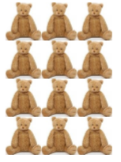  - Find ¾ of 20

Extension:
Y1 - Choose a number of counters. Place them onto 2 plates so that there is the same number on each plate. When can you do this and when can’t you? Try a few examples using a different number of counters each time. What do you notice?
Y2 – Using a piece of paper to help you if you need (you can fold it into the number of pieces in each fraction to compare the sizes). Put these fractions in the correct order, starting with the smallest. ½ ¼ 1/3

English
Reading: Can you share a story with a parent or a sibling each day this week? It is wonderful to read out loud and you can really use your voice to bring the words to life.
To listen to a story you can access hundreds of books FOR FREE on Audible here: https://stories.audible.com/start-listen

Reading comprehension: During the story reading or listening above, use questions starting with ‘who, what, where, when, how and why’ to allow them to explain what they are reading or listening to. I like to get them to describe what they can see in their heads at various point using ‘I wonder what that would look like…?’. There are also some really good reading and phonics games on the Oxford Owl website.

Writing: I wonder if you could take your experience of writing a news report from last week and develop your journalist skills further to create a magazine article or the cover of a magazine or both?
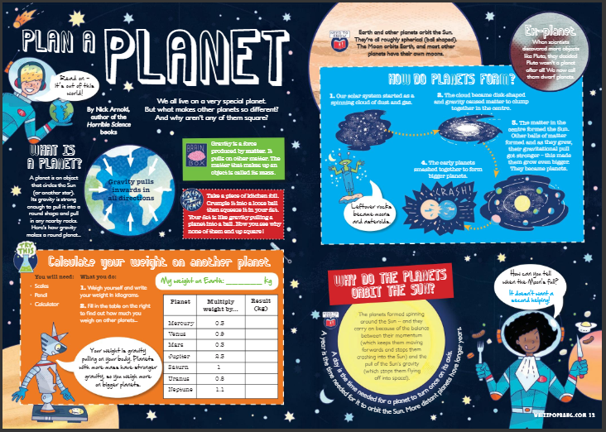
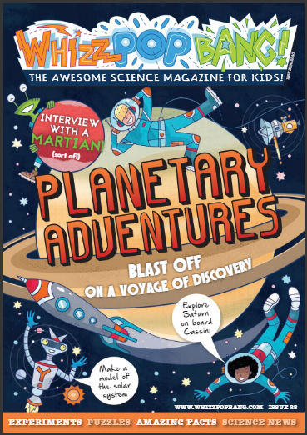

Above are some fantastic examples and you can have a look in the actual magazine by following this link - https://issuu.com/launchpadpublishingltd/docs/whizz_pop_bang_science_magazine_for?e=18498730/59446908 or maybe you have your own magazines at home that you can look at.

There are many features that you can add to make your magazine article or cover come to life:

- Think about a bold, colourful title.
- Use words in a clever way to make the reader laugh or catch their eye e.g. ‘Get Buzzy With Bees’ or ‘Penguins – Emperors of the Ice!’
- Include fact boxes and pictures to make it interesting for the reader.
- You could include interviews using the speech marks that I talked about last week for your news report, where you write down what somebody has said.
- You could include a games, competitions or jokes page!
- Be creative!

I want to let you choose what your magazine or article is about. You could choose to write about our theme of space like the magazine above. You could choose to do your magazine about one of you favourite subjects and choose something that really interests you. You could choose to write about nature, cookery, model building, gardening, sewing, art, music, gaming or anything at all – the more you are interested in the subject then the better your magazine will be!

SPAG: I have added the Year 1 and 2 High frequency and tricky word lists to the Class 2 page as I am aware that some children have completed the spellings that they have in their books. You can choose a selection of words from either or both of these lists and use them as an alternative. Once you have chosen the words to focus on, spend some time making sure children can sound out each word (stretching it out so you can hear each sound within the word), and that they know what each word means. Can they say it in a sentence? Can they write it in a sentence? Can they write the word in a tray of rice or sand? Can they write it in each colour of the rainbow?
There are some excellent spelling and grammar games on the brilliant Topmarks website suitable for year 1 and 2 https://www.topmarks.co.uk/english-games/5-7-years/words-and-spelling

Phonics (Year 1): If you want to be able to practice phonics then there is a fantastic resource on YouTube being introduced from 27/4 focussing on learning for the summer term with daily lessons being added. You can find the channel called ‘Letters and Sounds for Home and School’ in association with the DfE here https://www.youtube.com/channel/UCP_FbjYUP_UtldV2K_-niWw/featured?disable_polymer=1.

History:
Can you believe that people used to think that the world was flat?! There are lots of ideas that have changed over time as people came up with new ideas. Nicolaus Copernicus came up with an idea that changed the way that humans thought about the world. Can you find out about his idea and create a poster to explain who he was and what he found out? Why did people think he was a bit mad?! (HINT: there is an article in the magazine above, on pages 28-29, that might help you).

Science:
As the astronauts on board the International Space Station travel around the Earth each day (orbit) they see lots of sunrises and sunsets which create day and night here on Earth.
- What is day and night and how does it happen?

- Can you create a model (a bright torch and something like a football might help wth this) or a poster or fact card to explain what happens?

- Can you find the name of two places on Earth that would be day/night at the same time?

BBC Bitesize might help - https://www.bbc.co.uk/bitesize/topics/zkvv4wx/articles/ztdnyrd

DT/Art: The International Space Station (ISS) astronauts need your help. The food on the ISS is getting a bit boring and they need you to design some new meals for them to take into space. Can you rise to the challenge?

There are special rules for creating new space foods:
• Crumbs are not allowed • Minimize packaging and amount of rubbish • Make the weight of the food as little as possible

Preparing food to eat in weightlessness is a challenge. Crumbs are not allowed, as they can float around the cabin and could float into someone’s eye (or nose) or into instruments, or clog air vents. Also, the food must not float away while an astronaut is trying to eat it, so packages and foods are designed to make this less of a problem in space. Another challenge for food system developers is rubbish. Wrappers and empty packages must be compressible to minimize the amount of rubbish on the spacecraft. The bin truck doesn’t stop by the International Space Station!

Other challenges in developing space foods are making sure that they are tasty, have good nutrient content, and can be easily prepared. Another big challenge is shelf life (how long the foods will stay fresh). Even for an International Space Station flight, the foods have to be able to sit on the shelf (a shelf in the pantry, not in the refrigerator or freezer) and still be tasty for at least 9 months!

Good luck!

Geography: Let's explore the UK.
Use BBC Bitesize to help you - https://www.bbc.co.uk/bitesize/topics/zyhp34j/articles/z4v3jhv
I wonder if you could find out about the four countries that make up the United Kingdom? Could you create or colour in a map and label the different countries? Can you find out the capital cities of each country and put them on your map too? Have you visited any of these capital cities or countries – what do you remember about the places you have been?

PSCHE: This week there has been lots of things in the news about attitudes towards people.
The PowerPoint included might help to support ideas for discussion (I appreciate that this is a sensitive subject and this is entirely optional but I think it can be a worthwhile discussion).

What things make you special?
What would life be like if we were all the same?
If someone looks, acts, behaves or sounds different to you is this ok?
Is it fair that some people are treated differently because they are ‘different’?

Other Activities
  - Keep up with your PE by joining Joe Wicks LIVE every weekday morning from 9am for ½ an hour (or you can catch up anytime through his YouTube channel) https://www.youtube.com/playlist?list=PLyCLoPd4VxBvQafyve889qVcPxYEjdSTl
  - Check out the 100 things to do at home ideas from the Scouts - some useful ideas.
  - Keep adding to your nature diary – add sketches and information boxes to really bring it to life if you haven’t already.
  - When you look at the sky in the day, watch the clouds. Can you spot different patterns? Draw a picture of the clouds or imagine that you can see pictures in the different shapes (I often think I can see different animals – I have seen elephants and dragons recently!).
  - Can you learn to say ‘hello’ and ‘how are you?’ in 5 different languages?
  - Learn a new dance!

