Home Learning for w/c 15th June 2020
Hello Class 3

It’s been a very busy week as we have welcomed some children back into school; they have been busy completing the same activities as we have been using for everyone else learning at home. I hope you are all keeping well and busy and despite the weather have managed to get outside. The garden has welcomed the rain and it looks so lush and colourful, my vegetables are growing brilliantly and I am enjoying eating lots of home grown lettuce and rocket.

I hope you all have a good week and enjoy completing some of the activities below.

Take care Mrs Jordan

https://youtu.be/0ItLK5Bp9o4

Maths
This week we are focussing on time. It is quite a long time since we have looked at this as an area in maths so you may need to spend some time reminding yourself about the roles of the long and short hand as well as the number of seconds in a minute, minutes in an hour and hours in a day as well as days in each month and months in a year and leap year.

Remember each number on a clock is at five minute intervals. Practice of telling the time can be done at any time throughout the day.

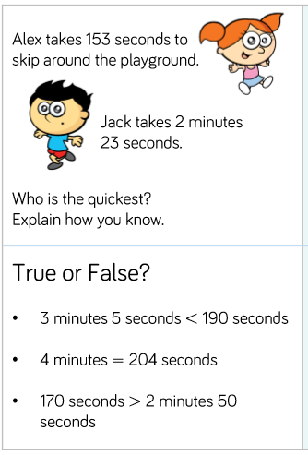
E.g. what time is it now? What time will it be in 20 minutes? If we have lunch at 12:00, how long is it till lunch time?

Year 3
- Estimate and read time with increasing accuracy to the nearest minute.
- Tell and write the time from an analogue clock using 12 and 24 hour clocks.

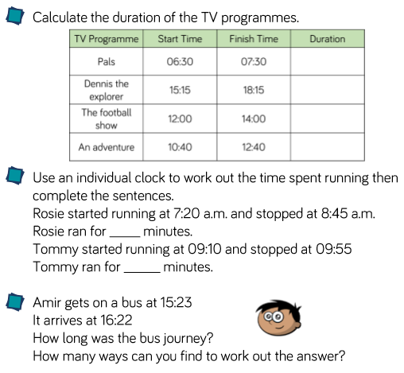
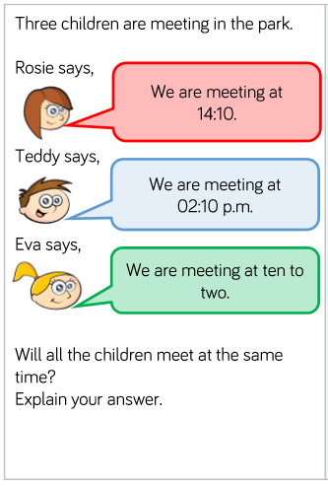

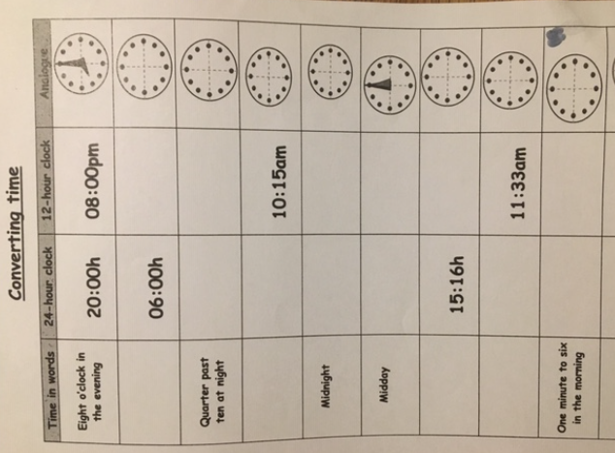
Year 4
- Read, write and convert time between analogue and digital 12 and 24 hour clocks.
- Solve problems converting time.

English

This week we are focussing on instruction writing. You need to remember to use imperative verbs (bossy verbs). Before you get started can you write a list of all the imperative verbs you can think of?

- Start by verbally giving some instructions to another member of the family. It could be helping them to play a game, make a drink, make a snack or build something in Lego. What words did you use when doing this? Remember those time connectives next, after, finally etc.
- You now need to write a set of instructions down. Think about something that you are very good at; it could be a gymnastics move, baking, Lego building or a sport. Can you write a set of instructions to help someone else? Remember the features of instruction writing. You need a title, a list of what you need, you could add in diagrams as well as a top tip. Your instructions need to be in a logical order using numbers or bullet points.

Why not write a poem for your Dad / Grandparent to go with their card you could do an acrostic poem.

- Can you complete the attached reading comprehension all about the Vikings? There are different levels of difficulty, choose one that you feel confident with.

Science -
This week we are looking at teeth! We will find out what the correct names are for your teeth as well as either making a diagram to label a tooth or drawing your own.

https://www.bbc.co.uk/bitesize/articles/zsp76yc

- Using the diagram below can you label the teeth using the correct scientific names?
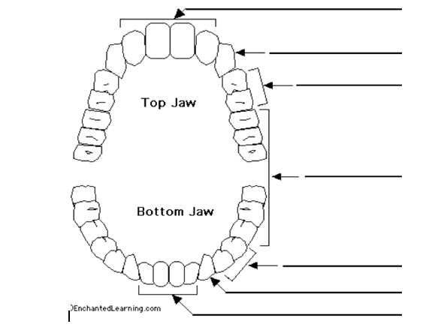

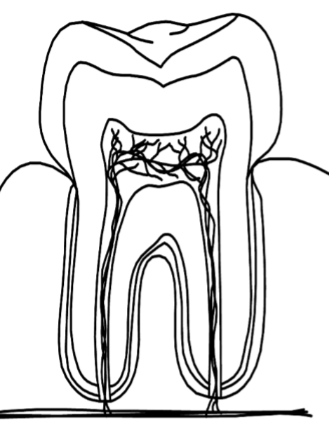
- Can you research, draw and label the different parts of a tooth or use the attached file to make your own diagram.

French

Lundi, Mardi, Mercredi, Jeudi, Vendredi, Samedi, Dimanche
What do the words above mean? Have a look at the clips below there are songs for both days of the week and months of the year.

https://youtu.be/Lpwf5N0rfVE

https://youtu.be/7_u2SigckNQ

- Can you draw hopscotch and write the days of the week in them in French then you can learn them while playing the game.
- Can you create a poster using the days of the week, you could write the word in French and then draw a picture to show what you do on each day or write the months of the year in French and then next to it draw something to make you think of that month.
Mrs Smurthwaite and her daughter have also made some videos to help with days of the week and months of the year.
https://youtu.be/TkEGyaAipeE
https://youtu.be/RESq5ytAhOI

Theme / – Vikings

This week we are focussing on Viking Ships. Start by looking at link below:

https://www.bbc.co.uk/bitesize/topics/ztyr9j6/articles/zw3qmp3

https://youtu.be/GZOWhLOARSw

The Vikings built fast 'dragon-ships' and 'long ships' for raiding and war.
They also had slower passenger and cargo ships called ‘knorrs’. They built smaller boats too, for fishing or short trips. A ship carried everything needed at sea - drinking water, dried meat to eat, tools, weapons, and furs to keep warm.
Viking longships could sail in shallow water so they could travel up rivers as well as across the sea. In a raid, a ship could be hauled up on a beach. The Vikings could jump out and start fighting, and then make a quick getaway if they were chased.

The prow of a Viking ship was very important; it is a carved wooden figurehead often a dragon or other fearsome animal and was meant to scare the enemy.

Can you draw and label your own Viking Ship and design a Viking ship prow for your long boat? You could also change the pattern on the shields to something of your own choosing. Can you then write five facts about your Viking longship.
Fearsome creatures, like dragons, were used for the figurehead
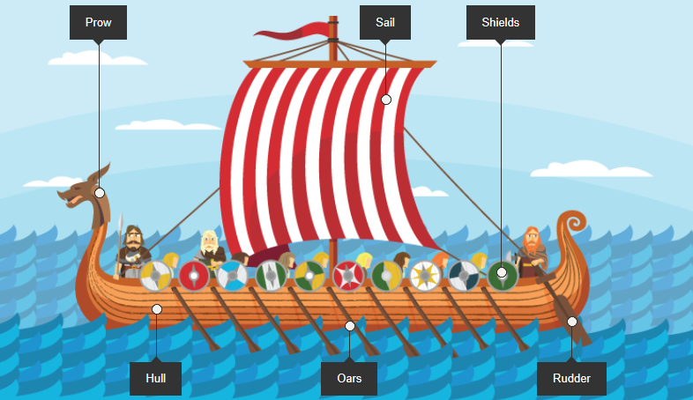

Why not make your own Viking Longboat from an empty cereal box, cutting it length ways and then adding shields, a sail and a prow?
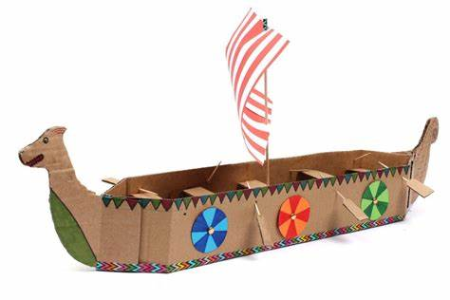

PSHE – Celebrating difference
Have a look at the power-point attached, what do we mean by celebrating difference?
We are all unique and all special. Some of our friends might have curly hair, wear glasses, play different sports or have a different eye colour. It is important that we embrace all differences.

https://www.twinkl.co.uk/resource/t2-p-216-embrace-our-differences-powerpoint
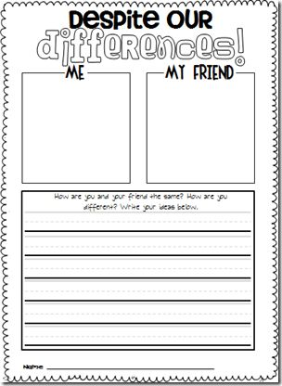
Think about all of your friends what makes you different to each other?

- Can you create a piece of work similar to this one? Draw a self portrait and then draw your friend, think about what makes you different to each other and what is the same.

Art and Design

Father’s Day is on Sunday 21st June, can you think about all the amazing things your Dad / Grandad / Grandpa does and the kind of things they like to do in their spare time and make them a card?

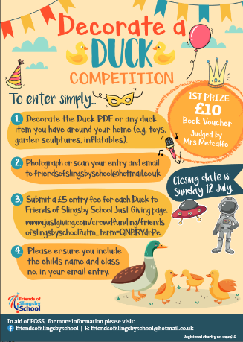
General

Have you seen the fantastic competitions that Foss are holding, I can’t wait to see your decorated ducks and I wonder what sponsored challenge you will complete as a family? I look forward to hearing all about it.

Blue Peter have started their ‘6 Badges of summer’, every week there will be a different theme to the badges ranging from sport, to helping save the environment, music, thank you as well as a final silver badge. I feel there is something for everyone so why not have a look a choose one to suit you.

