Home Learning for w/c 29th June 2020
Hello Class 3
I hope you have all had a good week and enjoyed the amazing weather we have had. The weekend has been full of showers but I have still managed to get outside and cut the grass, go on a walk as well as enjoy a BBQ with my family. I am missing you all and have enjoyed reading some lovely messages and seeing what you have been doing, it seems you have been very busy and learning lots of new things. Keep it up! Remember to have a look at the exciting competitions that FOSS are running I can’t wait to hear about your family challenges as well as see your decorated ducks.
Take care of yourself and your family.
Mrs Jordan

https://youtu.be/tVmJHgOSWfY

Maths

This week in maths we have got two different challenges for you to have a go at, the mysteries cover a range of different maths topics.

I have attached 2 mysteries there is ‘The Mystery of the Missing Macaws at Maythorpe Zoo’ or a more challenging mystery called ‘The mystery of the melted ice cream’.

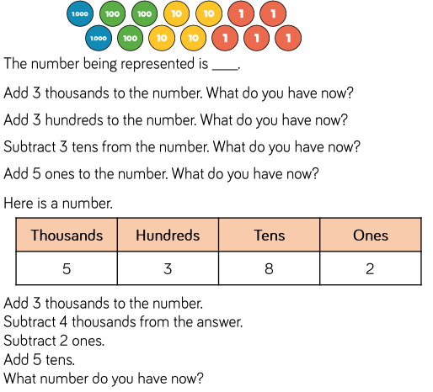
Below are a selection of reasoning and problem solving questions linked to addition and subtraction.

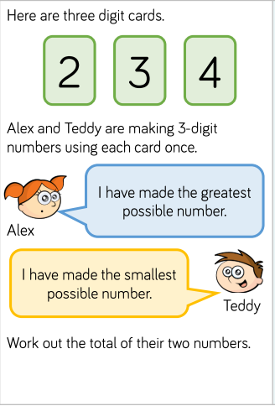
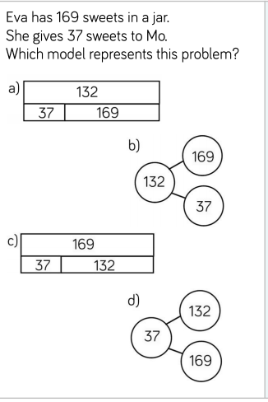

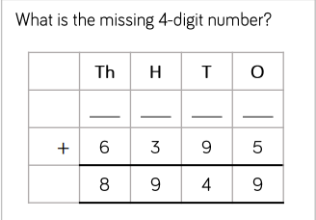
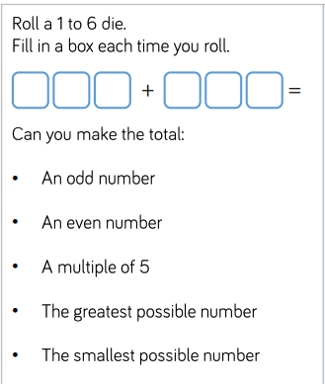

English

This week we are looking at ‘Kennings’, these are riddle poems which describe something without actually saying what it is!

Each line in a kenning poem has only two words. These words are joined using a hyphen. The two words are usually a noun and a verb or a noun and a noun. This two-word phrase is used instead of a one-word noun.
Kennings were originally used in Old Norse and Anglo-Saxon poems. We use kennings in our everyday language, such as 'sky-scraper' for a very tall building. Kennings describe what a person, idea or object is or does.
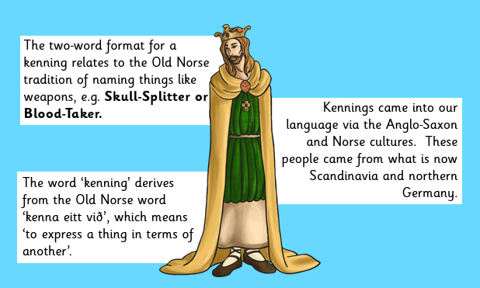

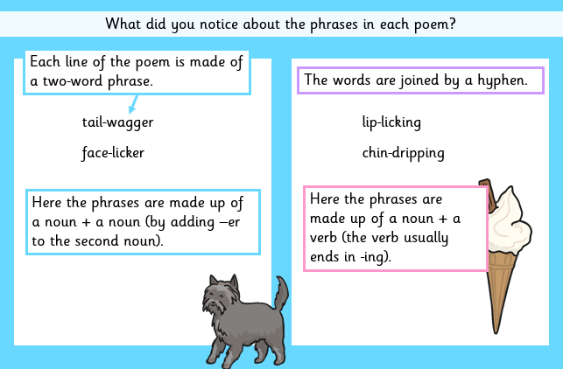

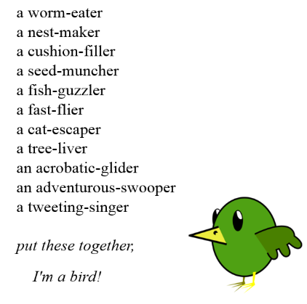
You then need to choose a theme (It doesn’t need to be gory like the Vikings).

Create a mind map and think about all the words and phrases associated with them.

Then start to put together your poem, remember not to say what the subject is.

It could be a sport, food, animal, pet, season or family member.

Additional activity

Study the picture below and answer the questions.

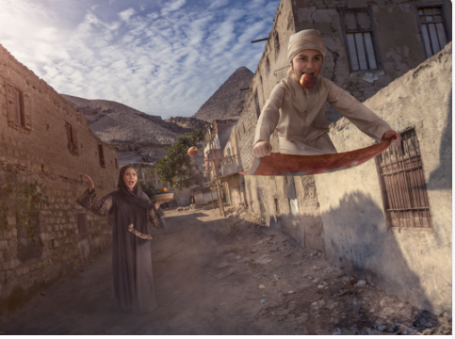

Can you describe what it would be like to fly on a magic carpet?

Think about how you would feel, how fast you might move, how you control the carpet, what you can see and hear and where you are going.

- Can you think of a name for the boy in the picture?
- How does he control the carpet?
- Where might the carpet have come from? Why is it in his possession?
- How might the other people in the village feel about the boy and his magic carpet?
- Where does the boy live?
- If you had a magic carpet, how would you use it?

Science – The digestive system and teeth

Start by watching the short videos on BBC Bitesize below, they explain why our teeth are so important and then the journey that our food takes through our bodies.

https://www.bbc.co.uk/bitesize/articles/z3nhjsg
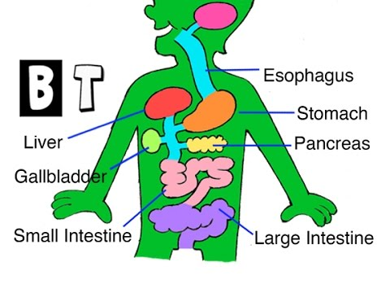

Watch this fantastic clip below from Operation Ouch

https://www.youtube.com/watch?v=AX34MoaLmzE

- Can you label the parts of the digestive system (Sheet attached / or you can draw the diagram and label.
- Complete the digestive system word search.
- Below is a short clip with a practical activity to show how the digestive system works – I will warn you in advance it is a little messy but lots of fun.
- Digestive system experiment (video)

PSHE

I wonder if you have watched the assembly as suggested on the newsletter by the Duchess of Cambridge all about kindness. It talks about the importance of being kind to others but also being kind to you.
- What do you think kindness means? How can you show kindness to someone else?
- How can you show kindness to yourself?
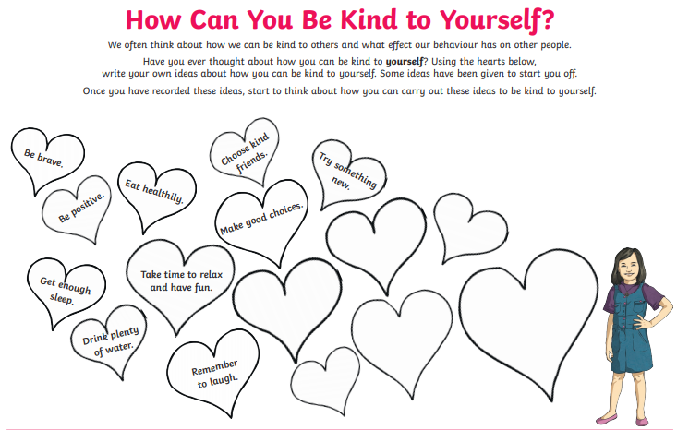
- Can you show a random act of kindness for someone in your family or a neighbour?

  - Set the table for dinner
  - Send a postcard to a friend
  - Empty the dishwasher or wash up
  - Tidy up without being asked
  - Weed the garden

Theme / – Vikings

We are looking at Viking shields this week and how they would have fought. Watch the clip and then have a go at making your own Viking shield.

https://www.bbc.co.uk/bitesize/topics/ztyr9j6/articles/zy9j2hv
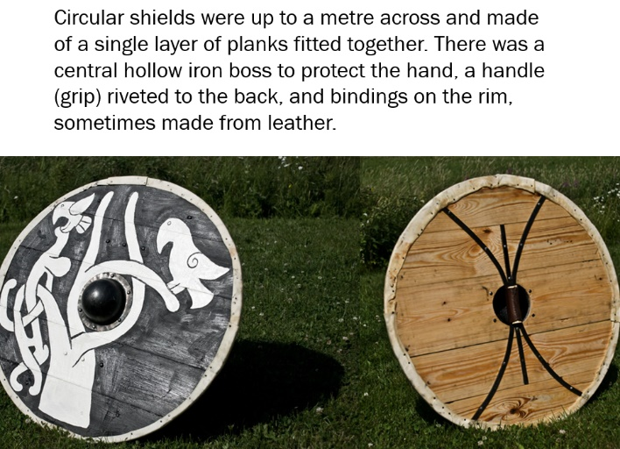
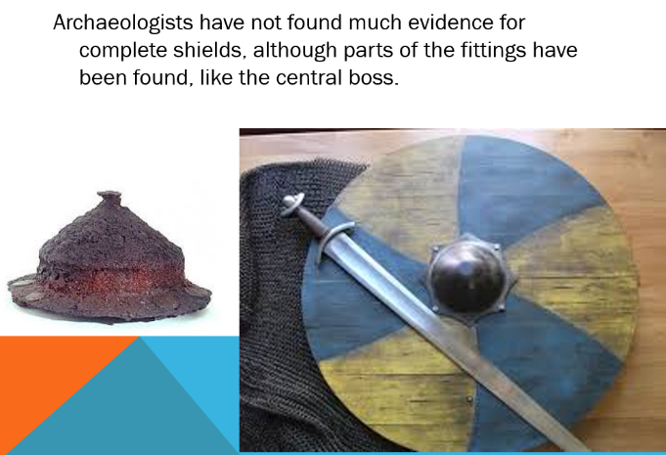

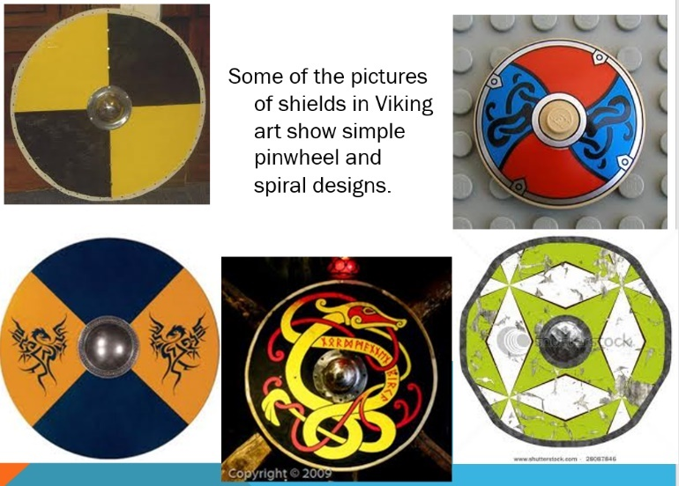

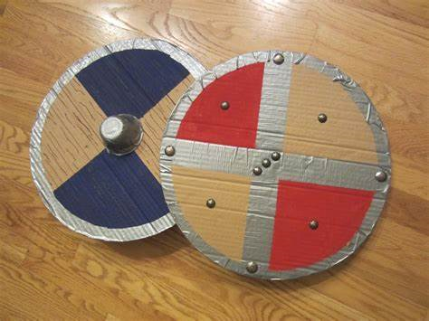

You could use a yogurt pot for the central boss.

Can you design your own Viking shield and then make it using a piece of cardboard?
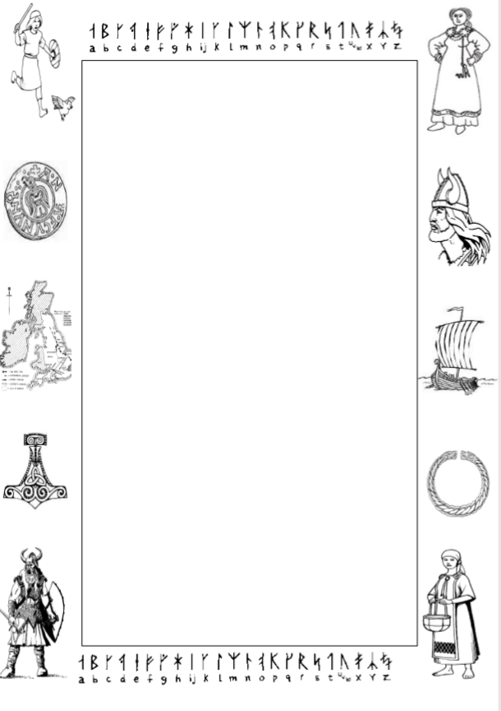

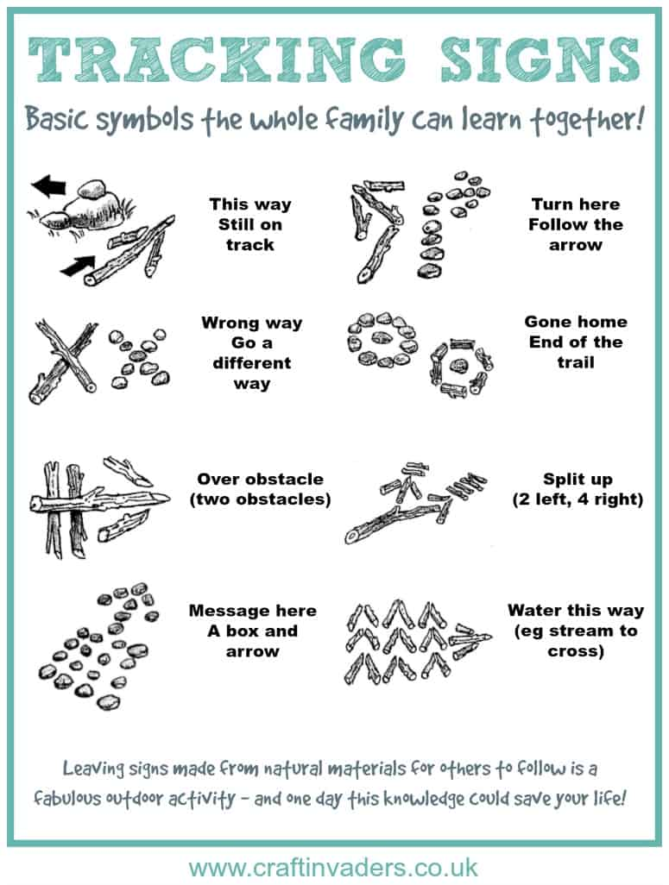
PE
Why not have a go at setting a track for your family using some simple tracking signs.

Art and Design

Following the announcement that this year’s Railway in Wartime event has been cancelled, North Yorkshire Moors Railways has launched a specially themed drawing competition, with the winner receiving a trip to the railway for their entire class.

They would like children to think about what the railway might have looked like during wartime and put pen to paper to draw their interpretation of it.

Please look at the website (link below for more details.

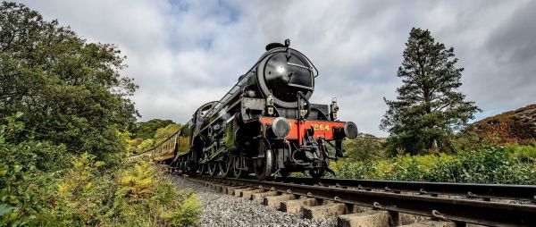
https://www.nymr.co.uk/

Armed Forces Day Saturday 27th June is Armed Forces Day and a huge celebration had been planned to take place in Scarborough. This has been postponed till next year but instead they have planned a virtual day.
There are some fantastic activities on the link below; it gives you instructions to make your own air raid shelter, spitfire as well as a war ship model.

https://www.scarborougharmedforcesday.co.uk/virtual/

