Can I draw the hands on a clock to show a time given to me in words?
(o’ clock and half past)

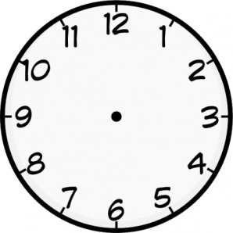
3 o’ clock | 5 o’ clock | 10 o’ clock
half past 8 | half past 1 | half past 11
12 o’ clock | half past 5 | 8 o’ clock
half past 2 | 6 o’ clock | 9 o’ clock
11 o’ clock | half past 3 | half past 4

Can I draw the hands on a clock to show a time given to me in words?
(o’ clock, half past and quarters)

3 o’ clock | half past 5 | 10 o’ clock
half past 8 | quarter to 6 | quarter past 8
quarter past 9 | quarter to 10 | 8 o’ clock
half past 2 | quarter to 7 | quarter past 1
quarter to 3 | quarter past 6 | quarter to 12

Can I draw the hands on a clock to show a time given to me in words?
(5 minute intervals)

3 o’ clock | half past 5 | quarter to 6
quarter past 8 | 10 past 3 | 20 to 8
25 to 6 | 5 past 10 | 10 to 10
5 to 9 | 20 past 2 | 25 past 7
20 to 1 | 10 to 1 | 25 to 12

Can I draw the hands on a clock to show a digital time?
(five minute intervals - digital)

3:00 | 10:47 | 6:33
8:15 | 1:26 | 5:54
8:40 | 12:13 | 4:20
5:25 | 9:35 | 2:55
7:40 | 2:05 | 9:25

