Hello Class 4!
I hope you are all doing well and enjoying doing at least some of the work I am setting for you to keep up with your skills at home. As always, just try to do what you can and remember that you can also choose to follow some of the lessons /ideas that have been posted on the BBC Bitesize website, as there is a lot of useful learning activities to try.
English
Did you have a go at writing a ‘Just So’ story last week? I did and I really enjoyed writing ‘How the Snake Lost its Legs.’
Monday:
Please complete your dictionary definitions for this week’s spelling lists, listing possible antonyms and synonyms if you can.
Tuesday-Friday: SPAG Activities.
Have a look at the links posted for this week for: punctuation, coordinating and subordinating conjunctions, and active & passive verbs.
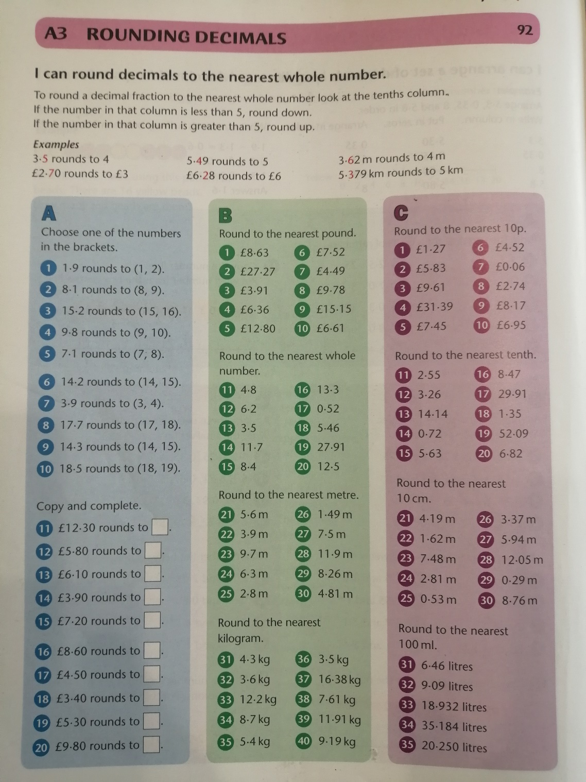
If you printed these out, it would be a lot of paper! Try to be kind to the environment and just read/copy what you need to directly from the screen you are viewing it from.
Mathematics
Year 5:

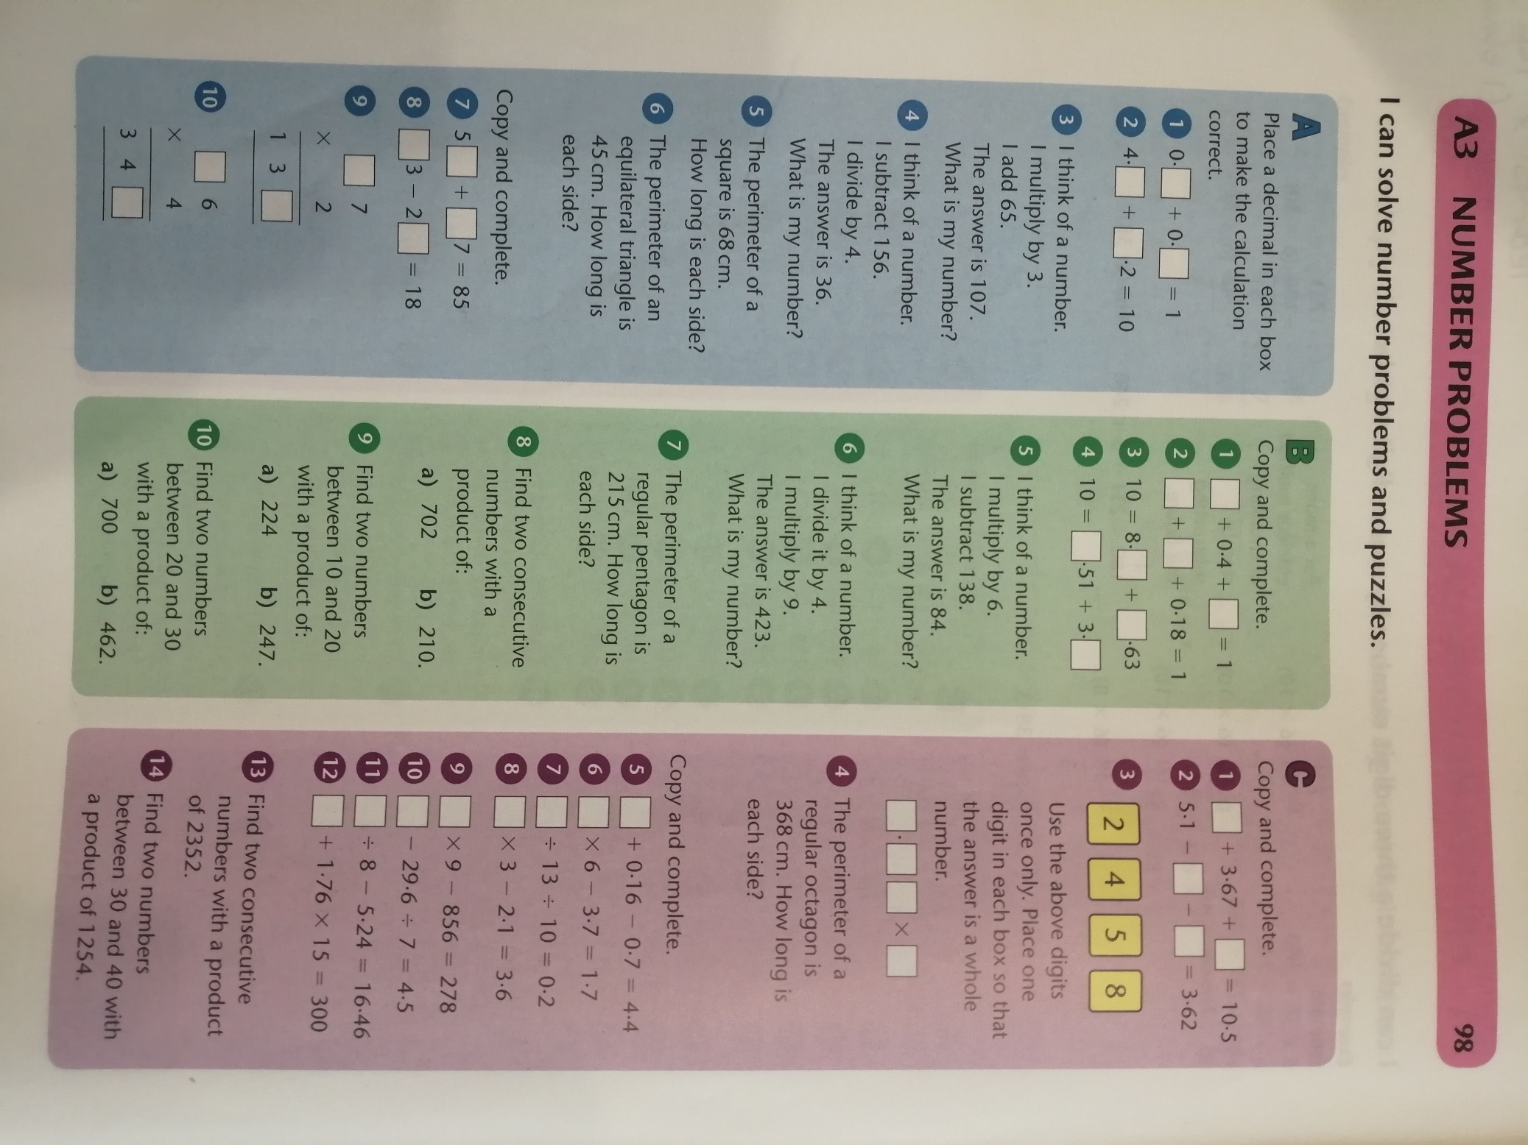

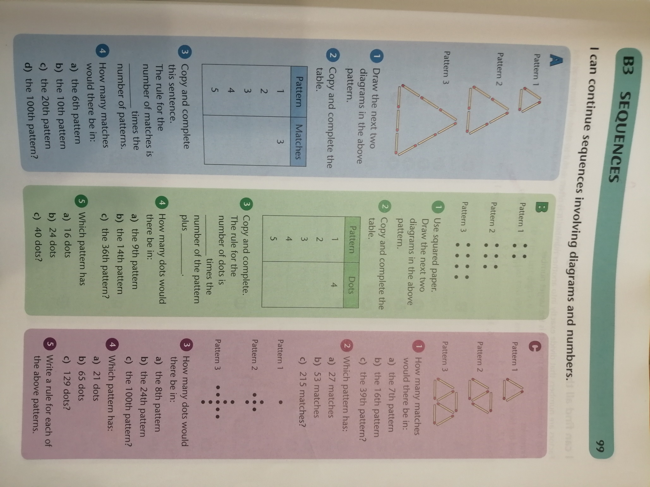

Year 6 Mathematics:
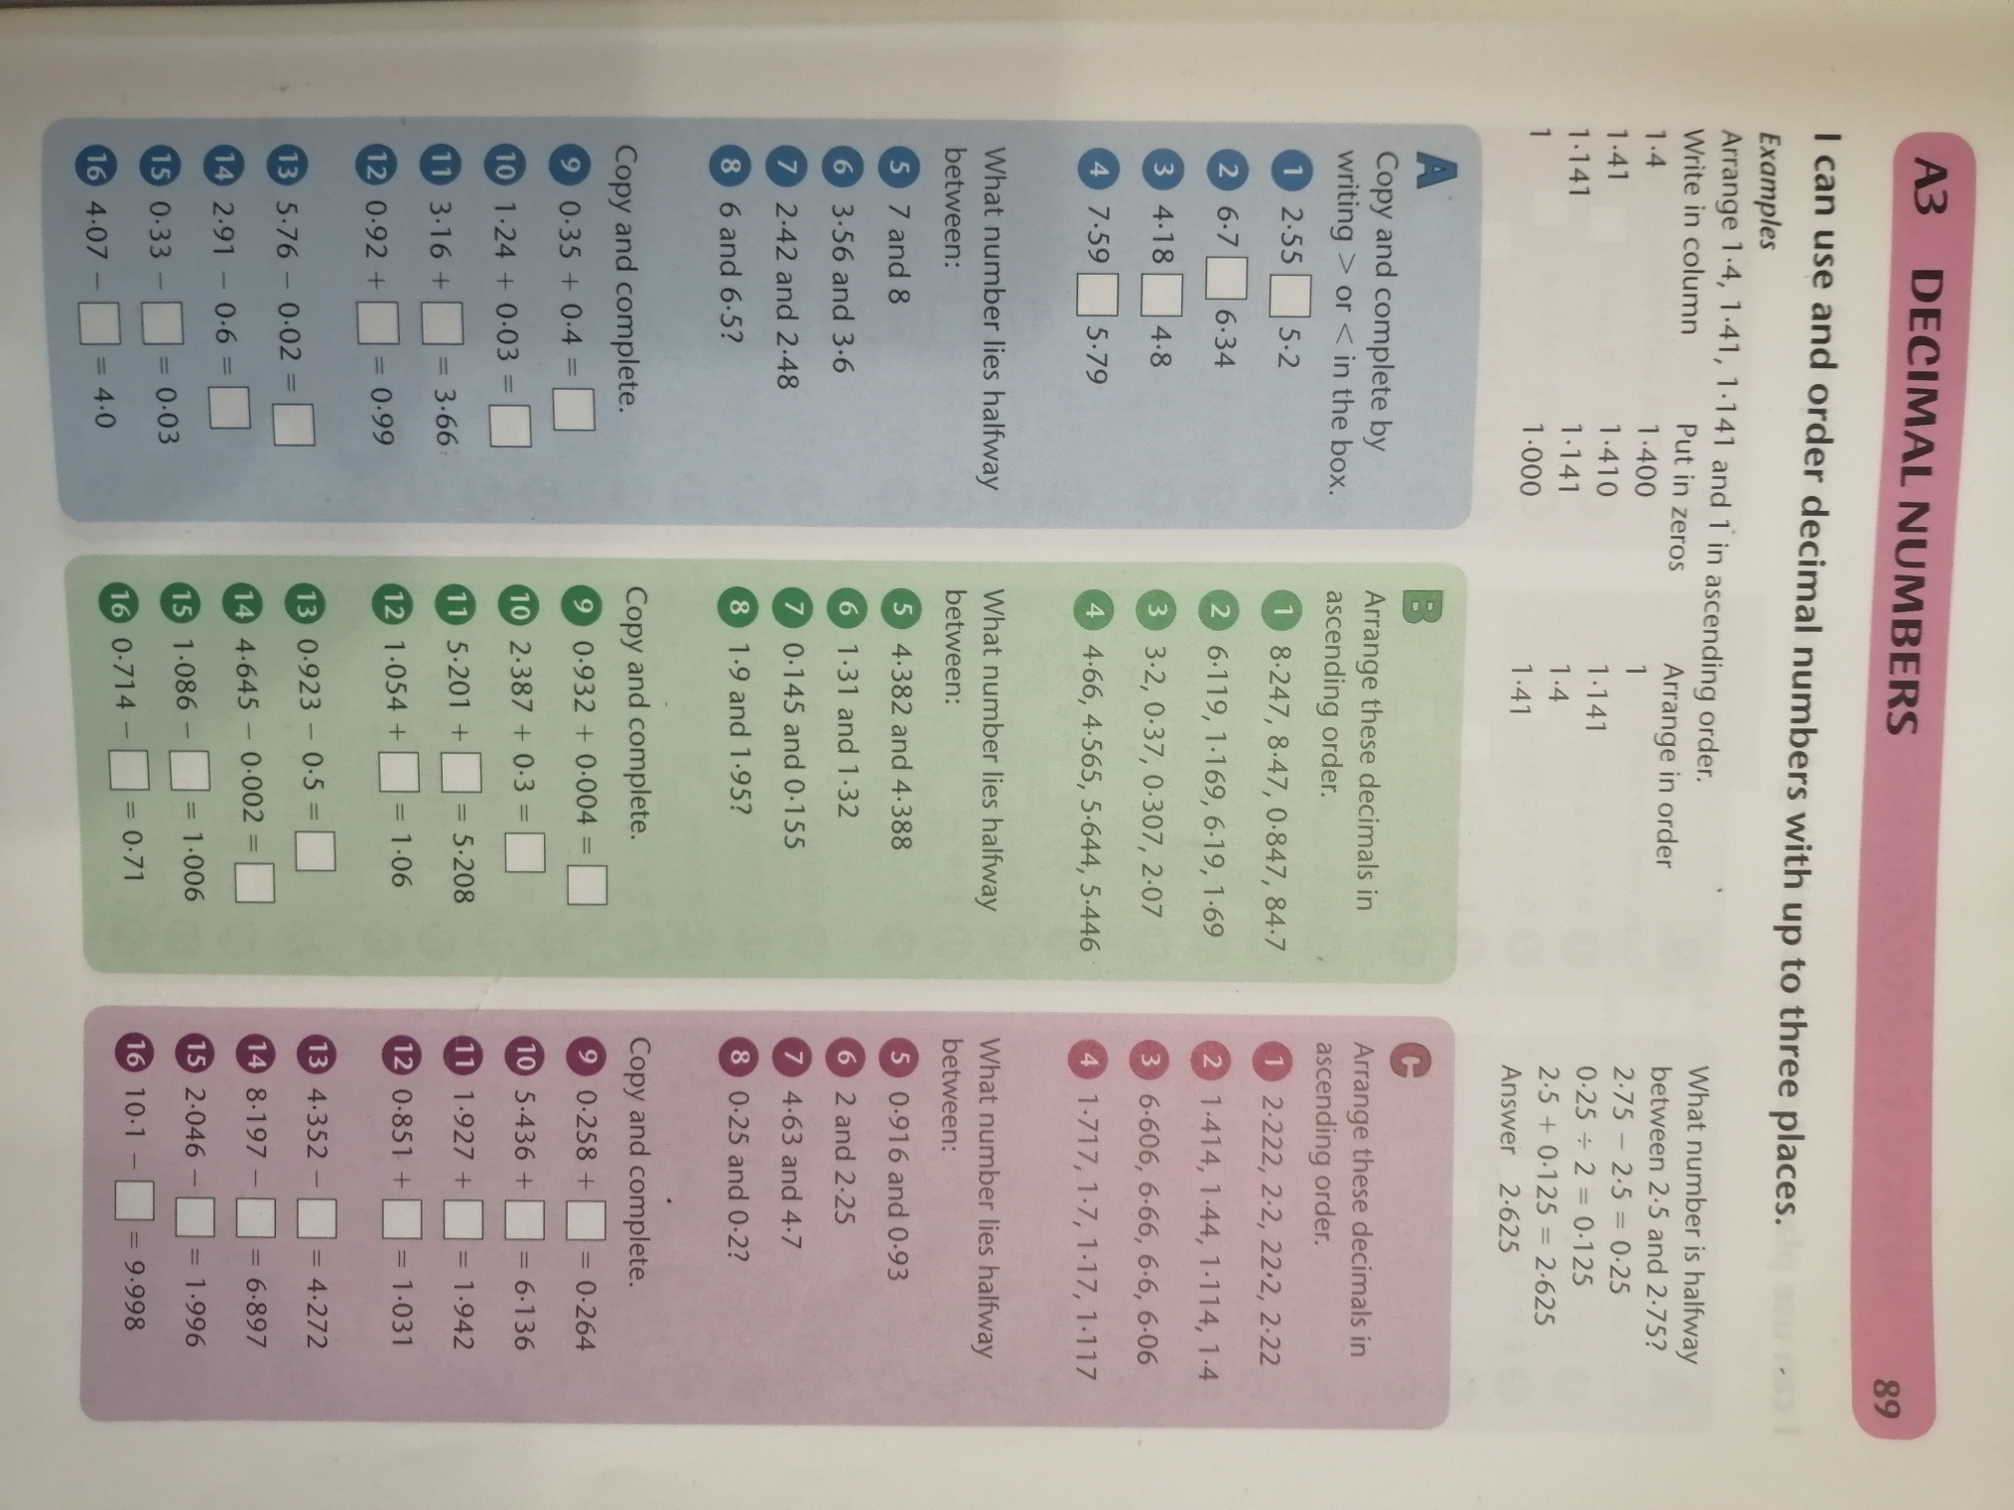

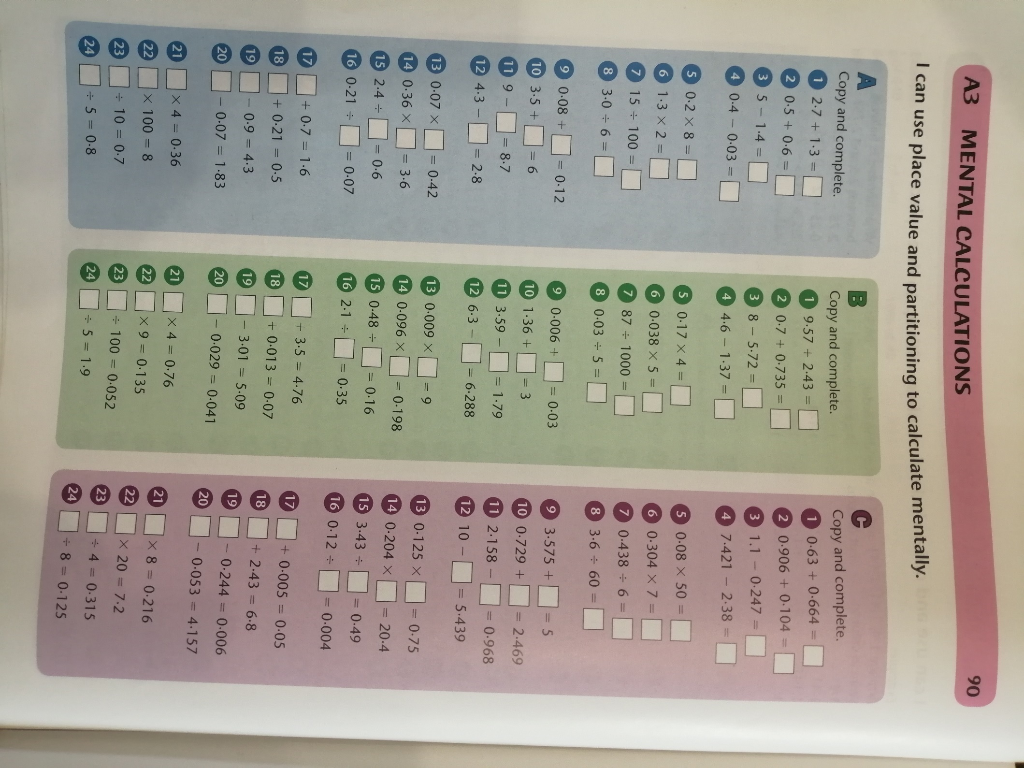

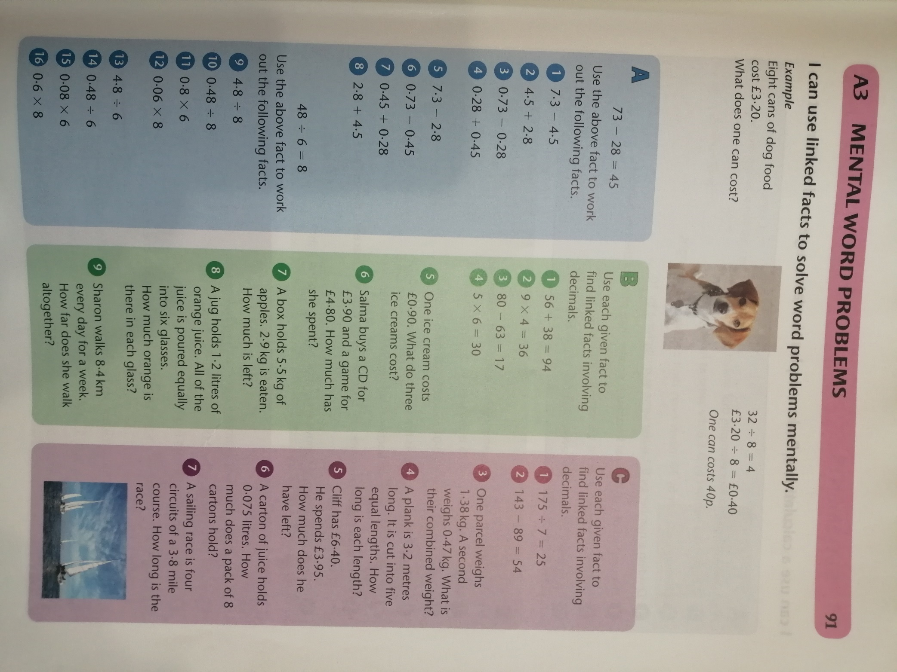

History:
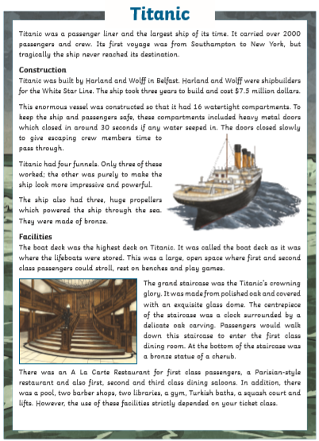
This week’s history idea for home learning comes from Lochlain, who wanted to do some work about the Titanic. You could write a diary of the events from the point of view of a passenger; use to internet to find out more; produce a painting/illustration/diorama of the sinking; design a poster to advertise its launch.

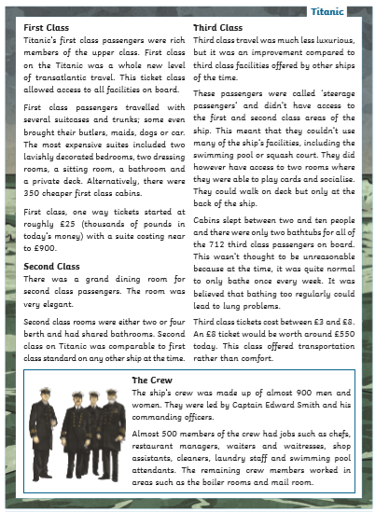
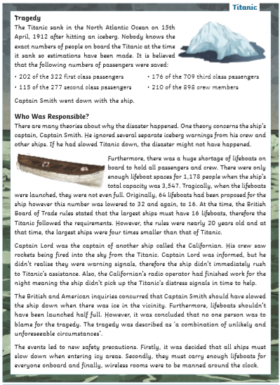

Science:
Linked to the ‘Titanic’ work. Investigate why it is that something so huge and heavy can possibly float in the water. What is the science behind this? A labelled diagram would really help to explain your findings and you could also test at home which materials float and sink (and explain why). https://www.bbc.co.uk/bitesize/topics/zc89k7h/articles/zytqj6f

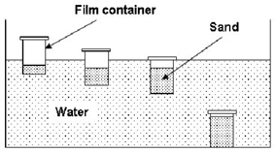
What is happening in this diagram?
This week’s spelling lists:
Class 4 spelling list for group 3: Week 34
Objective: To practise extending, and compounding words through adding parts, e.g. ful.
Spellings | Look, cover, write, check
 | Monday | Tuesday | Wednesday | Thursday
hopeful
grateful
careful
stressful
painful
dreadful
hurtful
thoughtful
thankful
powerful
wonderful
useful
peaceful
helpful
disgraceful
cheerful
beautiful
Class 4 spelling list for group 2: Week 34
Objective: Objective: Words ending in –ent or –ency.
Spellings | Look, cover, write, check
 | Monday | Tuesday | Wednesday | Thursday
agent
agency
urgent
urgency
consistent
consistency
fluent
fluency
decent
decency
current
currency
excellent
excellence
frequent
frequency

Spelling score this week =

Class 4 spelling list for group 1: Week
Objective: Objective: Words ending in –ent or –ency.
Spellings | Look, cover, write, check
 | Monday | Tuesday | Wednesday | Thursday
agency
frequency
dependent
dependency
inconsistent
inconsistency
president
presidency
efficient
efficiency
transparent
transparency
sufficient
insufficient
insufficiency
excellent
excellence
excellency

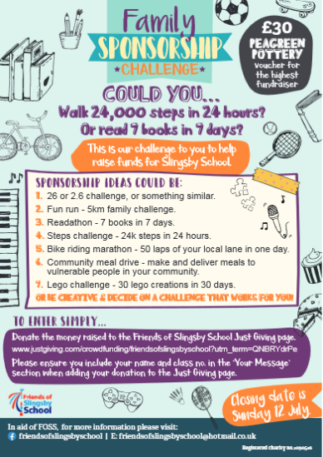
Don’t forget that FOSS are also currently running some fund-raising activities, so why not give them a try?
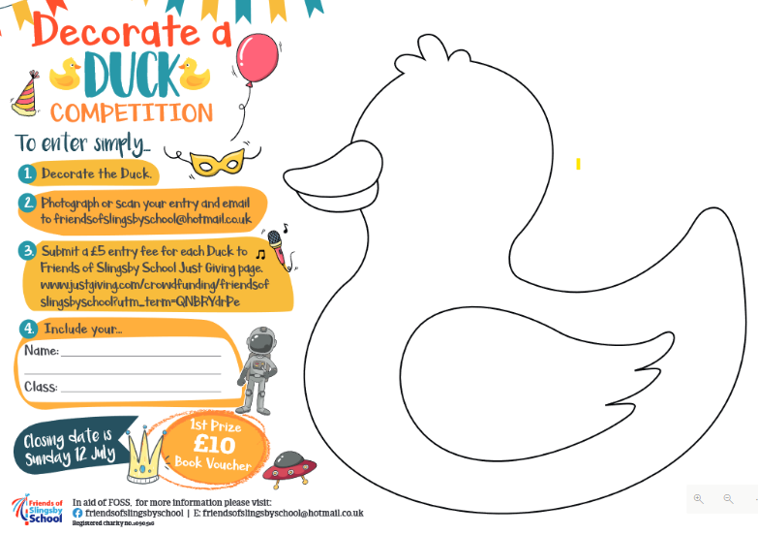
Stay happy, stay busy, and keep your mind and body active.
Mr. Smith

