Hello Class 4!
This week we welcome back some Year 6 pupils to school. They will be doing exactly the same work as the rest of the Year 6’s and 5’s at home, although if they have any good ideas for their learning I will share them with you next week so you can have a go too!
English:
Monday:
Please complete your dictionary definitions for this week’s spelling lists, listing possible antonyms and synonyms if you can.
Tuesday:
Produce a piece of writing that uses as many of your spellings as possible, making sure to use them in the right context (using them how they are intended to be used). The style, purpose and genre are entirely up to you. You could write a story, factual report, play-script or report.
Wednesday:
Spend time watching some ‘Just So’ stories by Rudyard Kipling: How the Camel Got its Hump, How the Rhinoceros Got its Skin and How the Leopard Got its Spots:
https://www.youtube.com/watch?v=RjmsOBAp9ak
https://www.youtube.com/watch?v=atSE_cZbcNg
https://www.youtube.com/watch?v=Mulf011-ksU
After watching these, plan a ‘Just So’ story of your own. Think about the animal, its feature you’d like to explain, characters and setting. How are they going to get their feature?
Some animals you may want to write a story for (if you are stuck!): How the Giraffe Got its Neck, How the Elephant Got its Trunk, How the Tortoise Got its Shell, How the Tiger Got its Stripes, How the Bat Got its Ears, How the Snake Lost its Legs. There are so many more wonderful animals you could write a ‘Just So’ story for.

Thursday & Friday:

Write up your story, adding illustrations along the way! Don’t forget to:
- Use a range of sentence openings
- Use a full range of punctuation
- New speaker = new line
- Use interesting description of character and setting

Mathematics:
Have a go at the problem solving packs that I’ll upload this week:
- The Mystery of the Brilliant Breakfast (Year 6)
- The Mystery of the Melted Ice Cream (Year 5)
- The Mystery of the Spoiled Party Bags (Year 5)
- The Mystery of the Locked Cupboard (Year 6)

Please also have a look at this page on ConkerMaths to continue to improve your speed and accuracy when working with number bonds and times tables: http://www.conkermaths.org/cmweb.nsf/products/conkerkirfs.html

Geography:
The coastline of the UK is slowly being eroded by the sea and weather, creating interesting features such as caves, arches, stacks and stumps. Your task this week is to write a short explanation (with labelled diagrams) to explain how these four features are created. You could also create a 3D model of a coastline to show these!

https://www.youtube.com/watch?v=00Khn0RSpYA
Watch this clip from 1:46 to see some amazing features of the Welsh coastline!
https://www.youtube.com/watch?v=2fS2Swi0q-U
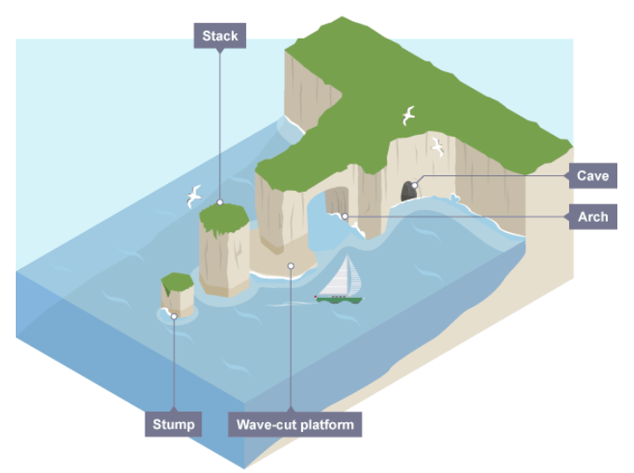

Art/Design Technology/History:
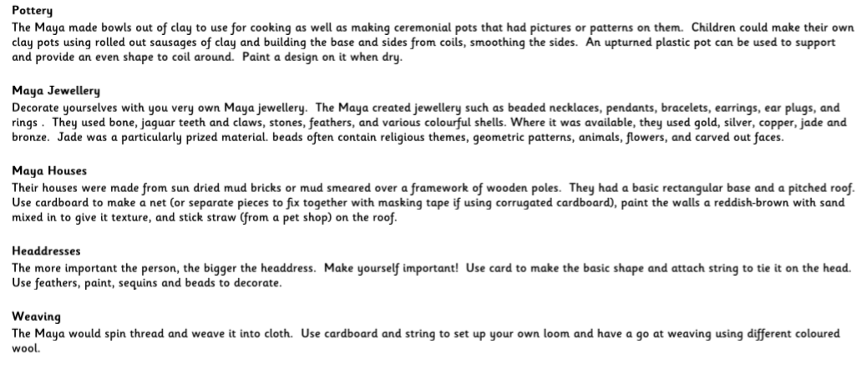
Have a go at one of these Maya themed activities:

French:
To link in with the geography I have been asking you to do in previous weeks, I thought it might be good to have a look and learn how the French say the name for some European countries and capital cities. Have a look at this week’s French Powerpoint and try to learn as many as you can.

This week’s spellings:
Class 4 spelling list for group 3: Week 33
Objective: To practise extending, and compounding words through adding parts, e.g. ic, ive, ist.
Spellings | Look, cover, write, check
 | Monday | Tuesday | Wednesday | Thursday
terrific
horrific
allergic
artist
artistic
stylist
novelist
active
expensive
motive
massive
captive
relative
native
energetic
scientific
photographic
exclusive
explosive
attractive

Spelling score this week =

Class 4 spelling list for group 2: Week 33

After completing ‘look, cover write, check,’ please try to write 5 interesting sentences in your spelling homework book. You can use more than one word from your spelling list in each sentence.
Objective: Words ending in –ant or –ancy (and words beginning with –dis).
Spellings | Look, cover, write, check
 | Monday | Tuesday | Wednesday | Thursday
disrupt
disruptive
pregnant
pregnancy
disturb
disturbance
disallowed
vacant
vacancy
discovery
disobeyed
occupant
disagreed
disagreeable
discount
vibrant
disorder
disorderly
discomfort
hesitant

Spelling score this week =

Class 4 spelling list for group 1: Week 33

After completing ‘look, cover write, check,’ please try to write 5 interesting sentences in your spelling homework book. You can use more than one word from your spelling list in each sentence.
Objective: Words ending in –ant or –ancy (and words beginning with –dis).
Spellings | Look, cover, write, check
 | Monday | Tuesday | Wednesday | Thursday
pregnancy
consultancy
vacancy
accountant
accountancy
discovery
occupancy
expectant
expectancy
vibrant
vibrancy
hesitant
hesitancy
poignant
poignancy

Spelling score this week =

Remember not to worry about getting everything done; but try to do as much as you can to keep your skills, knowledge and understanding improving.
Stay safe, keep smiling and take care of each other.
Mr. Smith

