Hello Class 4!
I hope you are all still doing well at home, although the weather has been a bit rotten this week. Hopefully the sun will come out again soon. This week’s learning focuses on the Lost City of Atlantis & I hope you enjoy finding out all about it.
Monday:
As usual, please complete your dictionary definitions for this week’s spelling lists, listing possible antonyms and synonyms if you can.
Tuesday to Friday
For the rest of the week, I’d like you to read the information about the lost city of Atlantis, then write a diary of its last days from the perspective of an Atlantean citizen. You’ll need to decide for yourself how Atlantis met its end: Was it flooded by a Tsunami? Destroyed by a terrible earthquake? Obliterated by volcanic activity (like Pompeii)? Or did the gods become angry and smite it with their powers?
If you are struggling to start, I’ve written a couple of opening sentences for you to get you going:

Dear diary,
Today I was awoken by strange rumbling from deep underground. It feels as though Hades himself is angry at what we have become. I warned Kashekim Nedakh that he should not have used the Heart of Atlantis as a weapon to conquer and colonize other lands to extend our empire, yet his arrogance blinds him to the warnings of the gods to use our precious artefact only for good…

You should try to include at least three daily entries as events lead to the demise of Atlantis.
Information about Atlantis:
The Lost Civilisation of Atlantis
The story of Atlantis is a famous myth. Atlantis is believed by many to be an ancient island that sank into the ocean. It was supposedly home to an advanced civilization that had conquered many nations. Kashekim Nedakh was the king and ruler of Atlantis at the height of its power. In his arrogance, he used the Heart of Atlantis as a weapon and begins a campaign that sees him conquer and colonize other lands and cultures.

The island collapsed into the sea, apparently disappearing during an earthquake.
The possibility that Atlantis was real has been discussed throughout history. This idea has usually been rejected because there is not enough evidence that it existed. Plato, a Greek writer, made the earliest recorded reference to Atlantis about 2,500 years ago.
According to Plato’s version of the myth, the Greek gods divided the planet between themselves. Poseidon, the god of the sea, received the island of Atlantis as his share. Poseidon shared Atlantis amongst his children. The eldest son, Atlas, was given the mountain where he was born and the neighbouring area as his kingdom.
Atlas was eventually made king of the entire island and the surrounding ocean, which was called the Atlantic Ocean in his honour. He made his birthplace into a city and enclosed it with three circular moats of increasing width which were separated by rings of land. The inhabitants of Atlantis then built bridges over the moats.
Plato described the Atlanteans as great engineers and architects. There were palaces, harbours, temples and docks. The capital city was built on a hill and surrounded by rings of water, which were joined by tunnels large enough for a ship to sail through. A huge canal connected the outer rings of water to the ocean. On the outskirts of the capital city there were huge fields where farmers grew the city's food. Past the field there were mountains where wealthy villagers lived. Plato went into great detail about the amazing buildings - complete with hot and cold fountains, shared dining halls and stone walls covered with precious metals.

Adventurers, treasure hunters and scientists have searched for the lost city of Atlantis. There have been dozens of locations proposed for Atlantis: most of them in or near the Mediterranean Sea. Researchers discovered a lost city off the coast of Cuba and thought that it might be Atlantis. Others believe it lies under mud lands in southern Spain.
The legend of Atlantis is featured in many books, films, television series and other creative works.
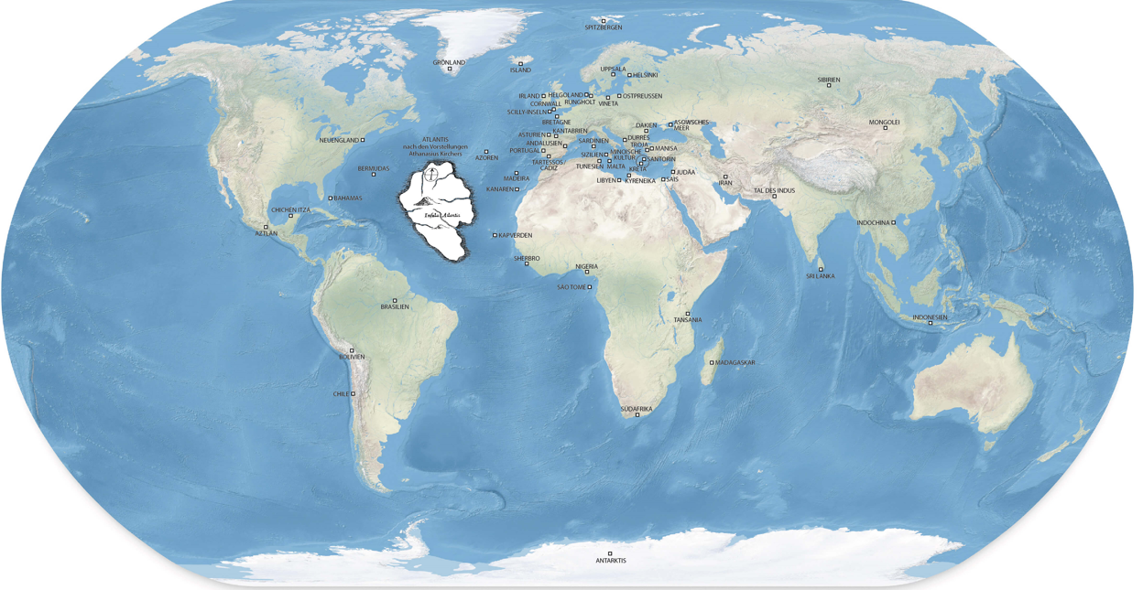

There may well be good reason to believe it actually existed. Many other ‘lost’ cities have been rediscovered, including Pompeii and Ubar. We know that earthquakes, volcanoes and tsunamis have great destructive power.
In 373 B.C. the city of Helike was completely destroyed by an earthquake. Tsunami waves crashed over the island and no one survived.
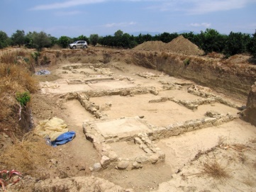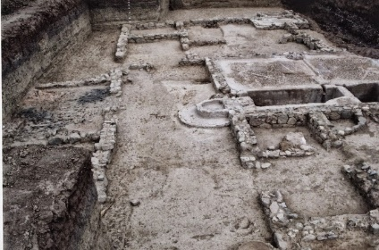
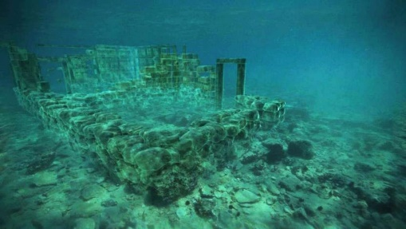
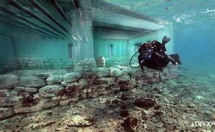
Discovered in 1961, the ancient Greek port city of Pavlopetri slipped beneath the ocean 3000 years ago.

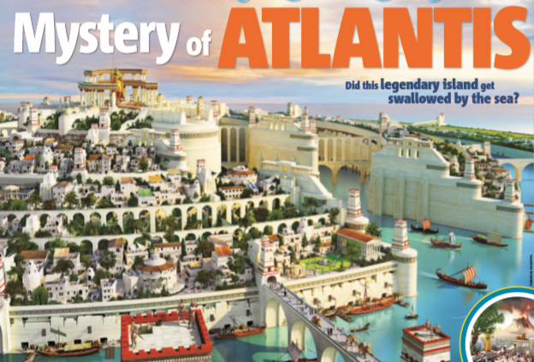

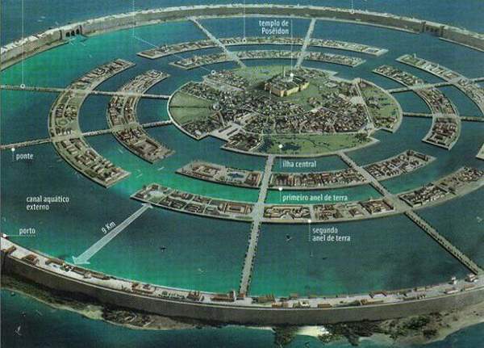

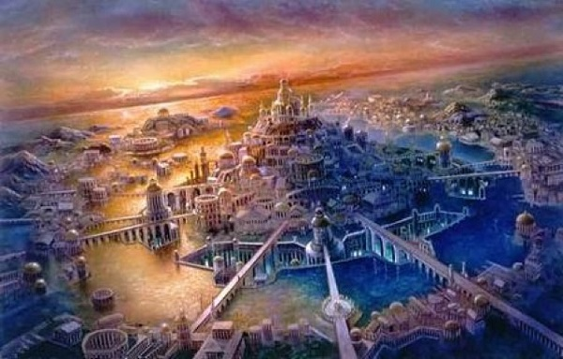

Mathematics
Year 6:
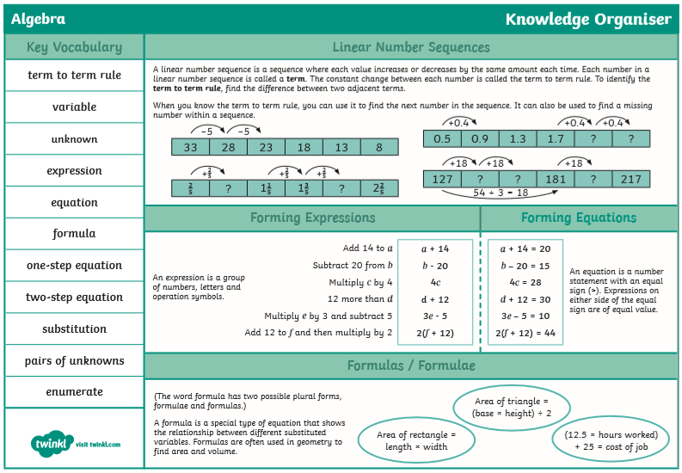
The focus for this week is to review our learning about using simple algebraic formulae. I have included three tasks for you to complete, as well as a knowledge organiser that I recommend you print/photograph to keep on your device, as it will also be of use for Year 7.

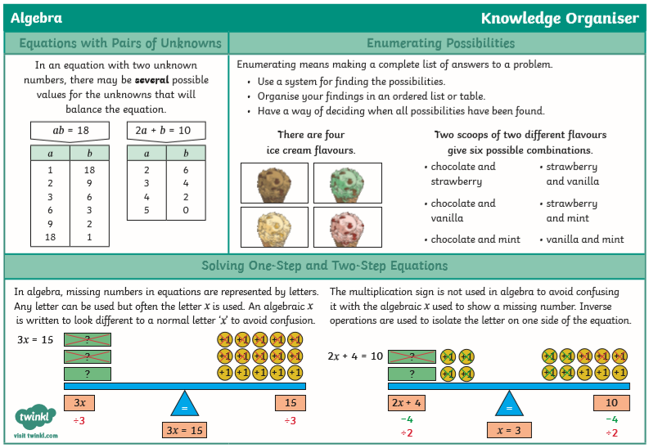

Task 1:
Use the slides in the Powerpoint (see link in this week’s work). as a starting point to this week’s mathematics learning. Take your time and work slowly through each task in order to review what we have already learnt in class this year.
Task 2:
Forming algebraic expressions (see link in this week’s work). As, always, if you do not have a printer or have run out of ink, simply copy and complete the work from your screen. Don’t forget to refer to the knowledge organiser if you get stuck – it’s very useful!
Task 3:
Finding pairs of unknowns (see link in this week’s work).

Year 5:
Year 5 pupils are welcome to try some of the Year 6 work but may need support in doing so. Otherwise, I have again chosen three pages for you to work through this week. Remember that section A is the easiest, B is medium and C is for when you are more confident.

This week I have chosen work which focusses on knowing your times tables; and using this knowledge to multiply and divide decimals and multiples of 10 and 100.
e.g. If I know that 8 x 3 = 24, I also know that 8 x 30 = 240 & 80 x 30 = 2400.
If I know that 18 ÷ 3 = 6, I also know that 1.8 ÷ 3 = 0.6 & 1800 ÷ 3 = 600.

You’ll also look at reviewing out learning about factor pairs. Do you remember this?
10 x 2
20 x 1

20
4 x 5

So the factors of 20 are: 1, 2, 4, 5, 10 & 20.
The last task this week is to find common multiples of two numbers.
e.g. What are the common multiples of 3 & 4?
Multiples of 3 | Multiples of 4
3, 6, 9, 12, 15, 18, 21, 24, 27, 30, 33, 36 | 4, 8, 12, 16, 20, 24, 28, 32, 36, 40, 44, 48
So the first 3 common multiples of 3 & 4 are: 12, 24 and 36 – What is the 4th one? How do you know?

As always, read the information on the page carefully and just try your best!
(See next three pages for this week’s Year 5 tasks).

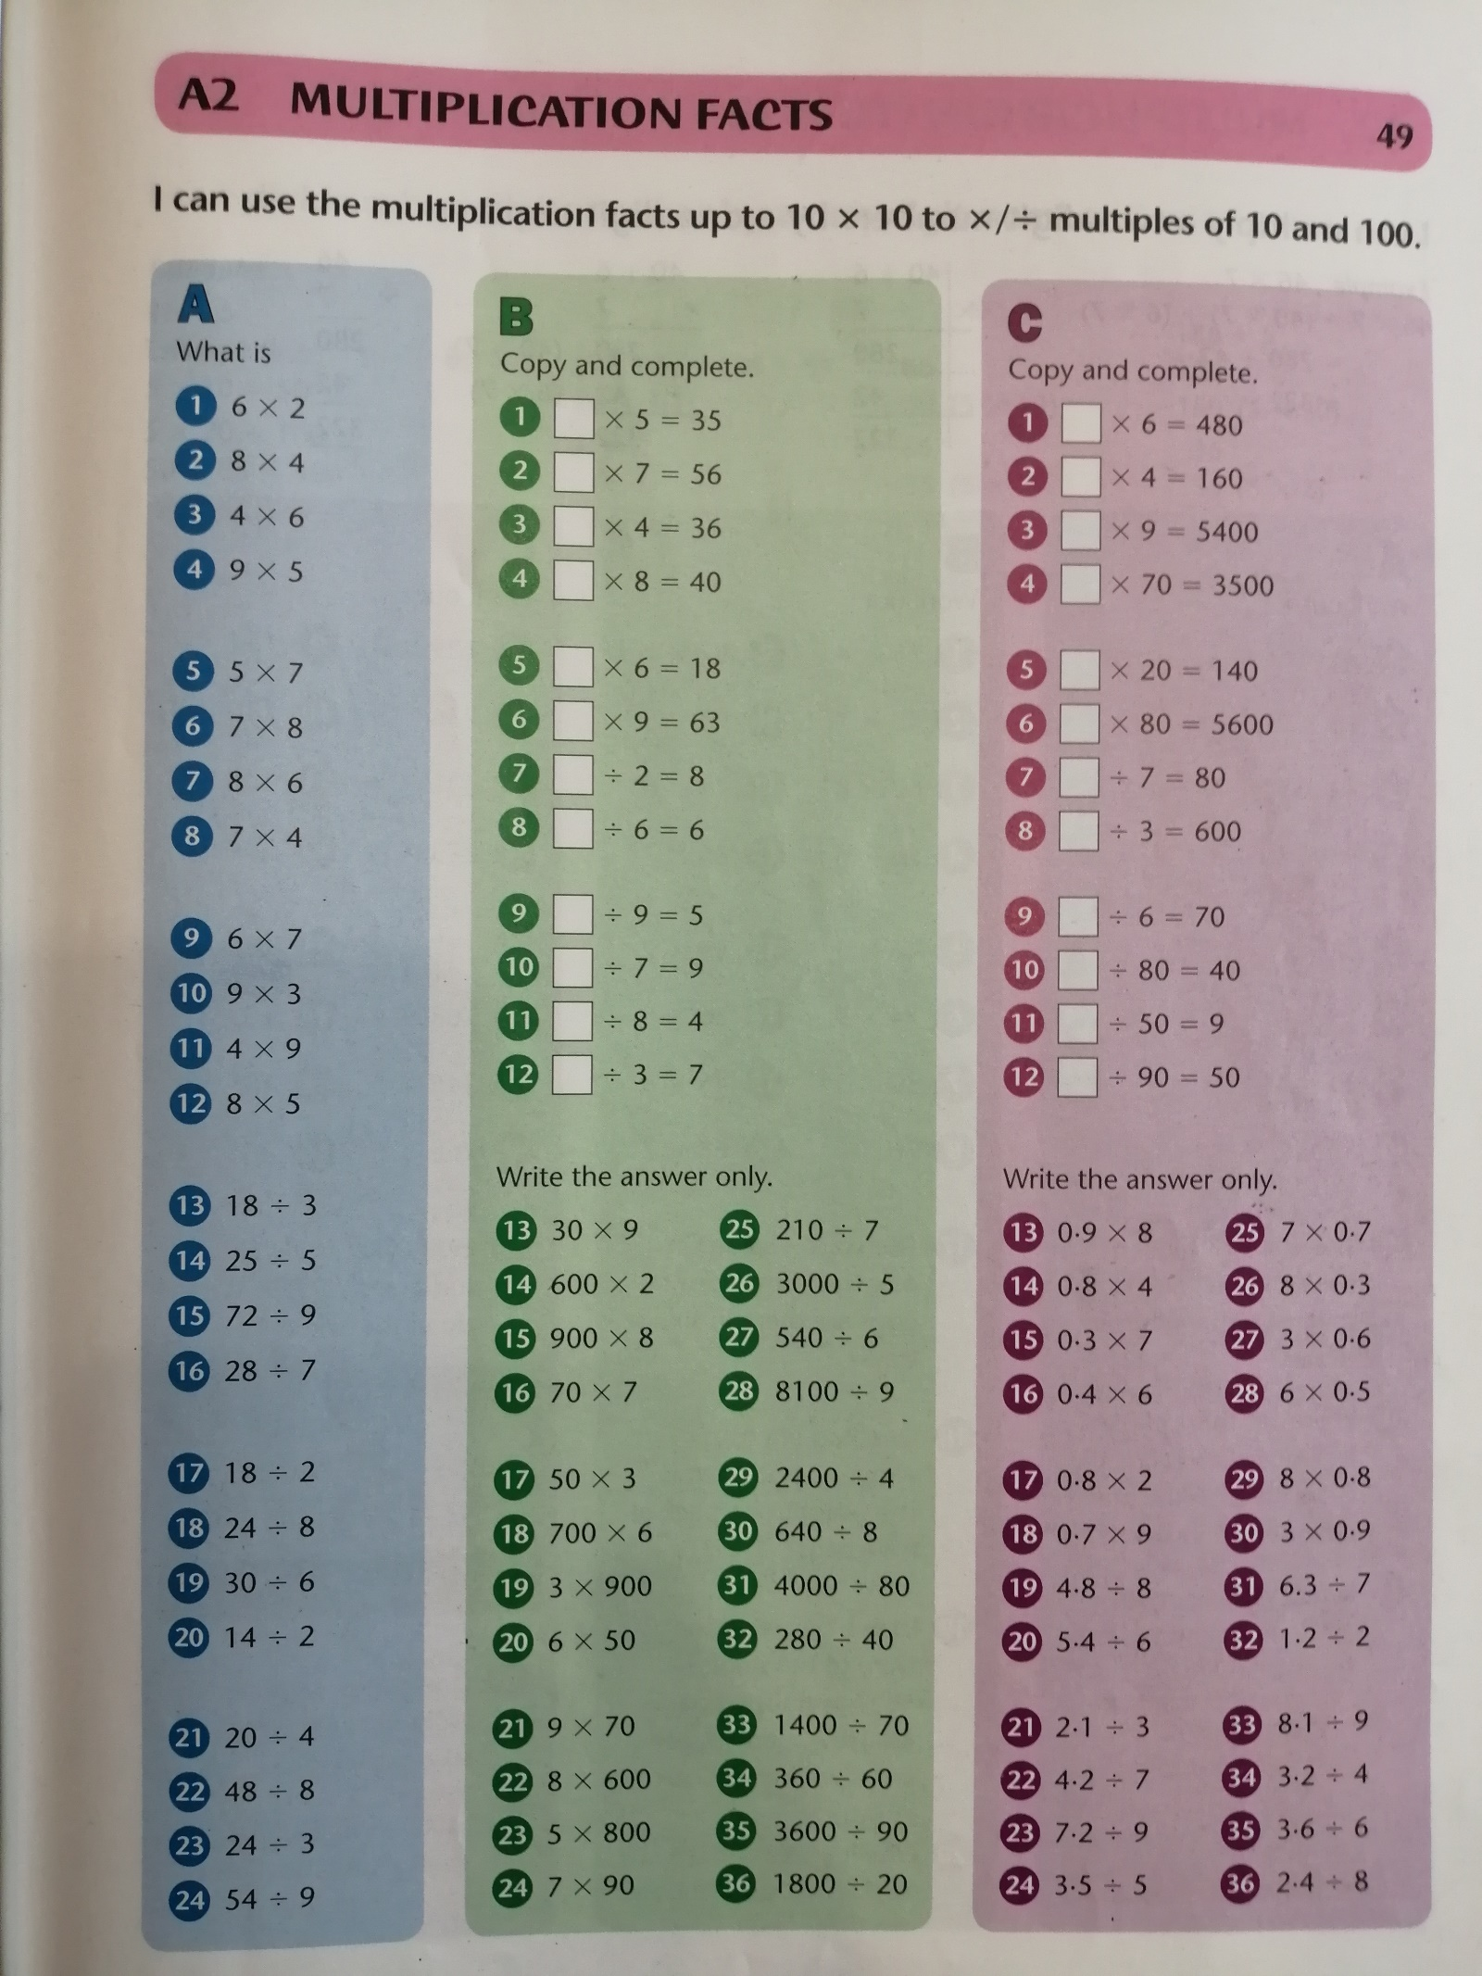
Year 5 Task One:

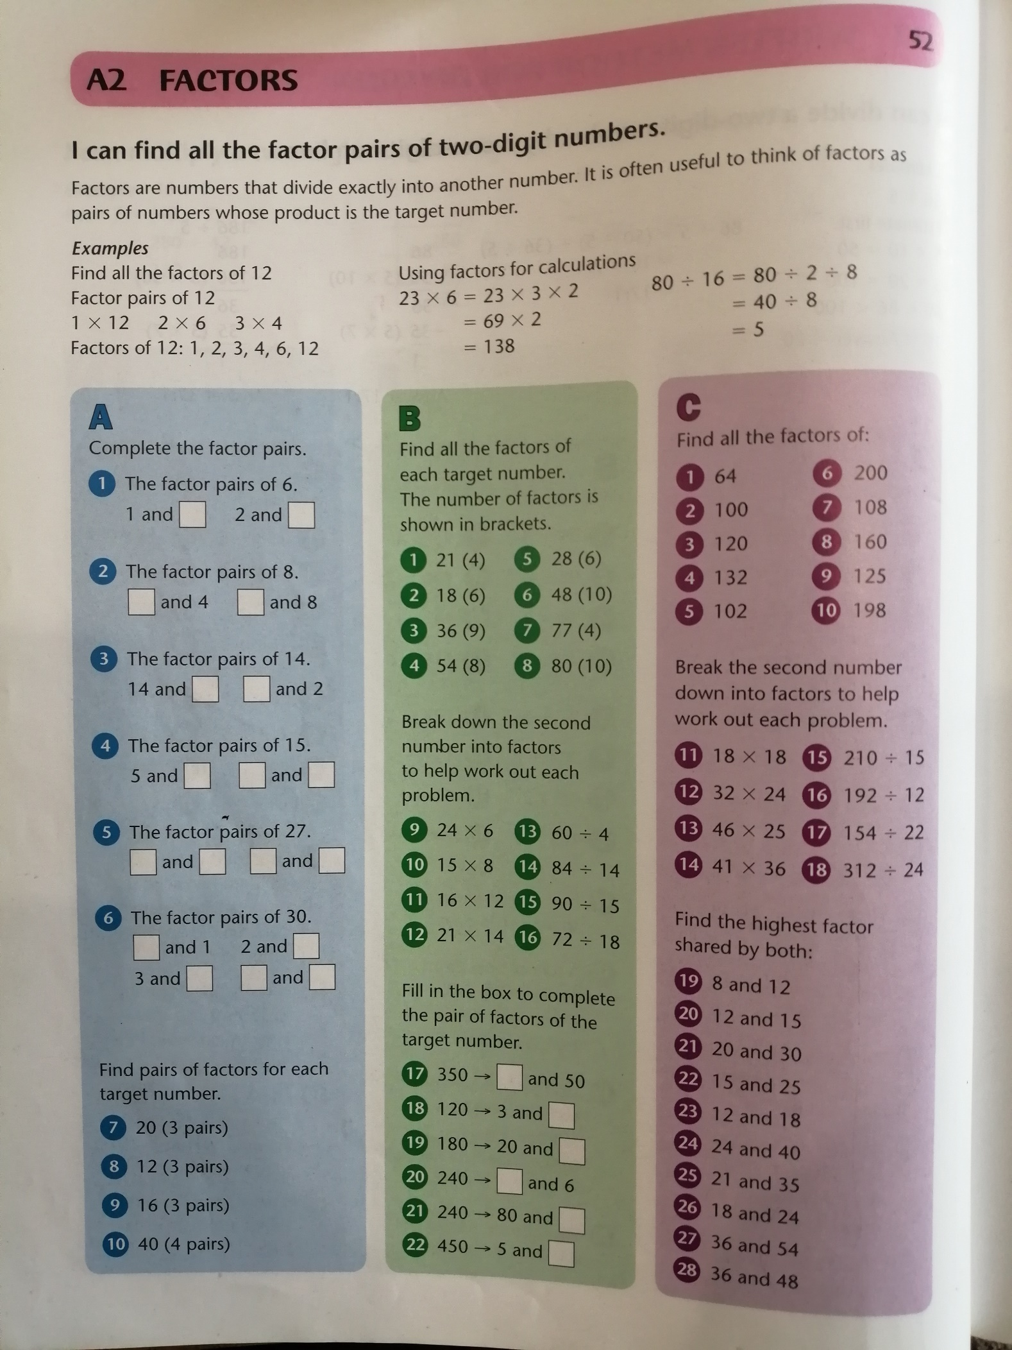
Year 5 Task 2:

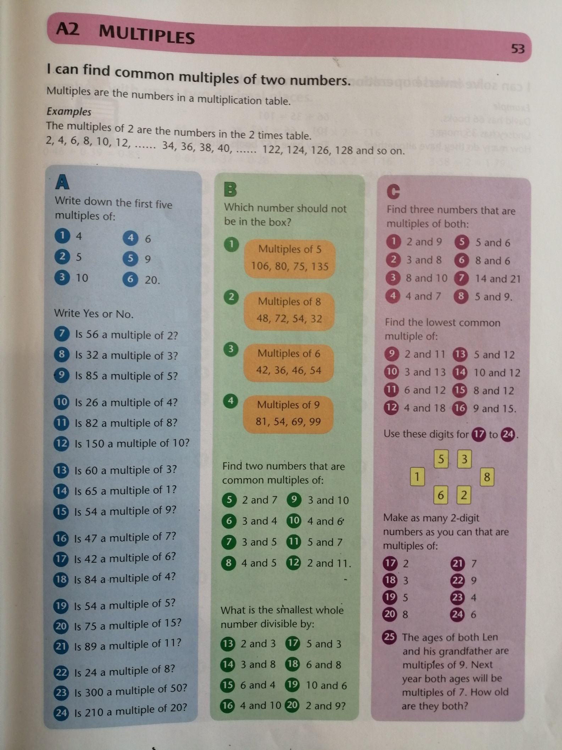
Year 5 Task 3:

Art & Design Technology
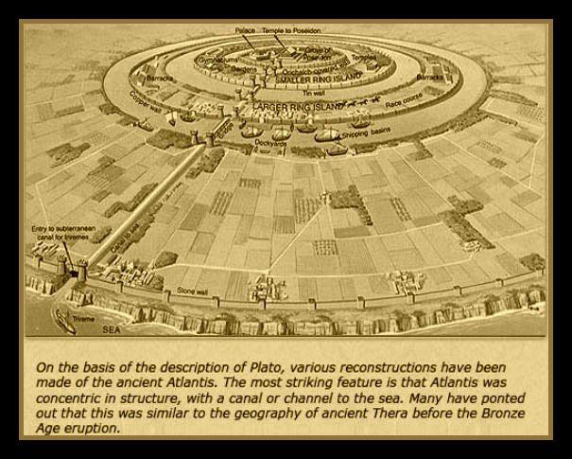
This week, why not have a go at creating either a painting or a 3D model of Atlantis or a scene from the mythical city? You could recycle materials from around your home or use Lego or clay.
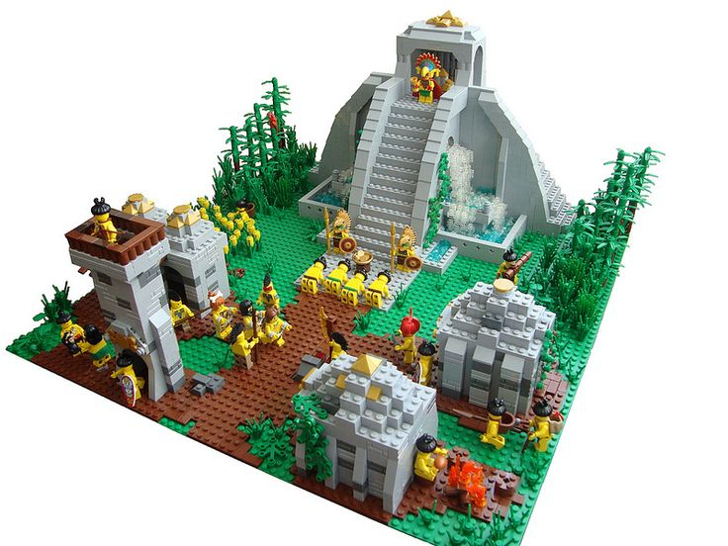

A couple of weeks ago, you were learning about caves, arches stacks and stumps. How did you do? I thought you’d like to see the model that I made, so if you have yet to make one yourself, why not give it a try?
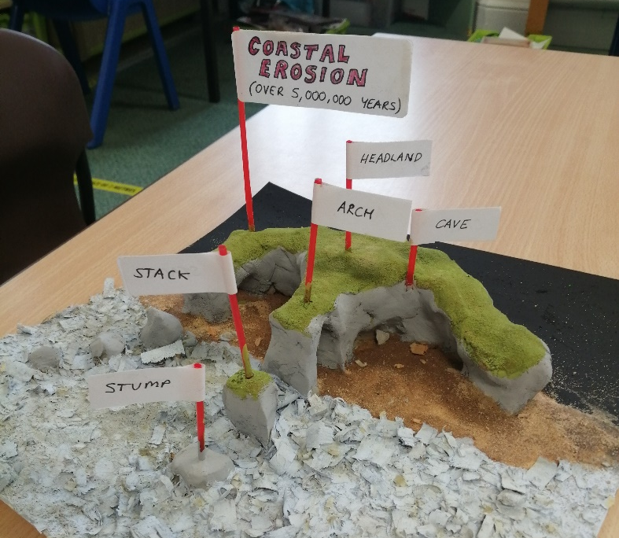
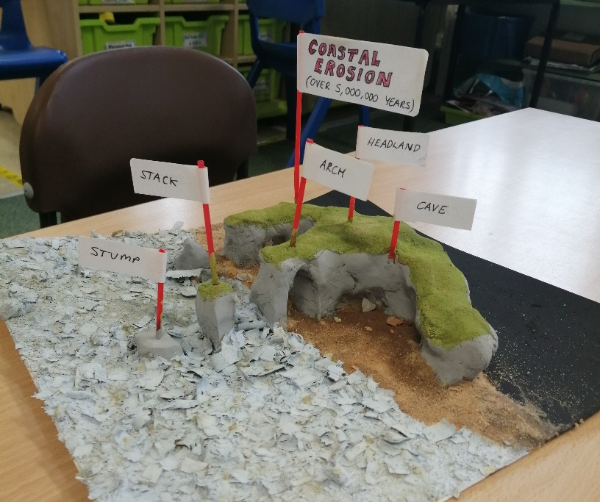

Science & Geography
Linked to your studies of the Lost Civilisation of Atlantis, I have included an information Powerpoint about Tsunamis and how they are created. Please read through this as it may well help you in your diary writing this week.
On the next page, there is also a science activity for you to try!

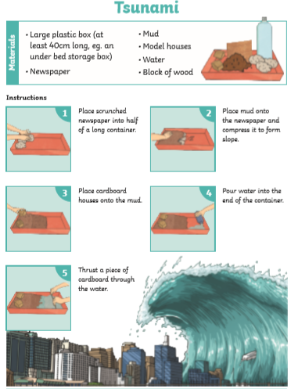

This week’s spellings:
Class 4 spelling list for group 3: Week 35
Objective: To understand how diminutives are formed.
Spellings | Look, cover, write, check
 | Monday | Tuesday | Wednesday | Thursday
sapling
gosling
weakling
duckling
piglet
eyelet
microscope
microchip
microfilm
microphone
miniature
miniskirt
minibus
minimum
statue
statuette
kitchen
kitchenette

Class 4 spelling list for group 2: Week 35
Objective: To transform words – making comparatives.
Spellings | Look, cover, write, check
 | Monday | Tuesday | Wednesday | Thursday
angry
angrier
angriest
heavy
heavier
heaviest
busy
busier
busiest
weight
weightier
weightiest
crazy
crazier
craziest
high
higher
highest
unhappier
unhappiest

Class 4 spelling list for group 1: Week 35
Objective: To transform words – making comparatives.
Spellings | Look, cover, write, check
 | Monday | Tuesday | Wednesday | Thursday
grumpier
grumpiest
speedier
speediest
busier
busiest
unhealthier
unhealthiest
stranger
strangest
funnier
funniest
hairier
hairiest
earlier
earliest
wrigglier
wriggliest
brainier
brainiest

Enjoy your learning, stay safe and keep smiling.
Mr, Smith

