Hello Class 4!
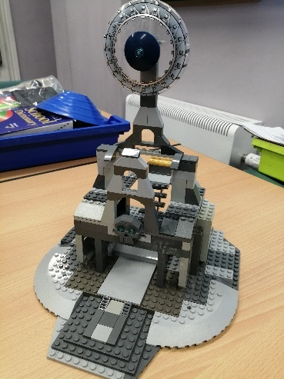
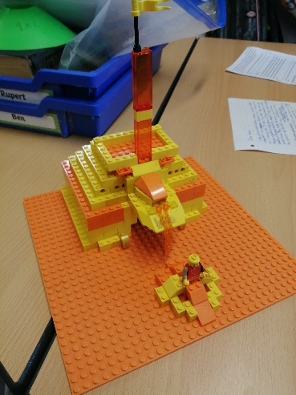
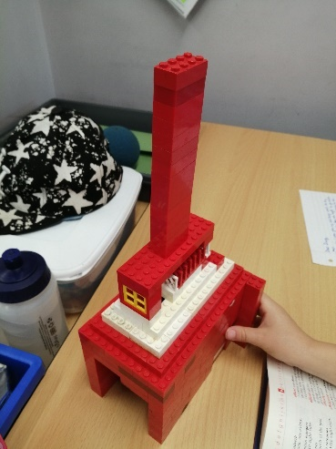
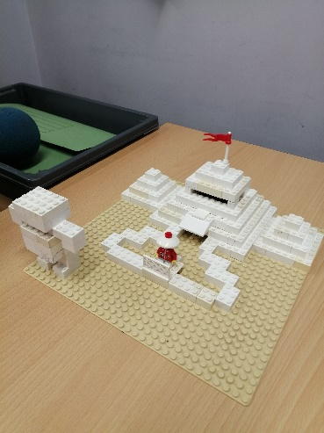
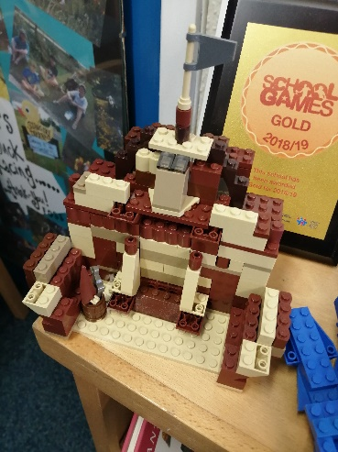
I hope you enjoyed finding out about the lost city of Atlantis last week. The children in our school bubble wanted to show you their Lego model temples. They were given just one colour to use to make sure they were not sharing pieces! These photos might give you some ideas if you haven’t tried this task yet.
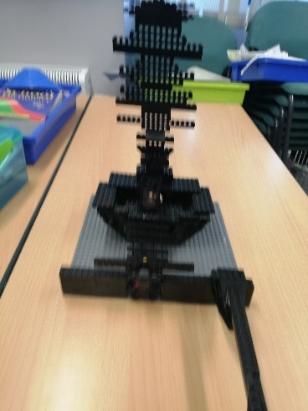
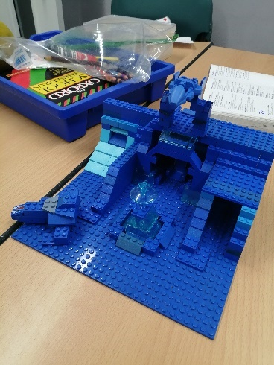
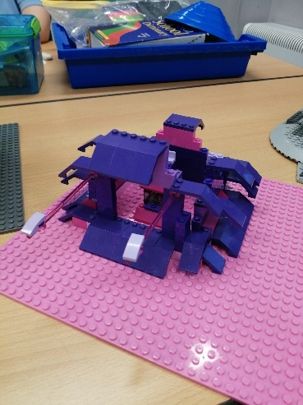
This week, we are going to continue our historical theme by learning about The Trojan War.
English/History
Watch the videos on https://www.bbc.co.uk/programmes/p08690qz
They tell the story of The Trojan War, how it all was caused, and how it ended in a really entertaining series of 7 short clips.
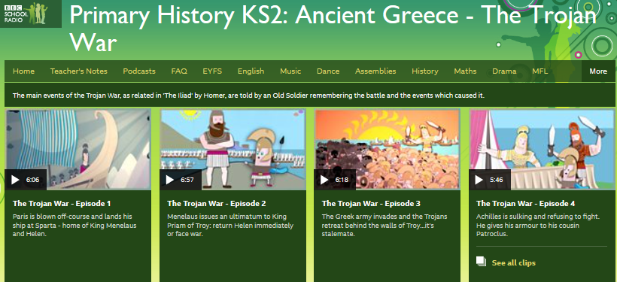
After you have watched the videos (you could watch a couple per day) have a go at re-telling the story in your own words. You could write it as a narrative; a playscript of a scene - like we did with Romeo & Juliet earlier in the year; write a song or poem/rap to tell the story in a different way; or make your own comic strip using speech bubbles and captions.

I’ve also included some extra information from the internet for you to read and talk about (see below).
The Trojan War was a legendary conflict between the early Greeks and the people of Troy in what is now Turkey. It was said to have taken place more than 3,000 years ago.
The story of the Trojan War fascinated the ancient Greeks. The conflict was an important theme in ancient Greek and Latin literature, including the famous Iliad and Odyssey by the Greek poet Homer. Nobody knows for certain how closely the legend of the war reflects actual events.
The city of Troy, where the war supposedly happened, was a real place. It was located in Asia Minor, an area that is now the country of Turkey. Many scholars believe that ancient Troy was destroyed by fire sometime between 1260 and 1240 bc.
The stories about the Trojan War were based on an actual struggle for control over rich trade routes. Troy lay at an important point on a narrow waterway called the Hellespont in ancient times (now the Dardanelles). That waterway links the Black Sea with the Aegean Sea through the Sea of Marmara. The city was very wealthy, probably because it demanded tolls and tax payments from trading ships and travellers. Troy’s interference with Greek trade may have been the Greeks’ reason for waging war.

Causes
The legends about the war suggest a cause other than trade disputes. According to Homer’s Iliad, the war was fought during the rule of the wealthy and powerful King Priam of Troy. The conflict began when Priam’s son Paris fell in love with a woman named Helen.
Helen was the wife of King Menelaus of Sparta, which was part of Greece. Paris went to Greece and won Helen’s love. He persuaded her to flee with him to Troy and refused to return her to Menelaus. The Greeks, led by Menelaus’ brother Agamemnon, then launched an attack against Troy.

War and Aftermath
With help from some allies, Troy withstood the Greek attack for 10 years. Gods and goddesses took sides in the conflict. Hera, Athena, and Poseidon supported the Greeks, while Aphrodite, Apollo, and Ares sided with the Trojans.
The Greeks eventually won the war through trickery involving the famous Trojan horse. According to legend, the Greeks, with Athena’s help, built a huge, hollow wooden horse. Many Greek warriors hid inside it. The rest of the Greek army then pretended to abandon the fight. They sailed away to a nearby island, leaving the horse behind.
The Trojans took the horse inside the walls of Troy as an offering to Athena. During the night the rest of the Greeks returned. The warriors hiding inside the horse came out and opened the city’s gates for them. The Greeks then conquered and destroyed Troy. King Priam and his remaining sons were killed. Menelaus took Helen back to Sparta, and they lived happily together. Homer’s Odyssey describes the adventures of some of the Greek victors on their way home from Troy.
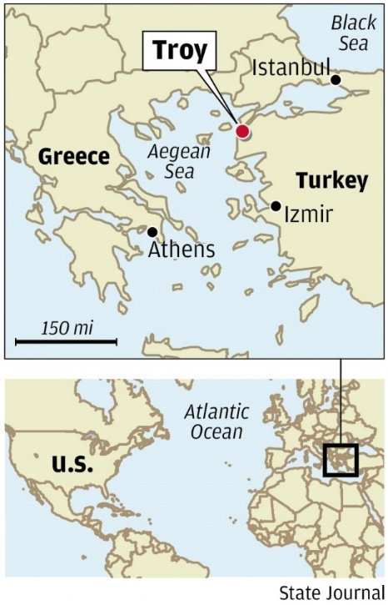
(Source: Britannica Kids)
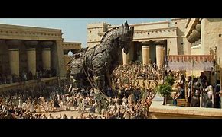
Research Quiz
1) Which of the following heroes was immortal except for a spot in his heel?
A: Odysseus
B: Ajax
C: Paris
D: Achilles
2) In which of the following modern countries is Troy located?
A: Turkey
B: Greece
C: Israel
D: Lebanon
3) Which of the following was kidnapped?
A: Cassandra
B: Helen
C: Priam
D: Hector
4) Which of the following did the Greeks leave on the beach at Troy?
A: A monument of clay
B: A wooden horse
C: A wooden altar
D: A stone box
5) Which of the following is given credit for writing down the story of the Trojan War?
A: Hector
B: Homer
C: Menelaus
D: Agamemnon
6) Which of the following began the earliest serious excavations at Troy?
A: Hermann
B: Schliemann
C: Gorman
D: Sulman
(Source: softschools.com)

Interesting Video showing where in the world Troy was located: https://www.britannica.com/place/Troy-ancient-city-Turkey

Science & Geography: The Oceans of the World
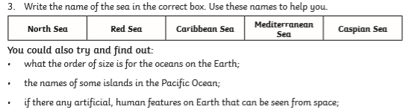
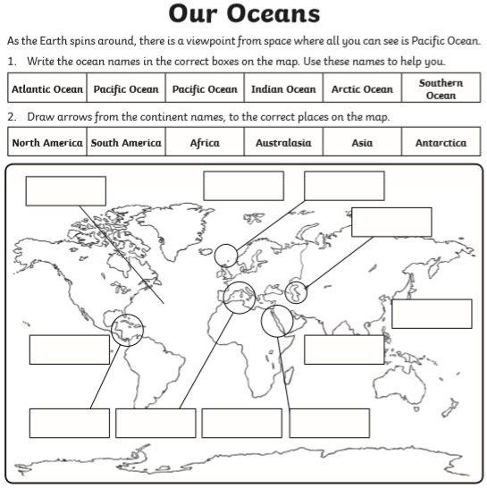
Before you leave primary school, you are expected to know the names of all the worlds oceans and main seas. This week I’d like you to have a go at completing the following activity:

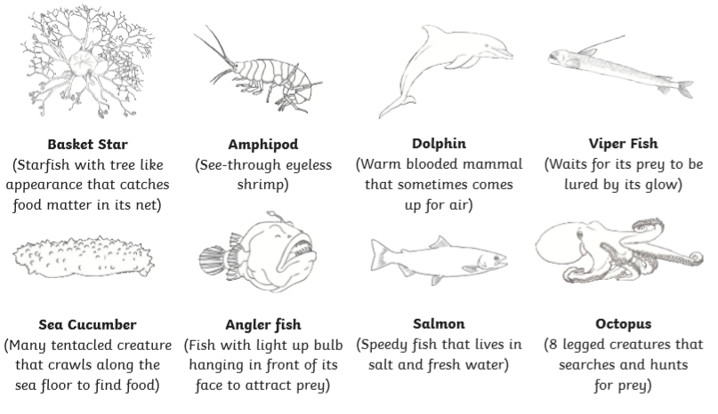
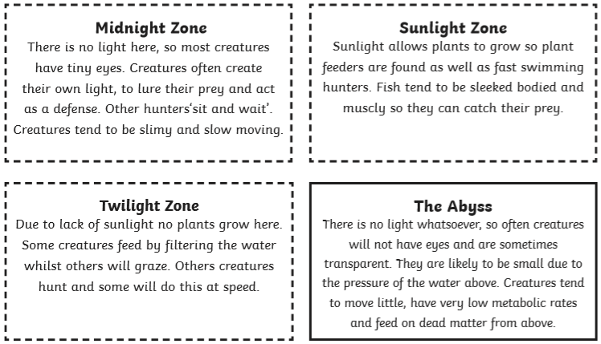
You could also investigate the different ‘layers’ of ocean depth and produce an information poster about the creatures that live in each zone.
On the next page is my example to help you to produce your information poster. I still need to add a few more living things to each zone.

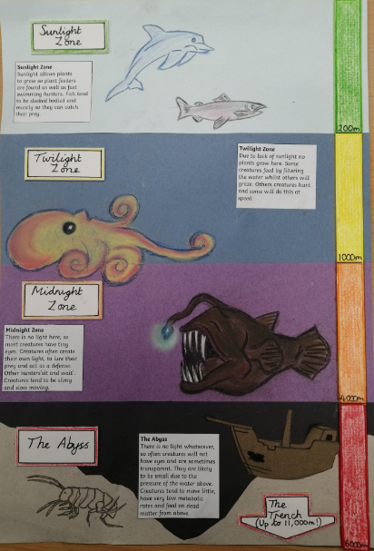
Art & Design
The challenge this week is to try to make a model Trojan Horse (any material).
OR…
You could try this (linked to our work on Atlantis last week). I used art straws, coloured paper and pastels.

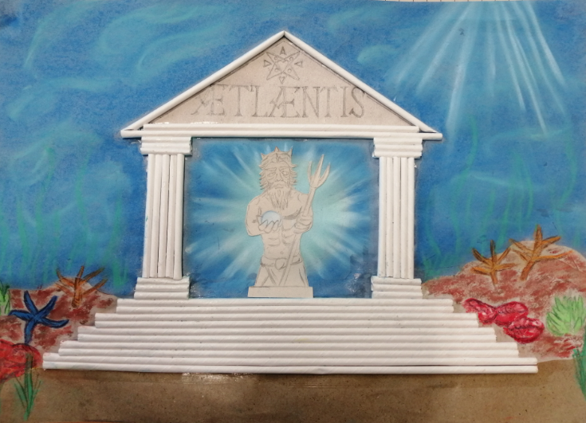
Latin

Heart of Atlantis,
held by
Poseidon

Mathematics
Year 5 & Year 6 Task One:
Try the Algebra Alphabet Challenge that is posted on the website for this week. Don’t forget to read carefully and start with the letter D.
Helpful hints if you get stuck:
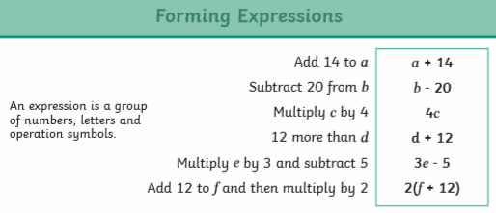

Year 5 & 6 Task Two:
Space-Themed ‘Moji Maths challenges. There are three different levels to choose from, so choose which level suits you best, but don’t be afraid of a challenge.
Year 5 Task Three:
Complete the linear number sequences (Also a choice of three difficulty levels). Can you describe the rule each time?
Year Six Task Three:
Expressing missing numbers algebraically. Please don’t forget to use the help sheet that I included with last week’s learning – it will really help you.
This week, I’d also like you to spend time improving your recall speed when answering x tables questions. Below is a great link to work on the tables you are least confident with – you can even print out a ‘speed report’ for how quick you are!
https://www.timestables.co.uk/speed-test/
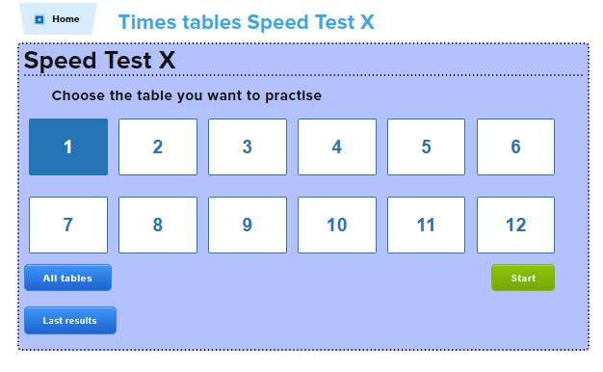

This week’s spellings:
Class 4 spelling list for group 3: Week 36
Objective: To spell words with the /k/ sound spelt ch.
Spellings | Look, cover, write, check
 | Monday | Tuesday | Wednesday | Thursday
echo
chaos
chorus
chrome
chemist
choir
anchor
school
Christmas
stomach
monarch
architect
character
mechanic
technology

Class 4 spelling list for group 2: Week 36
Objective: To transform words – converting nouns or adjectives in verbs (and revision of verb endings)
Spellings | Look, cover, write, check
 | Monday | Tuesday | Wednesday | Thursday
interesting
interested
suggesting
suggested
appearing
appeared
surprising
surprised
answering
answered
education
educate
reduction
reduce
proposal
propose
critic
criticise
confusion
confuse

Class 4 spelling list for group 1: Week 36
Objective: To transform words – converting nouns or adjectives in verbs (and revision of verb endings)
Spellings | Look, cover, write, check
 | Monday | Tuesday | Wednesday | Thursday
attention
attend
decision
decide
magnet
magnetise
achievement
achieve
collaboration
collaborate
critic
criticise
surprising
surprised
attentive
attentively
indecisive
magnetising
collaborative
collaboratively

And that’s all for this week. Stay safe, healthy, fit and happy. Until next week…
Totsiens, Ma'a as-salaama, Bidāẏa, Zdravo! Joigin, Donadagohvi, Doviđenja, Sbohem, Farvel, Tot ziens, Nägemist! Näkemiin, Au Revoir, Auf Wiedersehen, Yasou, Aloha, L'hitraot, Namaste, Viszlát! Vertu sæll! Sampai Jumpa, Slan, Arrivederci, Sayōnara, Annyeong, Uz redzēšanos! Atsiprasau, Zài jiàn, Ha det bra, Żegnaj, Adeus, Alweda, La revedere, Do svidaniya, Zdravo! Dovidenia! Nasvidenje, Adios, Adjö, Poitu varein, Laa Gòn Görüşürüz! Do pobachennia! Khuda hafiz, Tạm biệt, Hwyl fawr!
Can you find a famous/well known person who would say ‘goodbye’ for each one of these in their native language?
For example, Jürgen Klopp would say ‘Auf Wiedersehen!’
Mr. Smith

(I’m sorry, I had to ‘squeeze this in’ somewhere this week!)

