Home Learning for w/c 22nd June 2020
Hello Class 3
Another very busy week for those children in school and a busy week I am sure for everyone learning from home. I have seen some amazing pieces of work that have been sent in to school; via admin and I have felt so proud of what you have achieved. I wonder if anyone has used their time at home to learn a new skill or talent. I would love to hear about this as well.

Take care and have a good week.
Mrs Jordan

https://youtu.be/-dMUbf61dJE

https://youtu.be/IOjXB7SNdAM

Maths
I hope that everyone is feeling more confident about telling the time. This is something I would like you to continue to practice. Ask someone at home to choose random times throughout the day for you to say what time it is. You could do this using the 12 hour clock, 24 hour clock or writing the time in a digital format or even as a Roman numeral.
For the coming week we are looking at statistics.

Year 3
Interpret and present data using bar charts, pictograms and tables.
Solve one and two step questions.

Year 4
Interpret and present discrete and continuous data using different methods.
Solve problems.

Remember when you are drawing out your own bar / line graph to think carefully about the scale that you are using. If you had data from 100 people you could go up in 5’s or 10’s. If you only had data from 20 people you may go up in 2’s. Your graphs always need to be drawn with a ruler and must have a title as well as a clearly labelled x and y axis.

You can try the questions on the next page or why not use a tally chart to count the number and type of vehicles in an hour, or the number and type of garden birds and then record these on a bar graph.

Year 4 – You could collect the temperature outside over the course of a week and use a line graph to represent this continuous data. Or why not fill a cup with water and leave it in a sunny place and keep taking the temperature.

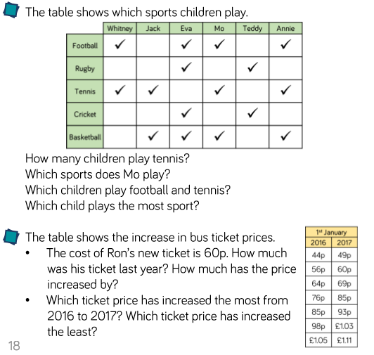
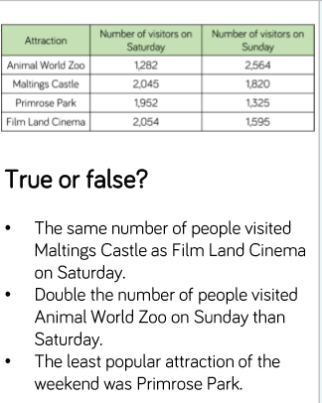
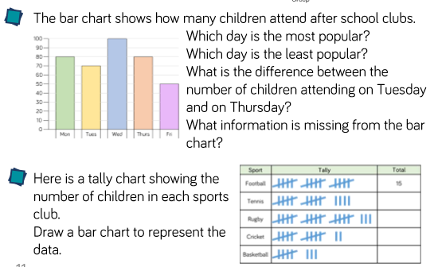

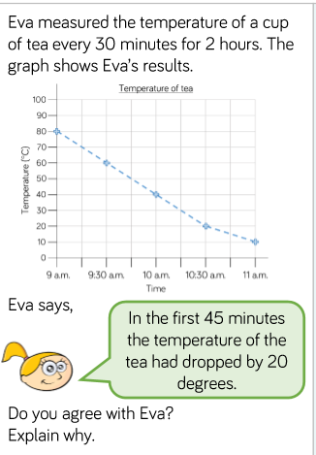
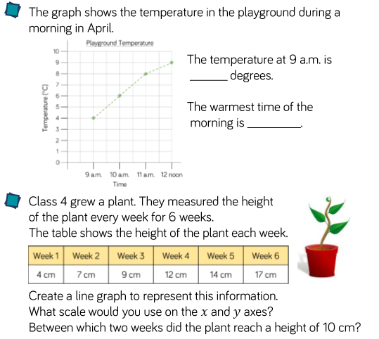

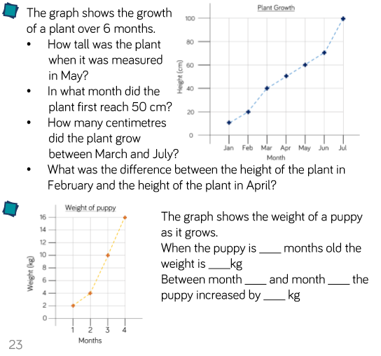

English / Theme / Geography

This week I would like you to learn all about the importance of Lindisfarne in relation to Viking invaders.

Start by watching the clips below as well as the attached power point.

https://www.bbc.co.uk/bitesize/clips/zrpnvcw

https://www.bbc.co.uk/teach/class-clips-video/history-ks2-the-vikings-animation/zhrygwx

Can you carry out some further research and create a fact file on Lindisfarne. Where is it? Can you find it on a map, you could even draw the country and label where Lindisfarne is. Who lived / lives there? What landmarks are there? What happened in 793?
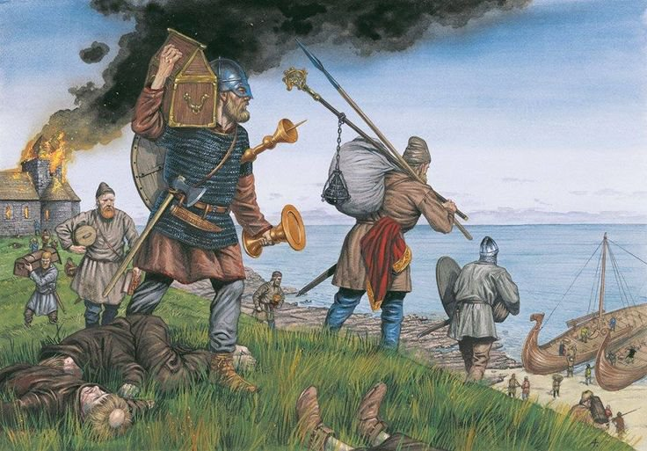

Imagine you are a news reporter, can you create a newspaper article all about the Viking raid. Your first sentence needs to be short and snappy giving facts about the event. Can you answer the questions, who, what, when, where, how, why? You could also use quotes to make your newspaper article more credible.

Science -

This week we are learning all about the fact that different types of animals have different teeth to suit their diet.

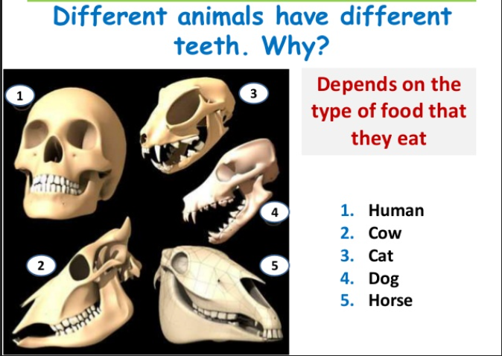

https://www.bbc.co.uk/bitesize/articles/z846gdm

http://www.bbc.co.uk/newsround/39113605

- Attached is a sheet for you to have a look at and complete but you don’t need to print it out. From your knowledge about teeth I would like you to look at the animal skull pictures, can you say by looking at their teeth whether they are herbivore, omnivore or carnivore? Can you guess which animal they are from?

I will give you the answers next week!

- An alternative activity would be for you to choose your favourite animal and think about the shape of their skull. Can you draw the animals head and the teeth that they would have. You can label your picture.

French
Over the last week we seem to have experienced every single type of weather imaginable so this week we will focus on weather.

Quel temps fait-il? What’s the weather like?
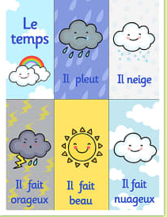

Please see the attached power point to help you with the words.
- Can you keep a weather diary for the coming week and write in French what the
weather is doing each day?
- I have attached a French weather fortune teller that you could make and practice say the different phrases.

Theme / – Vikings
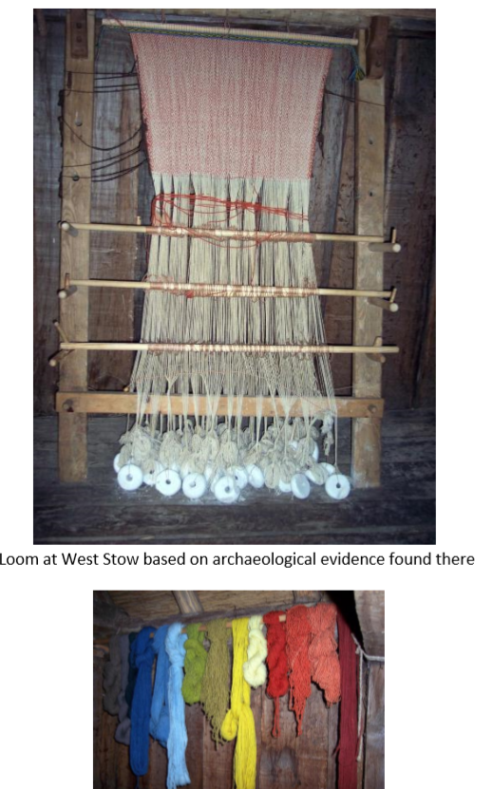
Coarse wool from sheep and goats would be used for clothing and would be dyed using natural materials. Women and children would then spin and weave the wool to make clothes.

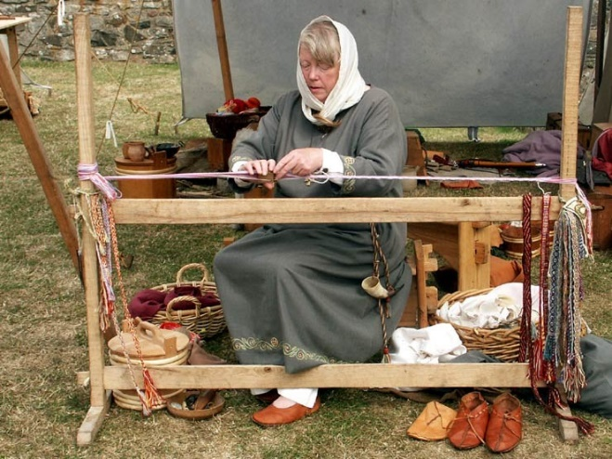

- Can you make your own loom and have a go at weaving? Use the instructions below to help you get started.

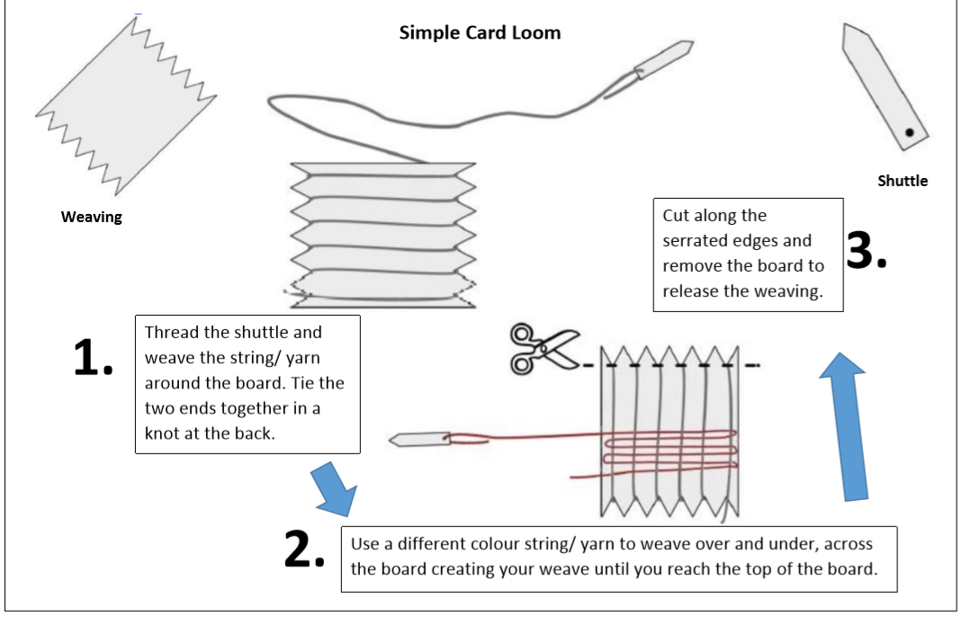
PE
In school we have been enjoying ‘Cosmic Yoga’ and practicing the different positions as well as listening to the fun stories. It doesn’t matter what exercise or activities you have a go at it’s just important to stay active and enjoy the fresh air. I have enjoyed going on lots of walks as well as playing badminton over the garden washing line!

Art and Design

Following the announcement that this year’s Railway in Wartime event has been cancelled, North Yorkshire Moors Railways has launched a specially themed drawing competition, with the winner receiving a trip to the railway for their entire class.

They would like children to think about what the railway might have looked like during wartime and put pen to paper to draw their interpretation of it.

Please look at the website (link below for more details.

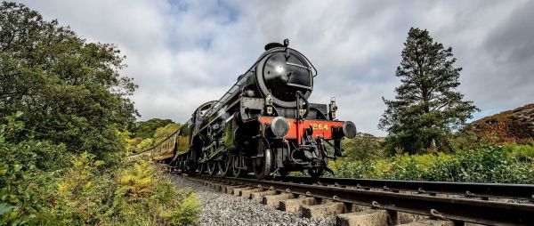
https://www.nymr.co.uk/

General

Blue Peter have started their ‘6 Badges of summer’, every week there will be a different theme to the badges ranging from sport, to helping save the environment, music, thank you as well as a final silver badge. I feel there is something for everyone so why not have a look a choose one to suit you.

