What to do
IMPORTANT Parent or Carer –
Please check that you are happy with any weblinks or use of the internet.

1. Counting practice

- Ask your child to start counting up to twenty slowly and clearly.
- Stop them by clapping once.
- They must whisper the number they would be saying next. Are they correct?
- Repeat this several times, stopping them at different points.
Extension
- Do as above but counting backwards from 20.
- Or start at 40 and count forwards. Or start at 56… etc.

2. Working together

- Look carefully at Animal Races below. Now follow these instructions.
  - Read each question carefully.
  - Encourage your child to work out the answer.
  - When you have finished answering all the questions, check the answers together. How many did you get right?

Try these Fun-Time Extras
- Create your own ‘Animal Race’. Use your soft toys or some pictures of animals.
- Arrange the animals in a race, then decide who is 1st, who is 2nd, who is 3rd, etc.
- Who comes last?

Animal Races
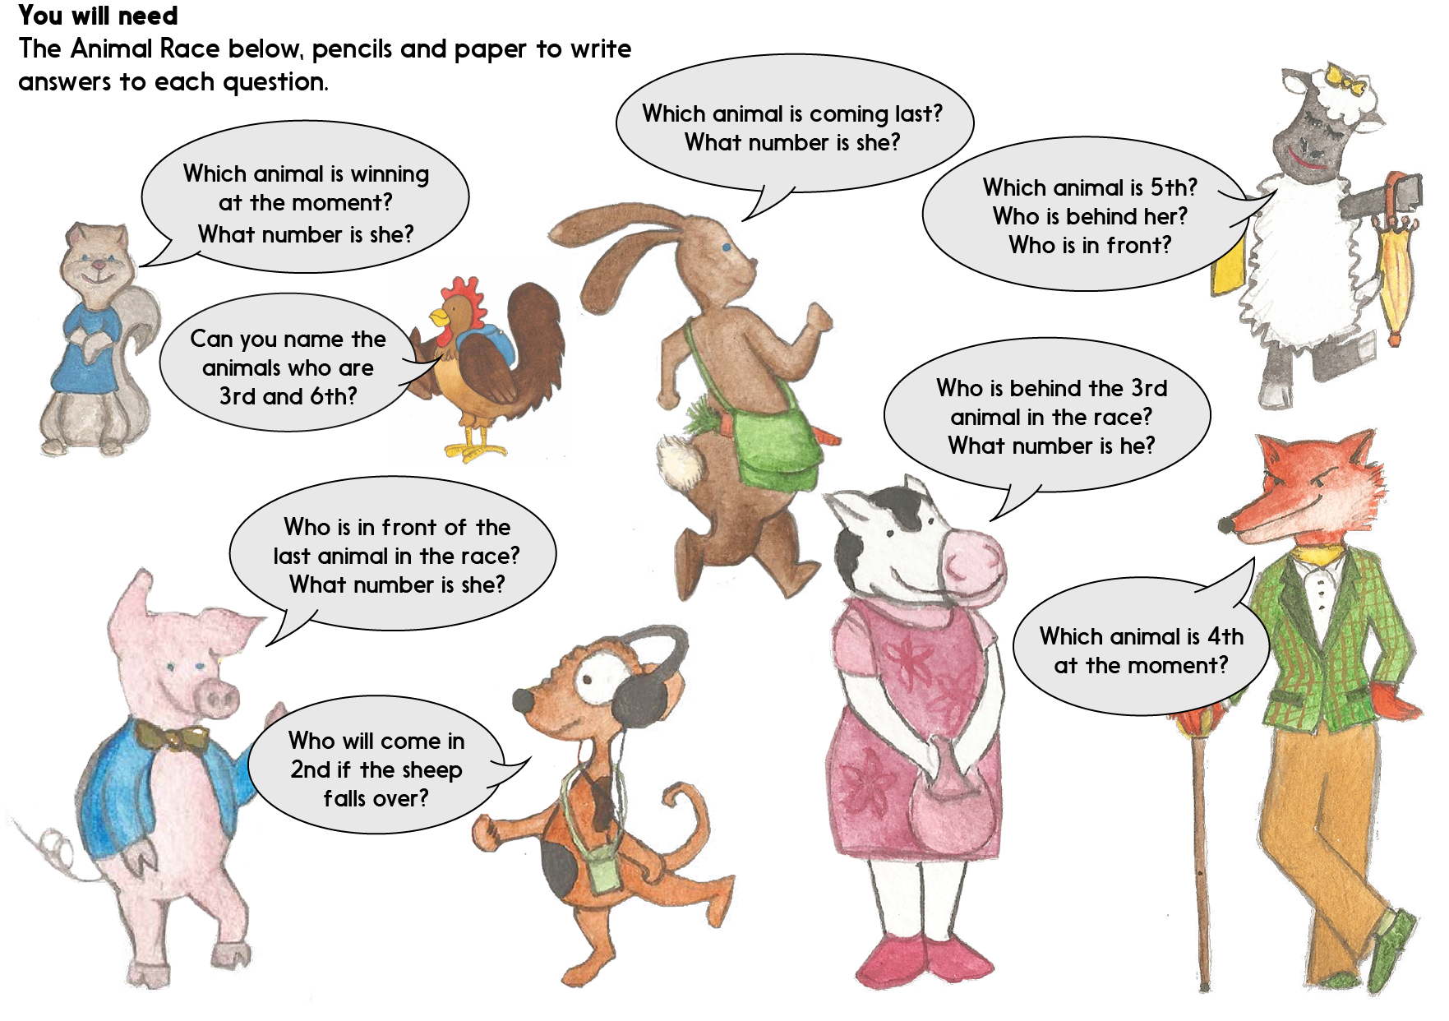

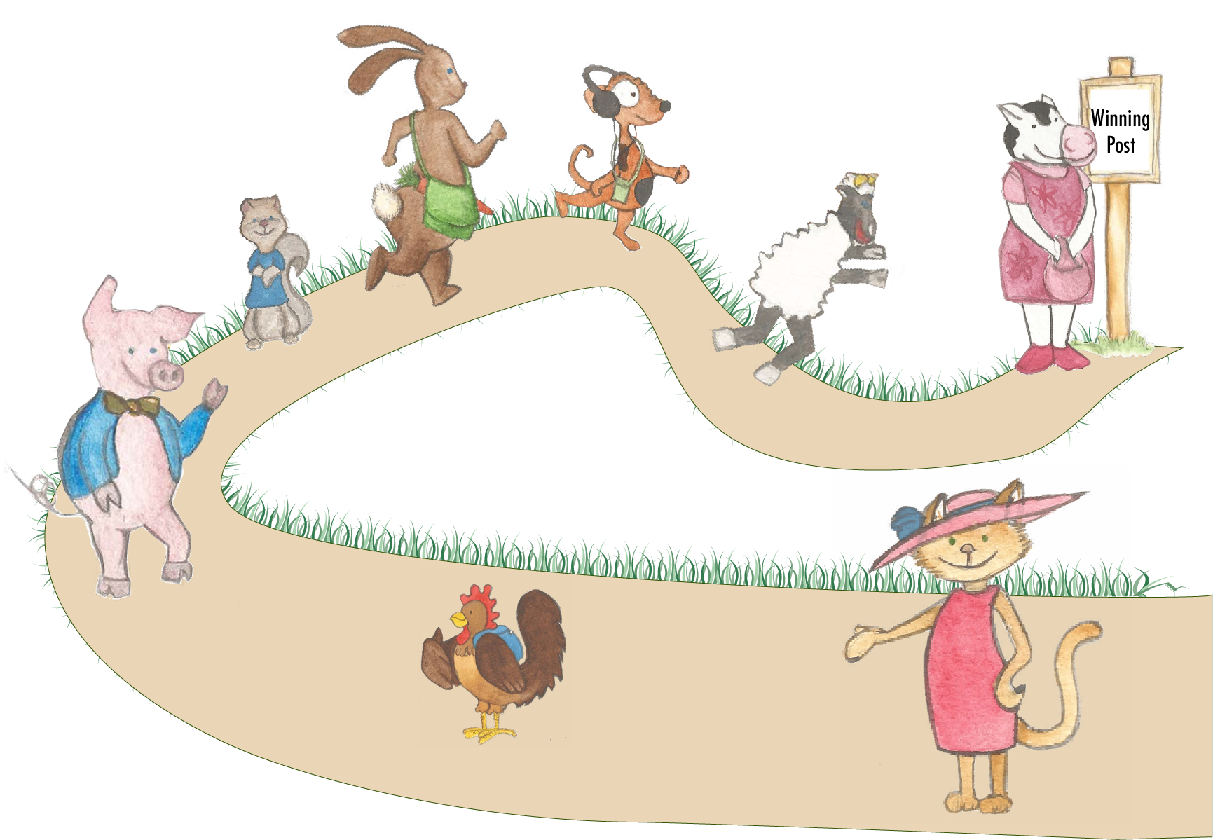
Animal Race

Animal Race Answers

Squirrel question: Which animal is winning at the moment?
Cow is winning. She is 1st.

Rabbit question: Which animal is coming last?
Cat is last. She is 8th.

Fox question: Which animal is 4th at the moment?
Rabbit is 4th.

Chicken question: Can you name the animals who are 3rd and 6th?
Dog is 3rd and pig is 6th.

Cow question: Who is behind the 3rd animal in the race?
Rabbit is behind Dog. Rabbit is 4th.

Pig question: Who is in front of the last animal in the race?
Chicken is in front of Cat. Chicken is 7th.

Sheep question: Which animal is 5th? Who is behind her? Who is in front?
Squirrel is 5th. Rabbit is 4th and Pig is 6th.

Dog question: Who will come in 2nd if the sheep falls over?
If sheep falls over, then Dog would be 2nd.

