What to do
IMPORTANT Parent or Carer –
Please check that you are happy with any weblinks or use of the internet.

1. Counting practice

- Count 10, 20, 30, … 100 with your child!
- Throw a soft toy (e.g. a teddy) to them. They say 1.
- They throw it back to you and you say 2.
- Keep up a good pace, throwing and catching and saying the next number. (This is harder than you think!)
- Keep throwing it back and forth. How far can you get?

Extension
- You can have a forfeit if you say the wrong number! E.g. Hop round the table twice!

2. Working together

- Work through Superhero Order together.
  - You will need cut out Superhero counters and the instructions below.
  - You also need pens and paper.

Try these Fun-Time Extras

- Read Superheroes All Sorts and discuss what superheroes you have in your home. What type of superhero are you?
Superhero order

The 8 superheroes are in a line.
You are going to use the clues to put them in order from 1st to 8th.
HINT
Use 8 pieces of paper to make the 8 spaces in the line.
You will need:
Superhero counters from sheet below
Pens and paper to help you answer the questions

What to do
- Cut out the counters below.
- Follow the clues to place the superheroes in order.
- Then answer the questions.
Clues
Boy superhero comes before skinny cat
Skinny cat superhero is 5th

Fat cat superhero is 7th
Sweet dreams superhero is 1st

Long dog superhero is in between girl superhero and Sweet dreams

Fat superhero is behind Short dog
Baby superhero is last

Questions
- Which superhero comes after Short dog?
- Who is 3rd?
- Which superhero is 5th?
- Who is second in the line?
- Which superhero comes before Fat cat?

Superhero Counters
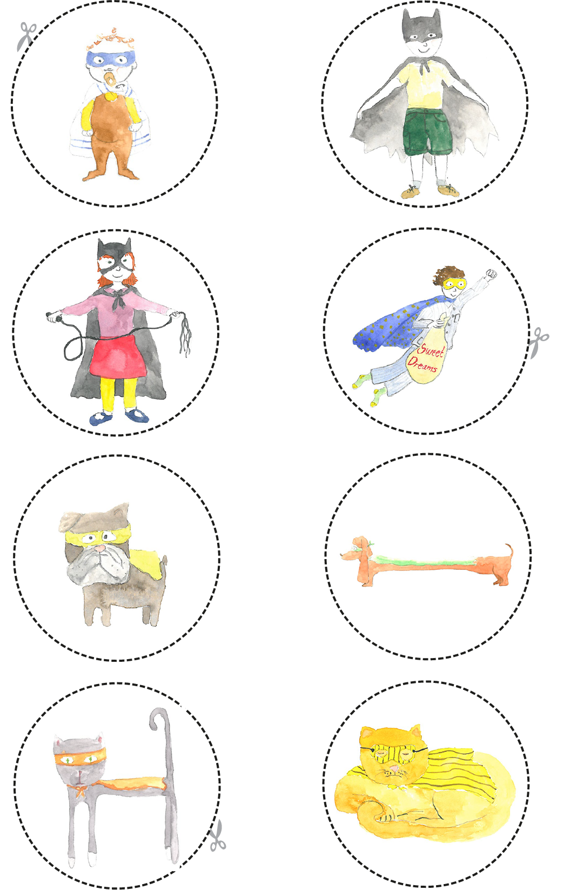
Cut round each counter.
Answers

The Superhero order is this.

Position | Superhero
1st | Sweet dreams superhero
2nd | Long dog superhero
3rd | Girl superhero
4th | Boy superhero
5th | Skinny cat superhero
6th | Short dog superhero
7th | Fat cat superhero
8th | Baby superhero

