What to do
IMPORTANT Parent or Carer –
Please check that you are happy with any weblinks or use of the internet.

1. Counting practice

- Show your child a 20p coin. Don’t name it.
- They have to count the number of pennies that coin is worth.
For example: you show 20p, and they count: one, two, three, four… up to twenty. Then they stop.
- Do they count correctly? Do they stop at the right amount?
- Repeat this using a 5p, a 10p and, maybe, a 50p.
Extension
- Do as above but use a £1 coin.

2. Play it together

- Find someone to play with. Then enjoy playing Track the Order.
  - You will need a counter each and a coin.
  - Place your counters on Start.
  - Move by taking turns to spin the coin. Heads you move one space. Tails you stay put!
  - At any point, instead of spinning the coin, a player may decide to
choose a speech bubble and obey its instruction.
  - No player may choose more than 4 speech bubbles in the whole game.
  - First person to get to Winner, wins!

Try these Fun-Time Extras

- Create your own track game made out of a ladder.
- Label the spaces in order from bottom to top.
10th is the bottom and 1st is the top.

Track the Order

You need: a counter each and a coin

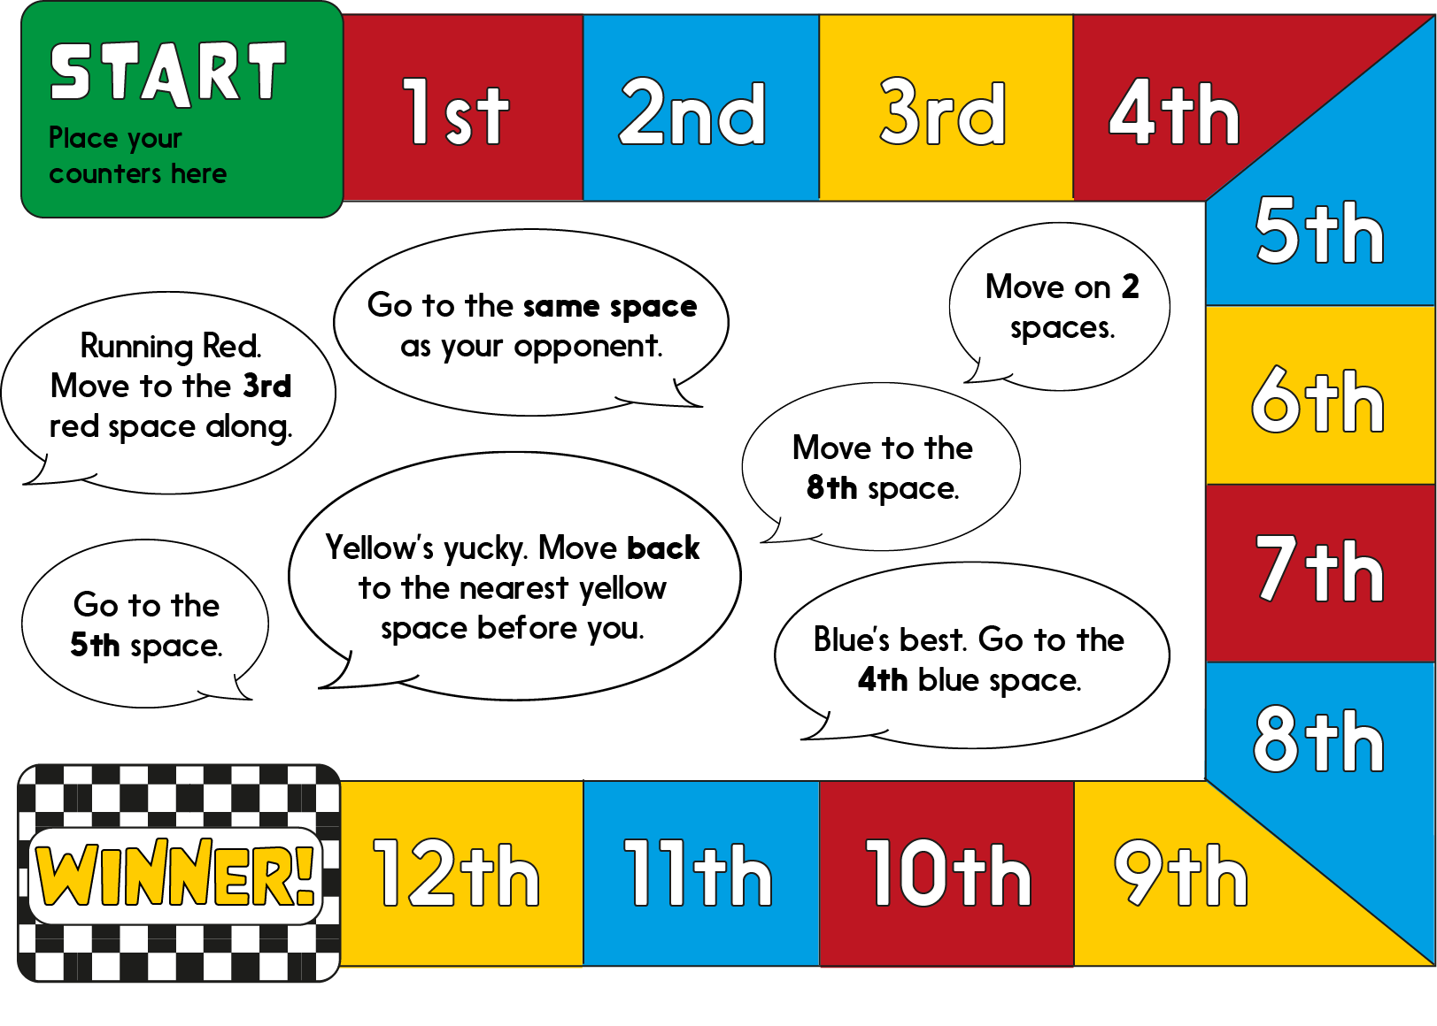
Instructions
  - Place your counters on Start.
  - Move by taking turns to spin the coin. Heads you move one space. Tails you stay put!
  - At any point, instead of spinning the coin, a player may elect to choose a speech bubble and obey its instruction.
  - No player may choose more than 4 speech bubbles in the whole game.
  - First person to get to Winner, wins!

